THIS WEEK AT BETHANY
April 30-May 7, 2017

Today 10:00 a.m. – Worship Service
11:10 a.m. – Sunday School
12:00 p.m. – Church Family Groups
7:30 p.m. – CWOP Service
Tuesday 6:00 p.m. – Handbell Choir
Friday 7:00 p.m. – Sr Youth: Survivor Night
Sunday 10:00 a.m. – Worship Service
11:10 a.m. – Sunday School
11:15 a.m. – BFC meeting
7:30 p.m. – CWOP Service

Speaking: Herb Sawatzky
Scripture: John 1: 14, 16-18; Matthew 4:17; 5:13-16
Theme: It starts and ends with Jesus

BETHANY MENNONITE CHURCH
WORSHIP SERVICES – 10:00 a.m.

Offices on East/West Line at Creek Road 468-3505
Office hours – Tuesdays – Fridays 8:30-3:30 p.m.

To receive a Bethany Bulletin by email, contact the church office.

Bethany Mennonite Church
A place to belong and grow in faith

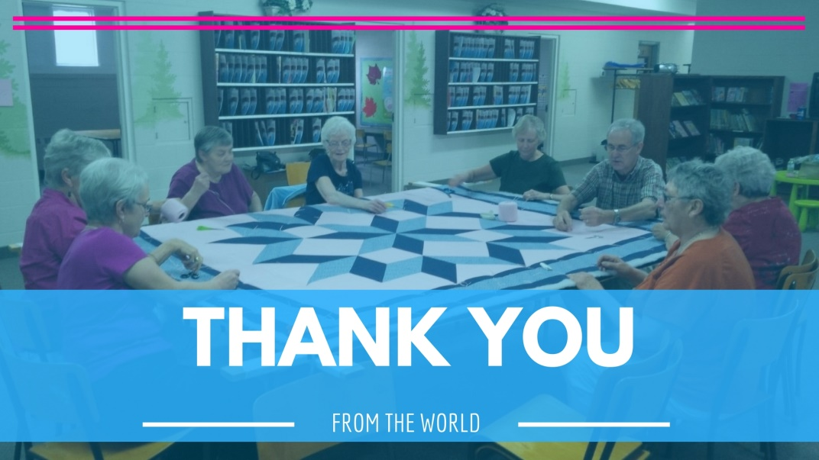

April 30, 2017
572 East & West Line
Box 249
Virgil, ON L0S 1T0
905-468-3505
Email: office@bethanymennonite.ca
Website: www.bethanymennonite.ca

Welcome here!
We’re glad you came! Your being here is a sign of God’s love for the world and encourages other Christians. We hope our worship together helps you find
A place to belong and grow in faith.

Praise and Concerns
Our missionaries:
- Sarah Roberts, a SIM intern
- Nathan & Taryn Dirks – at Bethany June 11th
- Margaret De Jong, our missionary in Senegal; finishing term in June
- Our sister church in Pereira, Colombia

Our prayers and sympathies are extended to Art & Anne on the passing of Art’s wife, Pat Bergen. We pray for comfort and strength for the family during this time.

Paul and Joanne Thiessen would like to thank our Bethany family for the many expressions of love and sympathy which we received after the recent passing of Joanne's brother, Ed. Your kind words, cards, flowers, prayers and hugs uplifted and comforted us during this time.

Our senior of the week: Lillian Andres

Our Donations Touching Lives: Pray for Mennonite Church Canada congregations and leaders as they relate to their Indigenous neighbours. May all peoples, together, release old patterns of relationship and behaviour and find new and life-giving ways to connect.

Bethany Announcements
We welcome Rick and his wife Louise to our service this morning!

Today, we'll be showing a Pioneer Girls video before the service beginning at 9:50 a.m.

Spiritual Formation Opportunities Today:
- 11:00 Worship Service
- 11:10 Children’s Sunday School
- Parent & Adult SS class combined in the gym

There are a few spots left for people to help out on June 11 for the CWOP Cricket Game & service. If you are able to help, please contact Steve Goertz.

This is the last opportunity to order Eden pork sausage before the summer! Stock up for BBQ time!! Garlic or regular smoked, 2 kg or 5 kg. Order and pay ONLINE until May 3 through the "School Cash Online" link on Eden's home page (eden.dsbn.org). Talk to Gayle Neufeld if you have any questions. Pick-up date is May 13, 10-12 at Eden. Thank you for your support!

Bethany's Being a Faithful Church Team (Ted Wiens, Iola Tiessen, Herb Sawatzky, Matthew King, Denise Falk) invites you to join the conversation about Bethany's response to LGBTQ individuals. Our intention is to provide a safe forum for discussion in our church family. If you would like to participate in these discussions, and to help us with our planning, please sign up on the sheet in the narthex. Meetings will be held on Sunday mornings May 7, 28, June 11 and 18 from 11:15-12:15 pm. If you choose to participate, you are encouraged to be at all 4 meetings and read the materials provided by the BFC team prior to participating in these conversations. Reading materials include:
- Ephesians 4: 1-3, Philippians 2, Galatians 5: 22-23, 1 John 4:18
- http://www.commonword.ca/FileDownload/23637/The_Bible_and_Same-Sex_Relationships.pdf (This article is available upon request from the church office.)

Mennonite Church
Today the Pilgrimage for Indigenous Rights starts the day at First Baptist Church, Oshawa, ON. To follow their progress, check out Facebook at www.facebook.com/pfirCanada/ or http://pfir.ca/. Thank you for your prayers and support.

The Summerbridge Program is an eight to twelve week service program for people of diverse cultural backgrounds to strengthen relationships with their home congregations and communities, experience the fulfilment of Christian service, support the development of their skills and build new friendships. For more information contact Joline Patfield at 519-745-8458 ext 241 or jolinepatfield@mcco.ca. Application deadline is May 1, 2017.

Grow Hope: Partner with MCC and Canadian Food Grains Bank to sponsor acres through Grow Hope Niagara and raise funds to help hungry people around the world. Your $400 per acre sponsorship becomes $2,500 through government matching. More info at mcco.ca/grow-hope-niagara.

Gardening Kits: MCC has been approached by 9 isolated First Nations communities in northern Ontario where the cost and availability of food is a serious issue. Help us raise funds and supplies to send site-appropriate seeds and a garden kit to communities working to sustain food production in their homeland. For a list of supplies and more info go to mcco.ca/gardening-kits.

Last Chance to Experience Silver Lake this Summer! A limited number of spots are left in most weeks of the summer including Mini Camp, Teen Camp, Skillz Camp and Arts & Adventure. Enjoy swimming, canoeing, sailing, kayaking, archery, crafts, nature exploration, low-ropes and climbing tower, gagaball, tether ball, homemade food, singing around the campfire, new cabins and much, much more. Financial assistance is available. For more information including pictures and videos, please visit www.slmc.ca or call 519-422-1401.

Paddle the Grand Fundraiser for Silver Lake Mennonite Camp, Saturday May 13: Silver Lake supplies the canoe, lifejackets and paddles and you enjoy a 1.5 hour paddle. Funds raised help to support Silver Lake’s summer camp program. To register or donate please visit www.slmc.ca or call 519-422-1401.

Annual General Meeting for Silver Lake Mennonite Camp, Saturday May 13 at 5:30 pm in Letson Park West Montrose. For more information please visit www.slmc.ca or call 519-422-1401.

The New Hamburg Mennonite Relief Sale Plant Tent is looking for donations of plants: perennials, succulents, house plants, native, berries, shrubs, and annuals. We would love your labelled potted plants and mention the colour if it has a bloom. More details at (www.nhmrs.com). 10th Annual Run for Relief – May 27th at 8:00 a.m. at the New Hamburg Mennonite Relief Sale. This fun event includes a 5k Run and a 2k Run/Walk. See details at nhmrs.com/run-for-relief. All money raised goes to support MCC.

AMBS course: Islam and Christian-Muslim Relations: June 12-30. Instructor: Jacqueline Hoover, a teaching affiliate in Islamic Studies and Muslim-Christian Relations at the University of Nottingham (U.K.) and a minister in the Mennonite Church. www.ambs.ca/academics/islam-and-christian-muslim-relations

Future Directions: Check out a progress report and a link to a survey about international Witness ministry at http://www.futuredirectionsmc.ca.

MCC will be turning 100 in 2020 and we want to celebrate! We hope to bring together a small group of our supporters to lead our birthday celebration. Are interested in joining the centennial team or have suggestions of others to join the team? Contact Sheryl Bruggeling at 519-745-8458 ext 265 or sherylbruggeling@mcco.ca.

Save-the-date for MCC Ontario's Annual General Meeting
12:30-3 pm, Sat, Sep 30, Community Room, 50 Kent Ave, Kitchener
The format of our AGM is different this year. We will begin at 12:30 pm with lunch, followed by worship and reporting on what MCC Ontario has been up to for the past year and what we have planned for the year ahead! More info will be available soon.

Emerging Voices Initiative needs your help to send youth delegates to the special Mennonite Church Assembly Oct. 13-15. Donate today to help youth delegates attend Assembly 2017. https://donate.mennonitechurch.ca/project/EVI-Youth2017.

Read about Mennonite Women Canada’s new President and Secretary-Treasurer, as well as updates about their projects and what women across Canada are involved in. All this and more in Mennonite Women Canada’s latest newsletter now available on CommonWord: www.commonword.ca/go/1168.

Broader Community
Citizens for Public Justice is an organization inspired by faith to act for public justice. CPJ is inviting churches to contribute to the government of Canada’s consultations on its Poverty Reduction Strategy via an easy-to-use online form via cpj.ca/cprs.

53 April 30, 2017 10:00 Service No. 18
Prelude
Welcome Herb Sawatzky
Songs

Announcements
Ministry Time & Prayer
Children’s Time Kathryn Walker
Scripture Reading - Matthew 25:34-40
Message – Thank you from the world Rick Cober Bauman
Offering & Song
Sending Song
Blessing

Band Members: Gayle Neufeld & friends
Candle Lighters: Mya & Khloe Greenside

