THIS WEEK AT BETHANY
July 2-9, 2017

Today 10:00 a.m. – Worship Service
Sunday 10:00 a.m. – Worship Service

Speaking: Dennis Dick
Scripture: 2 Corinthians 6:1-10
Theme: Tell the Story – A Mennonite Journey

BETHANY MENNONITE CHURCH
WORSHIP SERVICES – 10:00 a.m.

Offices on East/West Line at Creek Road 468-3505
Office hours – Tuesdays & Thursdays: 8:30-3:30 p.m.

To receive a Bethany Bulletin by email, contact the church office.

Bethany Mennonite Church
A place to belong and grow in faith

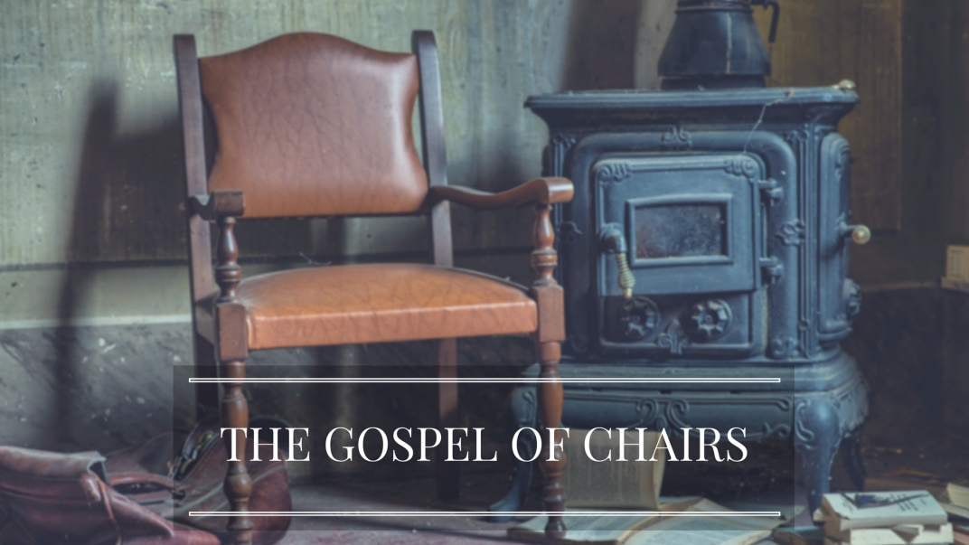

July 2, 2017
572 East & West Line
Box 249
Virgil, ON L0S 1T0
905-468-3505
Email: office@bethanymennonite.ca
Website: www.bethanymennonite.ca

Welcome here!
We’re glad you came! Your being here is a sign of God’s love for the world and encourages other Christians. We hope our worship together helps you find
A place to belong and grow in faith.

Praise and Concerns
Our missionaries:
- Sarah Roberts, speaking at Bethany in September
- Nathan & Taryn Dirks – as they transition into their next steps
- Margaret De Jong – speaking at Bethany October 15
- Our sister church in Pereira, Colombia

We share thanksgiving to God in memory of the life of Marg Dyck who passed away June 25th. A Funeral Service will be held here on Wednesday, July 5th at 11:00 a.m. Our prayers and sympathies are extended to Marg’s family.

Thank you for all your prayers. Art Bergen is making a slow recovery at home.

Thank you to all for your generous donations at last Sunday's church picnic. We made $900 after all expenses. Boys Club

Christian Peacemaker Teams, Columbia requests urgent prayers for El Guayabo, a village of 150 families who are dependent on the work of 60 farming families. In 2014, the entire village faced a threat of illegal eviction from their farms, but was able to prevent it, except for the village's teacher who was violently evicted by riot police. There is a new order of eviction schedules for July 5, 2017.

Our Donations Touching Lives: Pray for Mennonite Church Canada's Palestine and Israel Resolution Working Group as they continue to develop resources supporting resolution passed at Assembly 2016 and nurture relationships among Palestinian and Jewish neighbours. Pray for open hearts and minds to receive new understandings of justice and peace in this conflicted land. See the congregational study, Pathways for Peace and Justice in Palestine and Israel at www.commonword.ca/go/1032.

Bethany Announcements
A donation from the children's spring offering in the amount of $1,200 was made to the MCC Foodgrain Bank, Niagara Grow Hope program.

With July comes shorter office hours! Please note the office will be open Tuesdays & Thursdays from 8:30-3:30 for July & August. Marianne will be at the cottage various weeks during the summer, during which time Beth will sit in as our trusted, reliable, friendly administrator!

Youth Ministry - After prayerful consideration and personal reflection, Jessica and Jordan have decided to "step down" from their positions as leaders of the Junior and Senior Youth Ministry programs at Bethany. We thank them for their enthusiastic and dedicated years of service, and wish them God's richest blessings as they plan the next steps of their future together. A search to replace them has begun, and hopefully will be completed in time for the youth programs to commence this September.

Ordination Process - in January 2016 Heather Whitehouse was licensed towards Ordination as Community Chaplain. We are currently in a review process and have asked several homes in which Heather works and volunteers to provide feedback regarding her potential ordination. In addition, former members of PCRT are also providing feedback. If you wish to provide feedback as well, you may do so by contacting our pastor, Herb Sawatzky.

A green chair & some dishes were left at Virgil Sports Park last Sunday. Please contact Wern or Louise Rogalski to claim ownership.

Mennonite Church
SAVE THE DATE! Seeking Understanding: Reading the Bible in light of same sex relationships. A Seminar presented by Dan Epp-Tiessen, professor of Bible at Canadian Mennonite University, Winnipeg will be held on Saturday, September 30 from 9:00 am - 3:00 pm at Grace Mennonite Church, St. Catharines. The cost of $15 includes a coffee break and lunch. Planned by Grace Mennonite Church, The First Mennonite Church, & Vineland United Mennonite Church. Watch for more information.
Ride for Refuge Sept 30 – If you like to RIDE then
save-the-date for the RIDE for Refuge on Sept 30!
Grab your friends and family for a great time. More
info available at mcco.ca/ride or https://rideforrefuge.org/charity/mennonitechurchca.

Grow Hope: There are still acres available to sponsor through Grow Hope Niagara and raise funds to help hungry people around the world. $400 per acre can become $2,500 through government matching. More info at mcco.ca/grow-hope-niagara.

Summer is an opportunity to take out the lawn chair or beach blanket and read! CommonWord’s 9th annual Summer Reading list (items for sale or loan) is available here – www.commonword.ca/go/1213.

Broader Community
Erie View United Mennonite Church has enjoyed 70 years of serving our Lord and by faith in Christ anticipates another 70 years. Please consider this your invitation to celebrate this milestone with us Sept 10, 2017. The worship service begins for 10 am followed by a light lunch with an open mic for informal memory sharing. Seating for the lunch is limited. Please RSVP at your earliest to ptwarner1985@gmail.com.

Pleasant Manor is fund raising to improve the sidewalk surfaces for the courtyard and purchase new comfortable benches for the entire property. Donations will be accepted at the Pleasant Manor office.

53 July 2, 2017 10:00 Service No. 27
Prelude – “There's a Wideness in God's Mercy" #145
"For God So Loved Us" #167
Welcome Herb Sawatzky
Songs – “Wings of an Eagle"
"You are Holy"

Announcements
Ministry Time & Prayer
Children’s Time Shirley Dick
Scripture Reading – Isaiah 53:4-6 Denise Horne
Colossians 1:19-21 Linda Wiebe
Message – The Gospel of Chairs Herb Sawatzky
Offering – “I sing with exultation" verses 1, 2, 3 #438
Blessing
Closing Song

Band Members: Shirley Dick, Kenton & Sheryl Janzen, Adam Neufeld, Gayle Neufeld
Candle Lighters: Evan & Brooke Harlond

