THIS WEEK AT BETHANY
Oct 15-22, 2017
Happy Thanksgiving!

Today 10:00 a.m. – Worship Service
11:10 a.m. – Sunday School
Tuesday 9:00 a.m. – Quilting
6:00 p.m. – Handbells
7:00 p.m. – Pioneer Girls
Wednesday 7:00 p.m. – Church Board meeting
7:00 p.m. – Boys Club
Sunday 10:00 a.m. – Worship Service
11:10 a.m. – Sunday School for all ages

Speaking: Margaret De Jong
Scripture: Psalm 135:1-7; Matthew 14:22-33
Theme: Jesus’ presence stops the wind

BETHANY MENNONITE CHURCH
WORSHIP SERVICES – 10:00 a.m.

Offices on East/West Line at Creek Road 468-3505
Office hours – Tuesdays-Fridays: 8:30-3:30 p.m.

To receive a Bethany Bulletin by email, contact the church office.

Bethany Mennonite Church
A place to belong and grow in faith

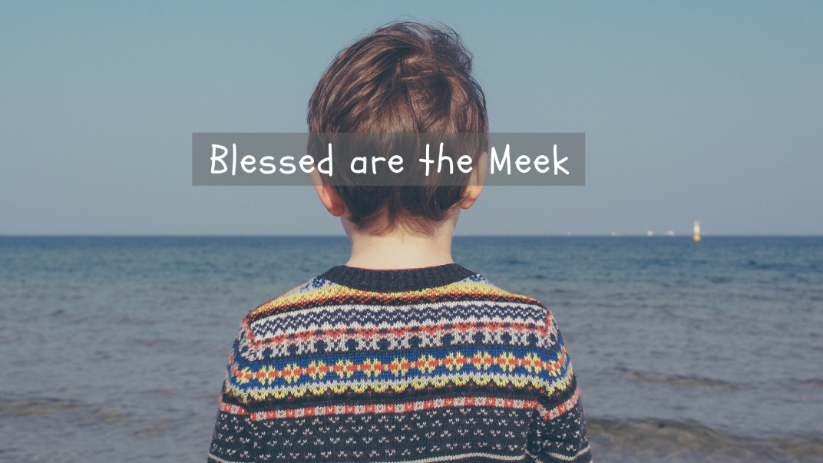

October 8, 2017

572 East & West Line
Box 249
Virgil, ON L0S 1T0
905-468-3505
Email: office@bethanymennonite.ca
Website: www.bethanymennonite.ca

Welcome here!
We’re glad you came! Your being here is a sign of God’s love for the world and encourages other Christians. We hope our worship together helps you find
A place to belong and grow in faith.

Praise and Concerns

Our missionaries:
- Margaret De Jong – speaking at Bethany October 15
- Our sister church in Pereira, Colombia

Associate Pastor Search – please keep our search team in your prayers as they continue to look for our next associate pastor.

Our best wishes to Abner Redekop, who will celebrate his 95th birthday on October 13th. Happy Birthday, Abner!

We thank you for the cards and best wishes on the occasion of our 50th Anniversary. Bethany has been a big part of those years and we are very thankful for our church family. Helmut & Sue Weier

Our Donations Touching Lives: Bill C-262 goes before Parliament for its second reading in November. If passed, this Bill will see that the laws of Canada are harmonized with the United Nations Declaration on the Rights of Indigenous Peoples. To find out how Mennonite Church Canada is supporting Bill-C-262 and how you can help, see http://pfir.ca/. Please pray for healing and the promise of reconciliation between setters and Indigenous people in this land.

Bethany Announcements
Spiritual Formation Opportunities Today:
- 10:00 Worship Service
- 11:10 Children’s Sunday School
- 11:15 Adult Sunday School (in library)
Parent Class (in Room 15)

Adult Sunday School will begin TODAY in the library.
Candy corn communion – TODAY the kids will serve us a “candy corn communion” after the message, providing us an opportunity to reflect on what we are thankful for.

Church Family Groups will begin again with the first Soup Lunch taking place on the last Sunday of October. Registration Forms are available at the back of the sanctuary this morning and the deadline to sign up is October 15, 2017. You do not need to be able to host a group in order to sign up. If you have any questions, please call Linda Van Bergen or Anne Litke.

Borscht Lunch and Bazaar November 18th. We will need items for our craft, preserves, and white elephant tables. This event is a tangible way to support missions. Your help is appreciated. Contacts - Barb Warkentine or Sue Weier

Guatemala Mission trip will be Feb. 1-9, 2018. Please contact Dave Dick for more information or to register. http://www.wellsofhope.com/. We will have a team meeting in two weeks’ time.

There are more announcements regarding our larger church on our website. Please visit www.bethanymennonite.ca!

Mennonite Church
Mennonite Church Canada has written a letter of reflections regarding the Being a Faithful Church process. Please find the letter on the bulletin board in the foyer.

Please find an MCC Annual Report in your mailboxes. The MCC Christmas Giving Catalogue is available on the shelf in the foyer.

Mennonite Church Canada invites you to view the Assembly live streamed from Winnipeg via http://home.mennonitechurch.ca/winnipeg2017Video on Oct. 13-15. Start Times are Manitoba time: Friday: 6:30 pm; Sat: 8:30 am; Breaks are at 10 am, 12:15 pm, 3 pm, 5 pm; Sun: 9 am.

October 14: Mennonite Historical Society of Ontario Fall Meeting – “Celebrating a Century of Mennonite Sewing Circles in Ontario" will be meeting at 2:00 pm, in the Community Room, (Mennonite Central Committee Ontario, 2nd floor). Come hear the history and personal reminiscences. A tour of Mennonite Central Committee Ontario's Material Resources operations will follow. For more information check our website.
Thursday, October 26 at 7:30 pm in the 2017 Eby Lecture, Professor Reina Neufeldt explores how moral and ethical claims that are intrinsic to peacebuilding can contribute to failure and can be part of transformational engagement. Her lecture is entitled When Good Intentions are not Enough: Confronting Ethical Challenges in Peacebuilding and Reconciliation. www.grebel.ca/events.

sixpointeight is a NEW youth, peace event rooted in the call of Micah to ‘do justice, love mercy and walk humbly with God’. High school youth from across Manitoba and beyond are invited for a day of worship, fun, learning, and community – motivating youth to be peace-builders in the way of Jesus. Sunday, October 15, 2017 | 2:00–8:00 PM at CMU. Full details and online registration www.cmu.ca/sixpointeight.

Niagara Area Mennonite Hymn Sing - Let’s sing together! Sunday, October 22, 2017 at 6:30 pm, Vineland United Mennonite Church. We will sing hymns and songs from our faith heritage as well as feature the singing of our choral groups. Refreshments will follow the hour of music making. All are welcome, bring a friend! For more information, please contact either Annie Schulz – 905-562-8129; Alf Redekopp -- 289-362-5963 or Louise Wideman – 905-562.4422.

Varenecki Supper! Fundraiser for "Friends of the Mennonite Centre in Ukraine" on Saturday October 28th at 6 p.m. at Niagara United Mennonite Church auditorium. Tickets are $35 per person ($20 receiptable) available from Linda Friesen 905-684-2929 or George & Teresa Dyck (Vineland) 289-929-3211. You’ll enjoy a great evening of good food and singing, fun and fellowship, and updates on Ukraine and the Mennonite Centre's projects.

The World Remembers: 1914-1918. From September 25-November 11, the names of 661,818 soldiers and nurses on all sides of the First World War killed in 1917 will be displayed at The Mennonite Archives of Ontario Gallery (3rd floor, Conrad Grebel University College). The commemoration is a unique expression of remembrance, reconciliation and education, and shows the enormous human cost of the war. www.uwaterloo.ca/grebel/nonresistance.

MCC is responding to the devastation needs: there are many opportunities for you to volunteer! Please check out their website at www.mcccanada.ca. Donations can be made by phone 800-313-6226 or mail cheques to MCC, 203-50 Kent Ave, Kitchener, ON N2G 3R1.

Mennonite Disaster Service Response to Windsor, ON Flooding: To help clean up, call SPC at 1-866-628-6565 and indicate you are part of MDS. If you have any questions call Martin Durksen at 905-736-1060.
Yella 2018: A Middle Eastern Learning Tour is a powerful three week trip for young adults to visit Israel and Palestine and to explore questions of Christian faith and life while interacting with Christians, Jews and Muslims. Participants encounter complex peace and conflict issues while seeing first-hand the context of Jesus' life and ministry. Applications are being received until October 31, 2017. For more information visit mcco.ca/yella-2018.

Bill C-262 goes before Parliament for its second reading in November. If passed, this Bill will see that the laws of Canada are harmonized with the United Nations Declaration on the Rights of Indigenous Peoples. To find out how Mennonite Church Canada is supporting Bill-C-262 and how you can help, see http://pfir.ca/. Please pray for healing and the promise of reconciliation between setters and Indigenous people in this land.

Broader Community
Niagara Life Centre has moved to 65 Lakeshore Road (formerly Lakeshore Baptist Church). Attend our Fundraising Banquet on October 27 and hear about our new location and God’s blueprint for Niagara Life Centre. For more info go to niagaralifecentre.ca or call 905-934-0021 to reserve your seat today.

The Watering Can generously donates a bucket of flowers each week to Heritage Place where they are distributed around the home. If you would like to volunteer to pick up the flowers on Tuesdays and deliver them to Pleasant Manor, please contact Norma Restivo at Normar@pleasantmanor.net or by calling Pleasant Manor.

Wednesday, October 11 at 1:00 pm, InfoHealth lecture at the NOTL Public Library will be on “Irritable Bowel Syndrome (IBS) Management.” The presentation and Q&A session will be conducted by medical students of McMaster University, Niagara Campus. For more information see the link: https://notlpubliclibrary.org/infohealth.

Westview Christian Fellowship & their Centre4Women invite you to an informal lunch and tour on Saturday, October 21st from 11:30-1:00 at 124 Queenston Street. RSVP to convener.westviewcf@gmail.com.

TRIP to see the operetta "Candide" by Leonard Bernstein on Friday, January 5, 2018, in Toronto (Bus trip, dinner, and show). Call Martha Bartel at 905-468-7029 to reserve your seat.

53 October 8, 2017 10:00 Service No. 41

Prelude
Welcome Herb Sawatzky
Songs

Announcements
Ministry Time & Prayer
Offering
Children’s Time Kathryn Walker
Scripture Reading – Isaiah 11:1-4; Matthew 5:5 Shirley Dick

Message – Blessed are the Meek Herb Sawatzky

Candy Corn Communion
Offering for Community Fund
Blessing & Closing Song

Band Members: Shirley Dick/Red Klassen/Gayle Neufeld & friends
Candle Lighter: Evan & Brooke Harlond

