THIS WEEK AT BETHANY
Oct 21-28, 2018

Today 10:00 a.m. – Worship Service
11:10 a.m. – Sunday School for all ages
Tuesday 9:00 a.m. – Quilting
6:00 p.m. – Handbell Choir
7:30 p.m. – JuBELLation
Wednesday 7:00 p.m. – Boys Club
Thursday 7:30 p.m. – Candlelight Practice
Friday 7:00 p.m. – Sr Youth
Sunday 10:00 a.m. – Worship Service
11:10 a.m. – Sunday School for all ages

Speaking: Karen Cornies
Scripture: Genesis 32:1-2, 24-31; Matthew 4:1-11
Topic: Into the Wild: Courage and Adventure

BETHANY MENNONITE CHURCH
WORSHIP SERVICES – 10:00 a.m.

Offices on East/West Line at Creek Road 468-3505
Office hours – Tuesdays - Fridays: 8:30-3:30 p.m.

To receive a Bethany Bulletin by email, contact the church office

Bethany Mennonite Church
A place to belong and grow in faith

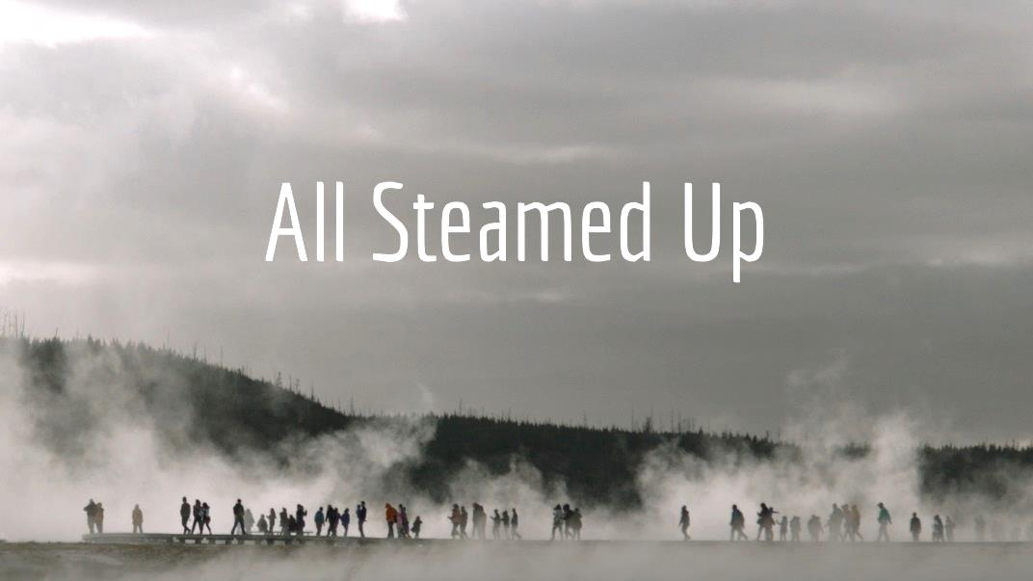

October 21, 2018

572 East & West Line
Box 249
Virgil, ON L0S 1T0
905-468-3505
Email: office@bethanymennonite.ca
Website: www.bethanymennonite.ca

Welcome here!
We’re glad you came! Your being here is a sign of God’s love for the world and encourages other Christians. We hope our worship together helps you find
A place to belong and grow in faith.

Praise and Concerns
Congratulations to Al & Barb Warkentine who are celebrating their 50th wedding anniversary on October 26th! We wish you God’s richest blessings as you continue your life together.

Our prayers and sympathies are extended to the Andres family on the passing of their brother Walter Andres on October 13th. The funeral was held at Niagara UM on Friday, October 19th. We pray for comfort and strength for them during this time.

Prayers:
- Our sister church in Pereira, Colombia

Our Donations Touching Lives: Pray for Urban Anabaptist Practitioners/MCEC Church Planters gathered this weekend in Montreal to learn, encourage and pray together as they strive to find God's idea that defeats economic, social and spiritual poverty.

Bethany Announcements
Spiritual Formation Opportunities Today:
- 10:00 Worship Service
- 11:10 Children’s Sunday School
Adult Sunday School

Quilting Fund – Donations to Bethany Women would be greatly appreciated! The need for quilts is great and our funds are low. Please consider helping us to continue this mission.

This November, Bethany will be sending care packages to our stressed-out college & university students. Please let Rebecca know if you'd like to contribute items to this project!

Guatemala Mission with Wells of Hope. This past February a team of 12 people from Bethany went to Guatemala. Our dates for our next mission with Wells of Hope is set for February 1st to 8th. If you would like to participate please contact the office. Our first team meeting will take place soon!

Mark your calendars! Candlelight Service will be at Bethany on Saturday, Dec 15, and at Niagara UM on Sunday Dec. 16. Choir rehearsals will begin on Thursday, October 25th at Bethany at 7:30 p.m. If you love to sing, please join us!

Family Group Soup Lunch – October 28th will be our first lunch. Group leaders will contact you with details next week.

Borscht Lunch & Bazaar – November 17 from 11:00 – 2:00 p.m. We welcome items for the White Elephant, craft, preserves and bake sale tables. Squares, & cookies are needed for dessert plates and a quilt raffle will also be held. If you are able to make a pot of Borscht, please sign up with Barb Warkentine or Anne Bergen. Your participation and support are greatly appreciated!

Mennonite Church
Cultural Translation: Negotiated Third Spaces and Those Who Live There This Grebel Gallery exhibit features the work of artist Soheila Esfahani, an Iranian Canadian. Soheila has lived in what she calls a “negotiated third space” and her artwork emerges from her reflections on this experience. Join us for the exhibit launch on Tuesday, October 23 at 4:30 PM or any time during regular gallery hours. Visit www.uwaterloo.ca/centre-peace-advancement/grebel-gallery.

Sing for Water – Under the leadership of Jane Ramseyer Miller, sing and reflect on the gift of water on Thursday, October 25th at 7:30 at Conrad Grebel University College Chapel.

Living History: Indigenous and Mennonite Stories of Encounter Join the Mennonite Historical Society of Ontario for a day of conversation about Mennonite settler stories and Indigenous histories on Saturday, October 27 from 10:00-4:00 at Conrad Grebel University College. www.mhso.org.

Attention students! The University of Waterloo Fall Open House on Saturday, November 3, 10 AM–5 PM, Conrad Grebel University College is a great time to see what it’s like to live in residence at Conrad Grebel University College and to learn more about the academic programs you’re interested in at the University of Waterloo. For more information visit: www.grebel.ca/visit

Three significant MDS events are planned for Saturday, November 17 to be held at the Floradale Mennonite Church, 22 Florapine Rd, Floradale, ON.
1. Learn about an ERT (Early Response Team), for a “Quicker and More Effective MDS Response” by being trained and ready for deployment after a disaster. This event starts at 9:30 AM and runs to noon. A light lunch will follow. For more info or to register please contact Nick Hamm at 905-401-3990 or hammnicholas.mds@outlook.com.
2. Annual CCP (Church Contact Person) Workshop from 1:00 to 3:30 pm to explain the role of a CCP, and how they can be the connection between MDS and their congregation. Please join us for lunch at noon prior to the workshop. For more info or to register please contact Martin Durksen at 905-736-1060 or cmdurksen@gmail.com.
3. MDS ON Awareness Evening – come help celebrate our youth involvement in MDS - 7:00 pm

MCC has recently joined a social enterprise called the Raw Carrot who partner with churches and non-profits to create meaningful employment for individuals on the Ontario Disability Support Program. If anyone is interested in participating in a visioning and brainstorming session to discuss expansion to the Niagara Region, please contact Sheryl Bruggeling at 289-407-4758. More info about Raw Carrot is available at https://mcccanada.ca/learn/more/raw-carrot-soup-enterprise.

There are more announcements regarding our larger church on our website. Please visit www.bethanymennonite.ca.

Broader Community
Mennonite Food & Craft Bazaar will be held Saturday November 3 from 10:00 am – 1:30 pm at St. Catharines United Mennonite Church, 335 Linwell Road. It features a Borscht lunch, baked goods, preserves, crafts, quilts, silent auction and attic treasures. The proceeds go to both local and overseas missions.

Start the Christmas season with the 10th Annual Homes of Distinction Christmas Home Tour on Nov. 16 +17 from 10:00-4:00, and be inspired by homes all dressed up in their Christmas best! The Tour features 10 tour stops including a heritage Bed and Breakfast, Winery Retreat, the largest selection of nativity scenes in Niagara and more. Purchase your ticket online or by phone (905-934-0021).

Niagara UM Church is looking for singers for their annual German Adventsfeier on Sunday, December 2. Practices will be every Tuesday 7:00-8:00. Please contact Lolita Hale if interested. All voices welcome!

You are invited to celebrate hope and its gift in healing at Niagara Life Centre's Annual Banquet and Silent Auction on October 26 at Holiday Inn. As we celebrate, our desire is to build both a spirit of thankfulness and a call to commitment for the ministry of Niagara Life Centre, as it offers help, hope, and healing to those in need. Please call 905-934-0021 for tickets and details.

Let’s sing together! The fall Niagara Area Mennonite Hymn Sing will take place at Niagara United Mennonite Church on Sunday, October 28, 3:00 pm. We will sing hymns and songs from our faith heritage as well as feature the singing of choral groups. Refreshments will follow the hour of music making. All are welcome ... bring a friend.

The "Adopt a Family Christmas Project" through Niagara Life Centre is a way for us to show God's love in a concrete way! We know it seems like a long way off, but Christmas will be here before we know it! For more information please call Joanne at 905-934-0021.

54 October 21, 2018 10:00 Service No. 42

Prelude

Call to worship Herb Sawatzky
Songs

Announcements
Ministry Time & Prayer
Children’s Time Joanne Thiessen
Scripture – Proverbs 30:33, Proverbs 15:1 Shirley Dick
Ecclesiastes 10:4 Denise Horne
Message – All Steamed Up Herb Sawatzky
Offering
Blessing
Closing Song

Band: Red Klassen & friends
Candle lighters: Mya & Khloe Greenside

