THIS WEEK AT BETHANY
Nov 25 - Dec 2, 2018

Today 10:00 a.m. – Worship Service
11:10 a.m. – Sunday School for all ages
12:00 p.m. – Church Family Groups
Tuesday 9:00 a.m. – Quilting
6:00 p.m. – Handbell Choir
7:00 p.m. – Pioneer Girls
Wednesday 7:00 p.m. – Jr Youth: SPAM night
Thursday 10:00 a.m. – PSCT meeting
7:30 p.m. – Candlelight Practice
Friday 6:00 p.m. – Sr Youth: Candlelight Stroll @ NUMC
Sunday First Advent
10:00 a.m. – Worship Service & Communion
11:10 a.m. – Sunday School for all ages
12:00 p.m. – Turkey Dinner Fundraiser!

Speaking: Herb Sawatzky
Scripture: John 6:1-14
Topic: 1st Advent: Preparing the Feast

BETHANY MENNONITE CHURCH
WORSHIP SERVICES – 10:00 a.m.

Offices on East/West Line at Creek Road 468-3505
Office hours – Tuesdays - Fridays: 8:30-3:30 p.m.

To receive a Bethany Bulletin by email, contact the church office

Bethany Mennonite Church
A place to belong and grow in faith

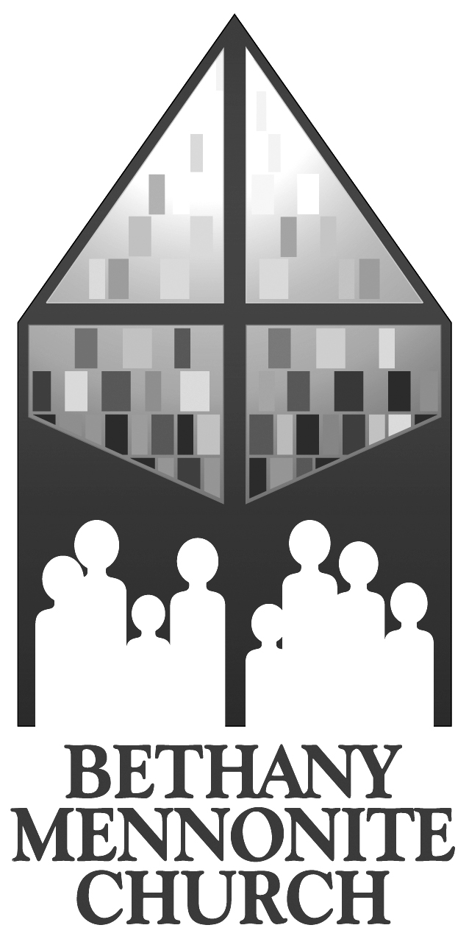

November 25, 2018

572 East & West Line
Box 249
Virgil, ON L0S 1T0
905-468-3505
Email: office@bethanymennonite.ca
Website: www.bethanymennonite.ca

Welcome here!
We’re glad you came! Your being here is a sign of God’s love for the world and encourages other Christians. We hope our worship together helps you find
A place to belong and grow in faith.

Praise and Concerns

Prayers:
- Our sister church in Pereira, Colombia

Our best wishes to Shirley Neufeld, who will celebrate her 80th birthday on November 30th. May God bless you as you celebrate with family and friends.

Next week’s First Advent worship service will include a celebration of Communion. We are all invited to prepare ourselves as we remember and anticipate the birth of our Lord and Saviour, Jesus Christ.

Our Donations Touching Lives: Please pray for our sisters and brothers at Chin Christian Church in Kitchener, ON as they deal with the traumatic death of a young adult this week. Please pray for family, friends, and the congregation as a whole as they walk through this time of grief. Pray as well for Pastor Joseph and other church leaders as they provide pastoral care and lead the funeral on Saturday.

Bethany Announcements
Contribution Statements to Oct 31st have been emailed out or placed in your mailbox. Please let the office know if you did not receive a statement or would like to change your preference for receiving it.

Spiritual Formation Opportunities Today:
- 10:00 Worship Service
- 11:10 Children’s Sunday School
Adult Sunday School

Membership Meeting There will be a brief Membership meeting TODAY immediately following the morning worship service (11:00 a.m.). Please plan to attend.

The Borscht lunch and Bazaar raised a total of $8,045: $5,905 for distribution to Missions, $1,395 for the sale of quilts and $745 for the Quilt Raffle (Newark Neighbours and Pikangikum water project). All are welcome to a meeting on Tuesday November 27 @ 1 p.m. in a SS room off the small gym to disperse funds. Comments/suggestions can be made to Sue Weier or Barb Warkentine. The winner of the quilt was Sig Neuhof of Niagara-on-the-Lake.

Silver Fox Dinner and Light Tour: Our tour is now full, and there is a waiting list. Anyone who is still unpaid, and wishes to hold his/her place, is asked to pay Ted or Syl today. Please be at Bethany between 4:00 and 4:15 on Thursday, Nov. 29 for a great evening!

The Mennonite magazine is a publication that helps to encourage readers to grow in their faith and to become agents of healing and hope in the world. Each monthly issue includes original feature-length articles, Bible study, columns, book reviews and more. If you would like to subscribe for $47./year, please call the office.

The October – December REACHOUT issue (Radiant Care update) is available on the bulletin board. Please help yourself.

Junior & Senior Youth
Next Sunday, we will be having our Youth Turkey Dinner Fundraiser. Come on down to enjoy turkey, mashed potatoes, corn, gravy....yum! Admission is by donation. All proceeds are to our youth groups!

This Wednesday at Junior Youth, we are having a SPAM night! Get ready for a series of fun challenges featuring everybody's favourite mystery meat!

This week in Senior Youth, we will be joining up with NUMC for the Candlelight Stroll. Meet at NUMC for 6 pm sharp. Hot chocolate and treats to follow. See you there!

On Friday, December 7, the Niagara Cluster will be hosting a Tacky Formal for Senior Youth at NUMC. Come prepared for big hair, big fun, big prizes. Remember to buy your $5 ticket in advance from Rebecca.

We are looking for more Junior Youth sponsors! Please talk to Rebecca if this is something that interests you.

Advent in Narnia - this coming Advent season our theme is based on the much-loved book series by C.S. Lewis. Everyone is encouraged to read "The Lion, The Witch, and the Wardrobe" over the next 3 weeks. The Audio book is also available for download at www.focusonthefamily.ca. We also ask that you save the following dates:
~ December 2 - Worship, communion, followed by Youth Turkey Dinner Fundraiser
~ December 9, 16, 23 - Worship Service
~ December 24, 6:30 pm - Christmas Eve, "Christmas in Narnia"
~ December 25, 10:45 am – Christmas Day Service at Niagara UM

Finally, all are encouraged to prayerfully consider who you could invite to this worship series: pray; pray again; invite!

Mennonite Church
Westview@night – Westview has taken over a drop in centre for the sex trade on Queenston Street, St. Catharines. They need your help: socks, underwear, finances, small blankets, gloves, scarves, and hygiene products. Please contact erikaeklassen@gmail.com if you are interested in volunteering!

IMCC Christmas Concert: Come to Bethlehem! On Sunday December 2, 2018 at 3:00 pm at St. Jacobs Mennonite Church.

There are more announcements regarding our larger church on our website. Please visit www.bethanymennonite.ca.

MCC & MDS
MCC is now accepting applications for SALT (Serving and Learning Together) 2019-2020 placements! It is a year-long service experience for 18-30 year olds with one of MCC's international partners. 2019-2020 placements include tech support, public health, project management and childcare in over 50 different countries. Go to mcccanada.ca/salt to apply or contact margaretsmart-wheaton@mcco.ca for more information.

Local Community
The Niagara Community Male Chorus will present its annual Advent concert TODAY at 7:00 pm at Niagara United Mennonite Church. A freewill offering will be held in support of Out of the Cold and MDS.

Canadian Food Grains Bank Information Night Come hear what CFGB is doing in Ontario and how it is making a difference in food aid and development projects around the world. Executive Director, Jim Cornelius, will share about the work that is ongoing for the past 35 years. Please join us Wednesday, November 28th, 7:00pm at The First Mennonite Church, 3557 Rittenhouse Rd., Vineland.

Eden High School Open House – November 29th from 6:30-8:30 p.m. in the gym. See poster in the foyer.

Niagara United Mennonite Church invites you to their annual German Adventsfeier (Advent Celebration), at 3:30 p.m., Sunday, December 2nd. There will be choral music, readings, and plenty of carol singing, including a special celebration of the 200th Anniversary of the beloved "Stille Nacht"! Refreshments to follow!

54 November 25, 2018 10:00 Service No. 47

Prelude

Call to worship Herb Sawatzky
Songs

Announcements
Ministry Time & Prayer
Children’s Time Shirley Dick
Scripture – Isaiah 58:1-12 Linda Wiebe
Matthew 25:31-45 Kenton Janzen
Message – What do you see? Shirley Dick
Offering
Blessing
Closing Song

Band: Gayle Neufeld & friends
Candle lighters: Alivia Nickason

