THIS WEEK AT BETHANY
Dec 16-23, 2018

Today Third Advent
10:00 a.m. – Worship Service
11:10 a.m. – Sunday School for all ages
Tuesday 6:00 p.m. – Handbell Choir
7:30 p.m. – JuBELLation
Friday 7:00 p.m. – Sr Youth
Sunday Fourth Advent
10:00 a.m. – Worship Service
11:10 a.m. – Sunday School for all ages

Speaking: Herb Sawatzky
Scripture: John 1:9-14; Philippians 2:5-11; Luke 2:1-12; psalm 98 (esp v9)
Topic: 4th Advent: Meeting Aslan/Meeting Christ

BETHANY MENNONITE CHURCH
WORSHIP SERVICES – 10:00 a.m.

Offices on East/West Line at Creek Road 468-3505
Office hours – Tuesdays - Fridays: 8:30-3:30 p.m.

To receive a Bethany Bulletin by email, contact the church office

Bethany Mennonite Church
A place to belong and grow in faith

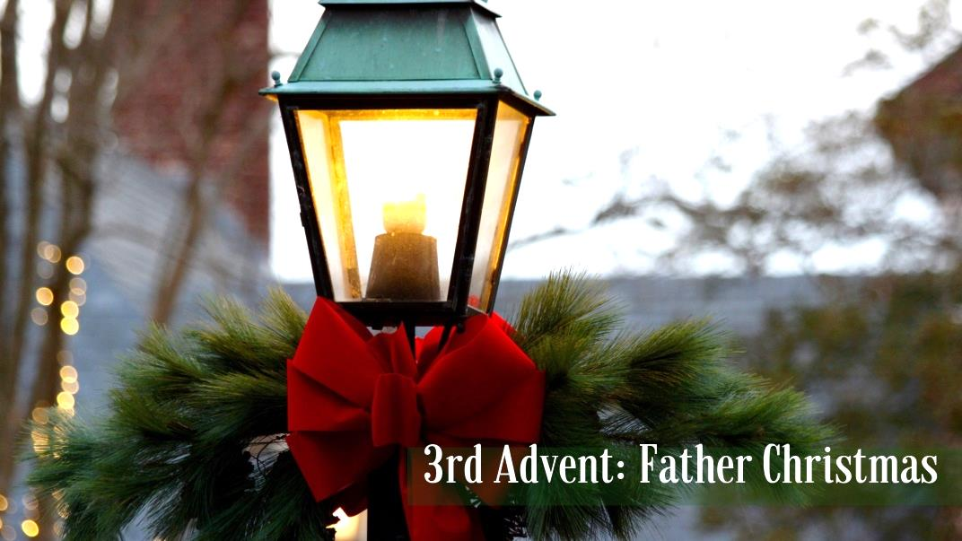

December 16, 2018

572 East & West Line
Box 249
Virgil, ON L0S 1T0
905-468-3505
Email: office@bethanymennonite.ca
Website: www.bethanymennonite.ca

Welcome here!
We’re glad you came! Your being here is a sign of God’s love for the world and encourages other Christians. We hope our worship together helps you find
A place to belong and grow in faith.

Praise and Concerns

Prayers:
- Our sister church in Pereira, Colombia
- Abner Redekop, went home from Shaver this past Friday
- Eleanore Epp recovering from surgery at St. Catharines General

Our Donations Touching Lives: The AMBS Board of Directors has appointed a search committee for the seminary’s next president. Chaired by AMBS Board Member Miriam Book, the committee will hold its first meeting Dec. 18 by video conference and its second meeting in person Jan. 9–10. The group is charged with seeking a successor to Sara Wenger Shenk, who plans to retire June 30, 2019.

Bethany Announcements
Spiritual Formation Opportunities Today:
- 10:00 Worship Service
- 11:10 Children’s Sunday School
Adult Sunday School

Christmas hours – During the week of Christmas, Marianne will be in the office on December 27 & 28. Herb & Rebecca will be away from home beginning December 25 for a week. Please call Pastor David Brubacher or Doug Schulz for Pastoral emergencies only.

Our Annual Membership meeting is January 26th. Reports will be due January 14th at the latest. Please work on your reports before the rush!

Advent in Narnia - this coming Advent season our theme is based on the much-loved book series by C.S. Lewis. Everyone is encouraged to read "The Lion, The Witch, and the Wardrobe" over the next week. The Audio book is also available for download at www.focusonthefamily.ca. We also ask that you save the following dates:
~ December 23 - Worship Service
~ December 24, 6:30 pm - Christmas Eve, "Christmas in Narnia"
~ December 25, 10:45 am – Christmas Day Service at Niagara UM
~ December 30 - Memorial Service
~ January 6 – Worship Service & New Year’s Potluck Brunch

Finally, all are encouraged to prayerfully consider who you could invite to this worship series: pray; pray again; invite!

Guatemala 2019 - This February we are sponsoring a team of 7 people to go to Guatemala with Wells of Hope. They are: Colton Sawatzky, Evan Van Vliet, Rylie Varmeyer, Jarod Miszk, Sam Beifuss, Chris Wiens, and Herb Sawatzky.

During our December 30th Memorial Sunday service, we will acknowledge those who have passed away in 2018. If you would like us to remember your loved one, please submit a photo with name, birthdate, date of passing, and names of immediate family members, to the office by December 21st at noon.

Our annual New Year’s Potluck Brunch will be held on January 6th at 11:00 a.m. after the worship service. Please bring some food to share.

The sock and mitten tree is set up in the foyer. Your donations are appreciated!

Operation Christmas Child shoeboxes were sent to Samaritan’s Purse. If you would like to donate towards the purchases, please mark your envelope “OCC”.

Junior & Senior Youth
We are looking for more Junior Youth sponsors! Please talk to Rebecca if this is something that interests you.

We will be having a games night this week in Senior Youth! Bring a favourite game if you have one : ).

After New Year’s, Senior youth will be changing from Friday evenings to Monday evenings.

Following Christmas break, Senior Youth will be starting back up on Monday, January 7, and Junior Youth will begin on Wednesday, January 16.

Mennonite Church
MEDA - Join us as we celebrate our new green global headquarters on Wednesday, Dec 19 from 3-7 pm featuring guided tours, refreshments and meet our new CEO, Dr. Dorothy Nyambi,! Please join us at MEDA, 595 Parkside Drive, Suite 2, Waterloo. RSVP required by December 14.

Volunteer work crews are needed in Montreal, QC. Hochma Church in Montreal had to do major renovations to their basement. Now that the contractor has finished correcting the foundation and flooring, Hochma needs help from some skilled volunteers to dry wall, partition the basement, paint, etc. Contact Michel Monette, pastor at Hochma, at michel.monette@hochma.org or 514.653.0877.

MENNONITE BURIAL SOCIETY Annual General Meeting will be held on Saturday, January 12, 2019 at 2 pm in the Pleasant Manor Oakview Chapel. Discussions to include levy rates and sustainability of society, revisions to constitution (for Jan 2020 AGM vote) regarding dissolution processes (society is not dissolving, however members may vote on this at a future AGM) and expanded eligibility of new members, etc. Board and committee positions are available. For further information, please contact Barry Boese at info@mennoniteburialsociety.com.

Fathers & Kids Retreat at Silver Lake Mennonite Camp from January 18-20, 2019: This is an amazing weekend for any dad looking to spend quality time with his kids. Skating on the lake, building snowmen and igloos, snowshoeing through the woods, roasting smores over the campfire, playing board games and mini-sticks in the dining hall and watching Hockey Night in Canada on the big screen! Dad’s enjoy some free-time on Saturday morning on the couches by the fire (newspapers and coffee will be in abundance) while our staff provide some outdoor programming with the kids. Sounds too good to be true we know, but that’s the Fathers & Kids Retreat. NOTE: Father can be defined as any male adult role model or mentor. For more information (including pictures from prior years) and to register visit www.slmc.ca/retreats or call 519-422-3200.

Women’s Retreat at Silver Lake Mennonite Camp from February 8-10, 2019: A Wild Heart: living the paradox of love in our lives. This Women’s only weekend is the perfect retreat for those looking to relax, reconnect and renew! Experience the beauty of creation. Be nourished by the relaxed pace and meaningful conversation. Play in the snow, breathe deeply in yoga, skate on the lake, treat yourself to a massage, snowshoe through the woods, stargaze on a horse drawn sleigh ride, savour exceptional food, or enjoy late night laughs in our brand new sauna. This time is all yours! Tanya Dyck Steinmann, pastor and spiritual director, offers times of worship, reflection and creative expression. For more information (including pictures from prior years) and to register visit www.slmc.ca/retreats or call 519-422-3200.

Save the date April 13, 2019 is our next WMCEC Spring Enrichment Day at Floradale Mennonite Church. Our theme, “Travelling Companions: We don't know where we are going, but we know how to get there!”, will touch on our lives in general, and the future of WMCEC. Our resource person for the day is Marilyn Rudy-Froese, MCEC Church Leadership Minister. We will share how we remain centered and attuned to God's voice in an unpredictable life. More information and registration will come soon!

MCC & MDS
Please consider donating to the MCC Christmas Giving Catalogue available on the shelf in the foyer. Or share God's love and invest in the dreams of entrepreneurs around the world. Visit www.giftsolutions.org to help create business solutions to poverty with MEDA (Mennonite Economic Development Associates).

There are more announcements regarding our larger church on our website. Please visit www.bethanymennonite.ca.

54 December 16, 2018 10:00 Service No. 50

Prelude JuBELLation

Call to worship Herb Sawatzky
Songs

JuBELLation
Announcements
Ministry Time & Prayer
Guatemala Team Introduction
Scripture – Mark 1:1-8; 1 Corinthians 12:4-7 James Sawatzky
Ephesians 6:10-17 Paula Lepp

Video

Message – Father Christmas Herb Sawatzky

Offering

Blessing

Closing Song

Band: Kenton Janzen & friends
Candle lighter: Charlotte Collins

