A place to belong and grow in faith

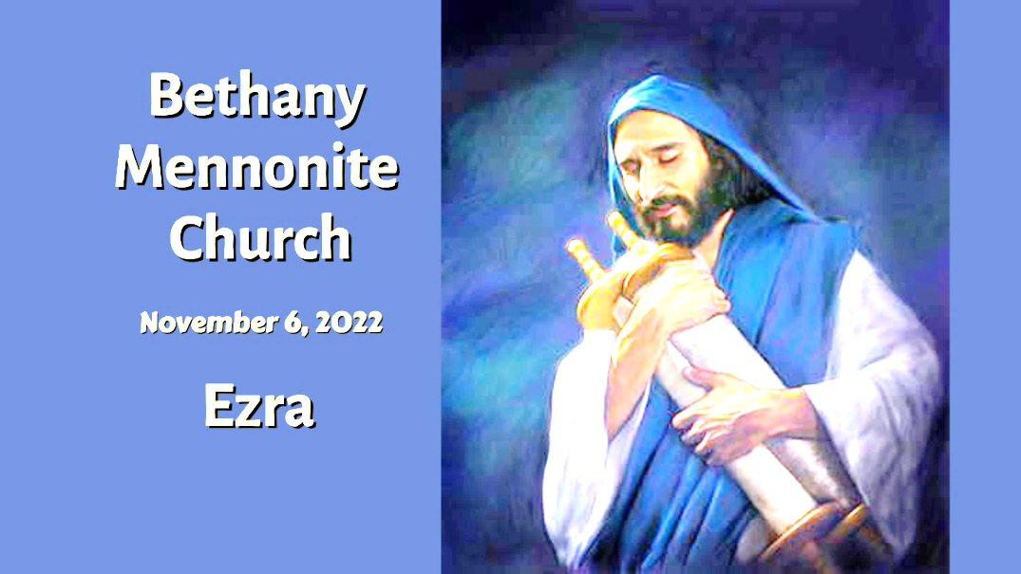

November 6, 2022
572 East & West Line
Box249
Virgil, ON L0S 1T0
905-468-3505
Email: office@bethanymennonite.ca
Website: www.bethanymennonite.ca

59 November 6, 2022 10:00 Service No. 45

Gathering
Prelude
Welcome & Call to Worship
Song – “O God our Help in Ages Past” vs 1-3 #328
“Speak, O Lord”
Prayer

Life Together
Announcements
Ministry time
Young Adult Update Rachel Frena
Pastoral Prayer
Song – “Spirit of the Living God” #349

Hearing the Word
Scripture – Ezra 7
Children’s Story
Message – Ezra Herb Sawatzky

Responding
Song – “Spirit of the Living God”
Offering & Prayer

Going
Song – “I’m Pressing on the Upward Way”
Blessing

Reader – Erik Nickel
Musicians – Shirley Dick & Friends

Welcome here!
We’re glad you came! Your being here is a sign of God’s love for the world and encourages other Christians. We hope our worship together helps you find
A place to belong and grow in faith.

Praise and Concerns
Prayers:
- Bill & Irene Goertz
- Dora Fisch-Willms dealing with a heart condition
- Sheila Gayman - friend of Reimer’s and Wiens’, undergoing cancer treatment
- Our sister church in Pereira, Colombia

Irene Schellenberg would like to thank everyone for their thoughts and prayers during her surgery and recovery time.

A big thanks to Abe Epp for the donations of fruit and vegetables to Pleasant Manor, and also to Linda Andres for her assistance at the tables in raising $2000 for our quilting ministry. This produce was available to all residents of Radiant Care and donations could be made. Thank you Abe for your generosity!

Our Donations Touching Lives
Friends of the Mennonite Centre of the Ukraine – Goal $30,000. Donations Received: $27,650. We ask that you continue to keep the Ukraine in your prayers and to consider supporting this humanitarian effort.

You can make your offering to Bethany by:
• E-transfer to office@bethanymennonite.ca
• Mail to church at Box 249, Virgil, ON L0S 1T0
• Drop in the mailbox beside the front door on Wednesdays or Thursdays 8:30-3:30 and let Marianne know.
• Canada Helps button on www.bethanymennonite.ca. CanadaHelps charges 3.75% of the donation, but you will be receipted for full amount.

Prayers:
Mennonite Church Eastern Canada
- Please pray for St. Catharines United Mennonite Church. Randy Klaassen and Paul Adams provide pastoral leadership for the congregation. Currently they are in a leadership transition, pray for them as they seek God's leading for their congregation.
- Pray for Nancy Dyck, wife of David Dyck (pastor, Leamington United Mennonite Church), as she recovers from brain surgery that took place Wednesday afternoon. David reported Wednesday afternoon that Nancy was doing well in recovery and that the surgeon was pleased with the surgery.
- Pray for Viola Dorsch and her family as they grieve the loss of Victor Dorsch, retired MCEC pastor, who died on October 25, 2022. Victor was an ordained minister who pastored at Maple View Mennonite Church. A memorial service will be held on November 24, 2022, at 11:00 a.m. at Steinmann Mennonite Church, Baden, Ontario. To find out more about Victor, please read his obituary/tribute.
- Continue to pray for peace and wisdom in Ukraine, Russia and in places throughout our world where the people cry out for peace.

Mennonite Central Committee
• On October 19, the Material Resources team loaded a container to Ukraine (Praise God)! The container had 4,595 heavy weight comforters, 1,267 infant comforters, 533 lightweight comforters, 800 hygiene kits, 237 relief kits, 200 sewing kits and 1,104 tubes of toothpaste. This load will be making its way to Ukraine via Poland. We ask for prayers for a safe journey and for those who will be receiving the items.
• As we head back to indoor settings to shelter from the onset of winter, we keep in mind remote communities such as Kitchenuhmaykoosib Inninuwug First Nation (Big Trout Lake First Nation). This northwestern First Nation of just over 1,000 members is coping with 175 COVID-19 cases, involving 53 households. The community is currently locked down and is operating with only two nursing staff. Please join us in praying. May God wrap arms around this remote Indigenous community.

Bethany Announcements
Spiritual Formation Opportunities Today:
- 10:00 Worship Service
- 11:10 Adult & Children’s Sunday School

Adult Sunday School is having a vigorous conversation regarding how Bethany Mennonite Church can meet the needs of our surrounding community. Grab your coffee and join us in the library right after the service.
Bethany Bazaar: Thank-you to everyone who has volunteered to help with the Borscht Sale next Saturday, Nov 12th. We look forward to working with you. Enjoy your cooking and baking this week as we prepare for the sale. Please bring your Borscht, bread, baked goods and preserves to the church by 9 am on Saturday. The sale starts at 10 a.m. Please share this date with your friends and neighbours.

Golden Coyotes! You are invited to a games night at the home of Kenton and Sheryl on November 19 at 7 pm. We will be doing a mix of group games, card games and board games. Bring along you favourite game and a snack to share.

Hear ye! Hear ye! The Silver Foxes are back in business & on the prowl. We are planning a Christmas Light Tour of Niagara, coupled with dinner at Betty’s Restaurant in Niagara Falls on Thursday Dec. 8th. Please be at Bethany Church at 4:30 pm on that date. The bus departs at 4:45 pm. The cost will be $ 55.00 per person (including tax & tip) for the bus and the dinner. Please contact Joanne Thiessen or Buddy Andres to confirm your attendance no later than Sunday Nov. 20th by e-transfer or a cheque payable to Bethany Mennonite Church.

MCC Peace Buttons are available for purchase on the table in the foyer. Donations are appreciated.

A box with a hearing aid in it has been found on the floor in the sanctuary. If you are missing yours, please contact the office.

Pleasant Manor feed – It has come to our attention that our worship service cannot be transmitted to Pleasant Manor through the antennae any longer. Services are streamed online. Residents have the option of borrowing a tablet from the front desk before Friday’s to view the service on Sunday. Staff will be available in the Creekview link on Saturday at 1:30 to answer any questions you have (ex how to operate the tablet).

Local Food Bank Drive: Area food banks inform us that donations are down 30% this year while need is up 20%! Your continued support for our food drive to local food banks is much appreciated. Please drop off your donations in the food bin at the front door. Foods and snacks for breakfasts and school lunches are especially appreciated.

Mennonite Church Canada
Philippines Learning Tour with MC Canada International Witness - January 2023. Register by November 11, 2022 and join Norm Dyck, MCEC Mission Minister.. For more information visit MC Canada's website or contact Norm Dyck at ndyck@mcec.ca.

Voices Together: A Celebration of Church Song – Sunday, November 20, 7:00 PM - 8:30 PM, WK Mennonite Church. Does your favourite part of a worship service include singing together? Sing hymns and worship songs from German Mennonite, African American, Laotian, Ethiopian and other Christian traditions along with other lovers of church song. All are welcome, masks encouraged. More information at uwaterloo.ca/music/events.

MCC, MDS, MEDA
MDS Canada is calling for volunteers to assist with clean up in Nova Scotia after Hurricane Fiona! We are asking volunteers to commit to a week at a time. The skills sets needed are experienced Chainsaw Operators and Roofing Crews. Accommodations and meals will be provided. Volunteers need to bring their own bedding. Some travel reimbursement is available. Please contact Clara Flores at cflores@mds.org or by calling 204-261-1274.

MCC Thrift Christmas Giving ornament! Proceeds from these gifts will provide fruit trees and chickens as a source of income and nutrition and clean water in homes. Plus, these ornaments are made from seed paper. Plant it, water it and watch it grow into beautiful wildflowers. Available at your local thrift shop while supplies last.

MCC Christmas Giving Guide is available on the foyer shelf. Please help yourself to a catalogue and give gifts of comfort and joy!

MCC Peace Conference Friday, November 18 at 7 PM and Saturday, November 19 from 9 am-4 pm. The MCC Peace Conference is your chance to see, hear and experience first-hand how you and MCC are changing lives and communities through peacebuilding. This event will inspire and inform through general sessions, workshops and conversations with messengers of peace. To learn more and register, go to mcco.ca/peace-conference.

MCC Peace Conference: Blanket Exercise – November 18th 7 pm, at Bethany Community Church (1388 Third St, St Catharines). The blanket exercise is an interactive educational program that teaches the history of Indigenous and Settler people in Canada from an Indigenous perspective. Participants stand on blankets representing lands inhabited by Indigenous Peoples. A facilitator tells the story of first contact, moving and removing blankets to show the way land was taken and peoples relocated, and to illustrate the impact of disease, war, and extinction. The exercise concludes with the participants discussing the experience in groups. Participation in the Blanket Exercise is free. Please register at: https://www.eventbrite.ca/e/2022-peace-conference-registration-425854059957 (select “Blanket Exercise”).

THIS WEEK AT BETHANY
November 6-13, 2022

Today 10:00 a.m. – Worship Service
11:10 a.m. – Sunday School
Monday 7:00 p.m. – Sr Youth: Brain Games
Tuesday 6:00 p.m. – Handbell Choir
7:30 p.m. – JuBELLation
Wednesday 6:30 p.m. – Jr Youth: Classic Games
Sunday 10:00 a.m. – Worship Service
11:10 a.m. – Sunday School

Speaking: Herb Sawatzky

