A place to belong and grow in faith

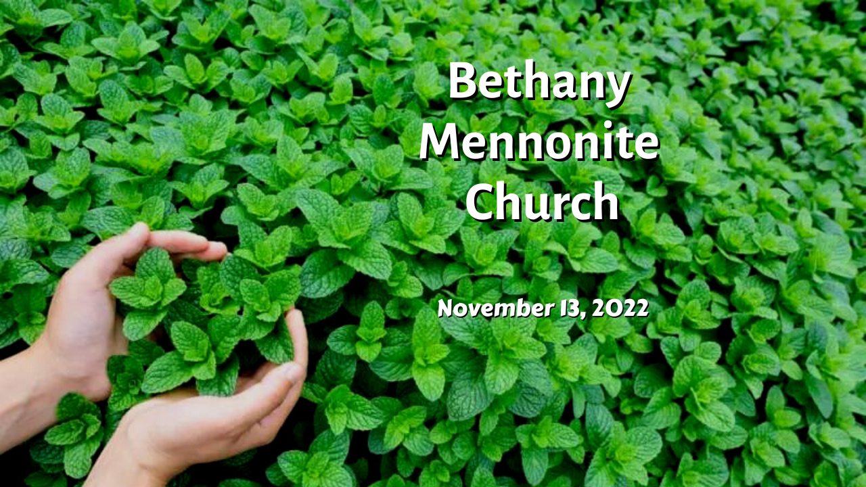

November 13, 2022
572 East & West Line
Box249
Virgil, ON L0S 1T0
905-468-3505
Email: office@bethanymennonite.ca
Website: www.bethanymennonite.ca

59 November 13, 2022 10:00 Service No. 46

Gathering
Prelude
Welcome & Call to Worship
Song
Prayer

Life Together
Announcements
Ministry time
Pastoral Prayer
Song

Hearing the Word
Scripture –
Children’s Story
Message – Working for Peace Herb Sawatzky

Responding
Song
Offering & Prayer

Going
Song
Blessing

Reader – Linda Wiebe
Musicians – Gayle Neufeld & Friends

Welcome here!
We’re glad you came! Your being here is a sign of God’s love for the world and encourages other Christians. We hope our worship together helps you find
A place to belong and grow in faith.

Praise and Concerns
Prayers:
- Bill & Irene Goertz
- Dora Fisch-Willms dealing with a heart condition
- Sheila Gayman - friend of Reimer’s and Wiens’, undergoing cancer treatment
- Our sister church in Pereira, Colombia

Our Donations Touching Lives
Friends of the Mennonite Centre of the Ukraine – Goal $30,000. Donations Received: $31,650. We ask that you continue to keep the Ukraine in your prayers and to consider supporting this humanitarian effort.

You can make your offering to Bethany by:
• E-transfer to office@bethanymennonite.ca
• Mail to church at Box 249, Virgil, ON L0S 1T0
• Drop in the mailbox beside the front door on Wednesdays or Thursdays 8:30-3:30 and let Marianne know.
• Canada Helps button on www.bethanymennonite.ca. CanadaHelps charges 3.75% of the donation, but you will be receipted for full amount.

Prayers:
Mennonite Church Eastern Canada
- Please pray for St. Jacobs Mennonite Church. Mark Diller Harder, Kevin Derksen and Janet Bauman provide pastoral leadership for the congregation. Pray for them as they seek to celebrate and listen to the Living God and demonstrate God's love in their neighbourhoods and the world.
- Continue to pray for Art Byer (retired MCEC pastor) and family as they grieve the death of Evelyn Byer, who died on November 3, 2022.
- Continue to pray for peace and wisdom in Ukraine, Russia and in places throughout our world where the people cry out for peace.

Mennonite Central Committee
• MCC partner, ISARC (Interfaith Social Assistance Reformed Coalition) invites you to join us for our Raise The Rates Interfaith Fast - an intentional time of prayer and fasting between Monday, November 14 and Friday, November 18. Justice, equity, and compassion are at the heart of many faiths, and it’s important for us as an interfaith community to support our most vulnerable neighbours. More information at www.isarc.ca.

Bethany Announcements
Spiritual Formation Opportunities Today:
- 10:00 Worship Service
- 11:10 Adult & Children’s Sunday School

Adult Sunday School is having a vigorous conversation regarding how Bethany Mennonite Church can meet the needs of our surrounding community. Grab your coffee and join us in the library right after the service.

Golden Coyotes! You are invited to a games night at the home of Kenton and Sheryl on November 19 at 7 pm. We will be doing a mix of group games, card games and board games. Bring along you favourite game and a snack to share.

MCC Peace Buttons are available on the table in the foyer. Donations are appreciated.

Bethany Christmas Potluck will take place on Sunday, December 4th at noon. More details to follow.

Providing A Dementia-Friendly community All are invited to come on Wednesday evening, Nov. 23, at 7 p.m., for an educational session, approximately one hour in length, provided by the Alzheimer's Society of Niagara. It is so important to provide a safe and supportive place for those living with dementia, and also for their care partners and their communities. Anyone who is interested in learning more about this important topic is welcome. If you would like to attend, please contact Joanne Thiessen or Ella Andres.

Hear ye! Hear ye! The Silver Foxes are back in business & on the prowl. We are planning a Christmas Light Tour of Niagara, coupled with dinner at Betty’s Restaurant in Niagara Falls on Thursday Dec. 8th. Please be at Bethany Church at 4:30 pm on that date. The bus departs at 4:45 pm. The cost will be $ 55.00 per person (including tax & tip) for the bus and the dinner. Please contact Joanne Thiessen or Buddy Andres to confirm your attendance no later than Sunday Nov. 20th by e-transfer or a cheque payable to Bethany Mennonite Church.

Pleasant Manor feed – It has come to our attention that our worship service cannot be transmitted to Pleasant Manor through the antennae any longer. Services are streamed online. Residents have the option of borrowing a tablet from the front desk before Friday’s to view the service on Sunday. Staff will be available in the Creekview link on Saturday at 1:30 to answer any questions you have (ex how to operate the tablet).

Local Food Bank Drive: Area food banks inform us that donations are down 30% this year while need is up 20%! Your continued support for our food drive to local food banks is much appreciated. Please drop off your donations in the food bin at the front door. Foods and snacks for breakfasts and school lunches are especially appreciated.

Mennonite Church Canada
Voices Together: A Celebration of Church Song – Sunday, November 20, 7:00 PM - 8:30 PM, WK Mennonite Church. Does your favourite part of a worship service include singing together? Sing hymns and worship songs from German Mennonite, African American, Laotian, Ethiopian and other Christian traditions along with other lovers of church song. All are welcome, masks encouraged. More information at uwaterloo.ca/music/events.

Hidden Acres Mennonite Camp is celebrating 60 years!! Please join us at our Annual General Meeting which will be held at Tavistock Mennonite Church on Tuesday, November 22 at 6:30 p.m. to hear stories and songs from the last 60 years. The evening will also include a short business meeting. RSVP to info@hiddenacres.ca or 519-625-8602.

Music, Liturgy, and the Making of Medieval Scotland, Thursday, November 24 - 7:30 PM, Grebel Chapel Enjoy a special performance of medieval liturgical music, made at the Cathedral of St Andrews to celebrate Saint Andrew’s relics, and learn how liturgical music shaped history. Presented by Kate Kennedy Steiner, Assistant Professor of Music & Director of Church Music and Worship at Conrad Grebel University College. Register to attend at grebel.ca/eby

Silver Lake Mennonite Camp is Hiring! Go to slmc.ca to learn more.
· Maintenance Coordinator. 1/2 time year-round to work on site at camp.
· Assistant Director Day Camps. Full time May 1- Aug 31. Must be available to work at Kitchener/Waterloo day camps in July and August.
Retreats: Come to Silver Lake this winter! Dads & Kids, Snowshoe Hike, Women’s Retreat & Couple’s Retreat. Go to Retreat & Events for info and to register (opens Dec 1). These make fantastic Christmas gifts!

MCC, MDS, MEDA
MDS Canada is calling for volunteers to assist with clean up in Nova Scotia after Hurricane Fiona! We are asking volunteers to commit to a week at a time. The skills sets needed are experienced Chainsaw Operators and Roofing Crews. Accommodations and meals will be provided. Volunteers need to bring their own bedding. Some travel reimbursement is available. Please contact Clara Flores at cflores@mds.org or by calling 204-261-1274.

MCC Thrift Christmas Giving ornament! Proceeds from these gifts will provide fruit trees and chickens as a source of income and nutrition and clean water in homes. Plus, these ornaments are made from seed paper. Plant it, water it and watch it grow into beautiful wildflowers. Available at your local thrift shop while supplies last.

MCC Christmas Giving Guide is available on the foyer shelf. Please help yourself to a catalogue and give gifts of comfort and joy!

MCC Peace Conference Friday, November 18 at 7 PM and Saturday, November 19 from 9 am-4 pm. The MCC Peace Conference is your chance to see, hear and experience first-hand how you and MCC are changing lives and communities through peacebuilding. This event will inspire and inform through general sessions, workshops and conversations with messengers of peace. To learn more and register, go to mcco.ca/peace-conference.

MCC Peace Conference: Blanket Exercise – November 18th 7 pm, at Bethany Community Church (1388 Third St, St Catharines). The blanket exercise is an interactive educational program that teaches the history of Indigenous and Settler people in Canada from an Indigenous perspective. Participants stand on blankets representing lands inhabited by Indigenous Peoples. A facilitator tells the story of first contact, moving and removing blankets to show the way land was taken and peoples relocated, and to illustrate the impact of disease, war, and extinction. The exercise concludes with the participants discussing the experience in groups. Participation in the Blanket Exercise is free. Please register at: https://www.eventbrite.ca/e/2022-peace-conference-registration-425854059957 (select “Blanket Exercise”).

BROADER COMMUNITY
You are invited to our annual fundraiser in support of the Spiritual Life Centre at Eden High School on November 18. Come and hear students share how the SLC has impacted their lives, and learn about the SLC’s Vision and Financial need for this school year and beyond. The event will once again feature catering provided by Chef Brad Rempel, home-made desserts, and lots to bid on during our silent auction. If you or someone you know, is willing to donate a silent auction item, please contact Tracy Mumford at tmumf@sympatico.ca. The event will be held at New Hope Church Niagara (2360 First Street Louth, St. Catharines). For further information and for tickets ($50), please go to slceden.com.

Niagara United Mennonite Church invites all German speaking friends in the region for a German Advent Celebration, Sunday, Nov. 27th, at 3:00 p.m. Come, sing together those beloved German carols, take in the stories of Christ’s coming in words & pictures, and meet the folks who have been sharing German worship on Cogeco Cable 10 and online since 2020. We’d love to see you there. Coffee/tea & cookies to follow!

THIS WEEK AT BETHANY
November 13-20, 2022

Today 10:00 a.m. – Worship Service
11:10 a.m. – Sunday School
Monday 7:00 p.m. – Sr Youth: Couch Party
Tuesday 6:00 p.m. – Handbell Choir
7:30 p.m. – JuBELLation
Sunday 10:00 a.m. – Worship Service
11:10 a.m. – Sunday School

Speaking: Herb Sawatzky
Scripture: Matthew 14:19; Jeremiah 29:7; Matthew 5:9
Theme: Peace Sunday

