A place to belong and grow in faith

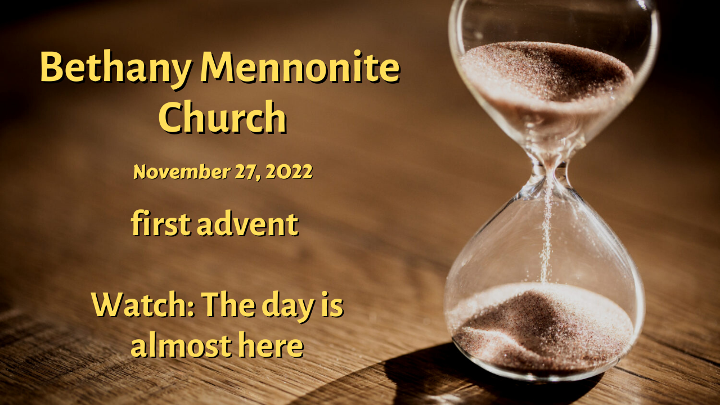

November 27, 2022
572 East & West Line
Box249
Virgil, ON L0S 1T0
905-468-3505
Email: office@bethanymennonite.ca
Website: www.bethanymennonite.ca

59 November 27, 2022 10:00 Service No. 48

First Advent

Gathering
Prelude
Welcome & Call to Worship
Song – “Come Thou Long Expected Jesus” #178
Advent Candle lighting
Song – “While we are waiting, come”
Prayer

Life Together
Announcements
Ministry time
Pastoral Prayer
Song – “O Little Town of Bethlehem” #191

Hearing the Word
Scripture – Matthew 24:36-44; Romans 13:11-12
Children’s Story
Message – Watch: The day is almost here Herb Sawatzky

Responding
Song – “A Christmas Alleluia”
Communion
Offering & Prayer

Going
Song – “Joy to the World” #318
Blessing

Reader – Ted Wiens
Musicians – Shirley Dick & Friends

Welcome here!
We’re glad you came! Your being here is a sign of God’s love for the world and encourages other Christians. We hope our worship together helps you find
A place to belong and grow in faith.

Praise and Concerns
Prayers:
- Dora Fisch-Willms dealing with a heart condition
- Sheila Gayman - friend of Reimer’s and Wiens’, undergoing cancer treatment
- Our sister church in Pereira, Colombia

A Communion Service will be held today. Communion cups, with bread and drink will be available for pick up as you enter the service. Those worshipping at home are invited to prepare their own bread and cup, and grapes and crackers for your kids. We are all invited to prepare ourselves as we remember Jesus’ sacrifice for us and enter into the Advent season of Hope, Love, Joy, and Peace.

I thank you prayer warriors. I hurt my leg July 8th. It was a deep trauma wound. The last dressing finally came off. Thank you for your prayers. God hears and answers. Anne Bergen & nurses.

Bethany Announcements
Spiritual Formation Opportunities Today:
- 10:00 Worship Service
- 11:10 Adult & Children’s Sunday School

Please read the latest letter from our sister Church in Pereira.

Niagara UM Church is inviting all who would like to serve the community through song at the Candlelight Stroll in Niagara-on-the-Lake, to join us on Friday, Dec 2, at 6:30 until approximately 8:00 p.m. We will be standing on the corner of Gate and Johnson streets. Hot chocolate will be served. Please pray for this evening that the music heralding Christ’s birth will bring light to the community.

Bethany Christmas Lunch – The Hospitality Team is hosting a Christmas Potluck-style lunch on Sunday, December 4 at 11:30 a.m. We are looking for volunteers to roast turkeys (turkeys will be supplied), make mashed potatoes and stuffing. If you want to volunteer, please speak to Anne Litke, Patty King or Linda Van Bergen. Everyone else who attends is asked to bring a vegetable side dish AND a dessert.

Mark your calendars! On Sunday, December 18, at 3:00 p.m., a special Christmas Choral Concert, "Joy to the World" will be hosted at Bethany Mennonite Church, featuring the Seasons Chorale, under the direction of Bert Warkentin, with choir members from many of our community churches. A prelude by the Niagara Bethany Handbell Choir will begin at 2:45 p.m. All are welcome, please join us to celebrate Christ's coming! There will be an opportunity to make a free will offering to support our local food banks. Donations of non-perishable groceries are also welcomed.

Local Food Bank Drive: Area food banks inform us that donations are down 30% this year while need is up 20%! Your continued support for our food drive to local food banks is much appreciated. Please drop off your donations in the food bin at the front door. Foods and snacks for breakfasts and school lunches are especially appreciated.

Our Donations Touching Lives

You can make your offering to Bethany by:
• E-transfer to office@bethanymennonite.ca
• Mail to church at Box 249, Virgil, ON L0S 1T0
• Drop in the mailbox beside the front door on Wednesdays or Thursdays 8:30-3:30 and let Marianne know.
• Canada Helps button on www.bethanymennonite.ca. CanadaHelps charges 3.75% of the donation, but you will be receipted for full amount.

Prayers:
Mennonite Church Eastern Canada
- Please pray for Stirling Avenue Mennonite Church. Kim Penner, Glenda Ribey Rozomiak, Josie Winterfeld and Brandon Leis provide pastoral leadership for the congregation. Pray for them as they joyfully respond to God in worship, spirituality, learning, caring relationships and living justly.
- Pray for Bible Missionary Church and Anabaptist Church Myanmar. Praise God that Mennonite Church Canada Witness has been able to send support for these ministries after months of delay and that these congregations continue to minister despite economic hardship and risk of violence. Pray for the churches in Chin State as violence increases.
- Pray for the Tokyo Area Fellowship of Mennonite Churches as it makes decisions on what to do with the building that housed the Tokyo Mennonite Centre. Pray that they will be of one heart as they move forward with plans. Pray for Mennonite Church Canada relationship catalysts, Rie and Gerald Neufeld, as they support TAFMC in this process.
- Remember Mennonite Church Canada Witness workers during the holidays. As Christmas season approaches, pray for children, grandchildren and families of Witness workers who will not spend Christmas with their family members. Consider reaching out to our Witness workers and their families to thank them and encourage them in their work.
- Continue to pray for peace and wisdom in Ukraine, Russia and in places throughout our world where the people cry out for peace.

Mennonite Central Committee
• We are thankful that our Restorative Justice program has received a grant that will allow us to continue our reintegration projects like Circles of Support and Accountability and Guiding Good Choices.

Mennonite Church Canada
Resistance: Confronting Violence, Power, and Abuse within Peace Churches, Tuesday, November 29, 2022. A virtual book launch presented by Professor Carol Penner, featuring interview clips from book contributors including storytellers, academics, poets, administrators, students, activists and pastors. Q&A to follow. Register at uwaterloo.ca/grebel/resistance-book

Silver Lake Mennonite Camp is Hiring! Go to slmc.ca to learn more.
· Maintenance Coordinator. 1/2 time year-round to work on site at camp.
· Assistant Director Day Camps. Full time May 1- Aug 31. Must be available to work at Kitchener/Waterloo day camps in July and August.
Retreats: Come to Silver Lake this winter! Dads & Kids, Snowshoe Hike, Women’s Retreat & Couple’s Retreat. Go to Retreat & Events for info and to register (opens Dec 1). These make fantastic Christmas gifts!

MCC, MDS, MEDA
MDS Canada is calling for volunteers to assist with clean up in Nova Scotia after Hurricane Fiona! We are asking volunteers to commit to a week at a time. The skills sets needed are experienced Chainsaw Operators and Roofing Crews. Accommodations and meals will be provided. Volunteers need to bring their own bedding. Some travel reimbursement is available. Please contact Clara Flores at cflores@mds.org or by calling 204-261-1274.

MCC Thrift Christmas Giving ornament! Proceeds from these gifts will provide fruit trees and chickens as a source of income and nutrition and clean water in homes. Plus, these ornaments are made from seed paper. Plant it, water it and watch it grow into beautiful wildflowers. Available at your local thrift shop while supplies last.

MCC Christmas Giving Guide is available on the foyer shelf. Please help yourself to a catalogue and give gifts of comfort and joy!

Mennonite Disaster Services’ On the Level e-newsletter is available from the office.

BROADER COMMUNITY
Niagara United Mennonite Church invites all German speaking friends in the region for a German Advent Celebration, today at 3:00 p.m. Come, sing together those beloved German carols, take in the stories of Christ’s coming in words & pictures, and meet the folks who have been sharing German worship on Cogeco Cable 10 and online since 2020. We’d love to see you there. Coffee/tea & cookies to follow!

THIS WEEK AT BETHANY
November 27-December 4, 2022

Today FIRST ADVENT
10:00 a.m. – Worship Service
11:10 a.m. – Sunday School
Monday 7:00 p.m. – Sr Youth: Christmas Competition
Tuesday 9:00 a.m. – Quilting
6:00 p.m. – Handbell Choir
7:30 p.m. – JuBELLation
Sunday second ADVENT
10:00 a.m. – Worship Service
11:10 a.m. – Sunday School
11:30 a.m. – Christmas Potluck

Speaking: Herb Sawatzky
Scripture: Isaiah 11:1–10; Psalm 72:1–7, 18–19; Romans 15:4–13; Matthew 3:1–12
Theme: Prepare the way of the Lord

