A place to belong and grow in faith

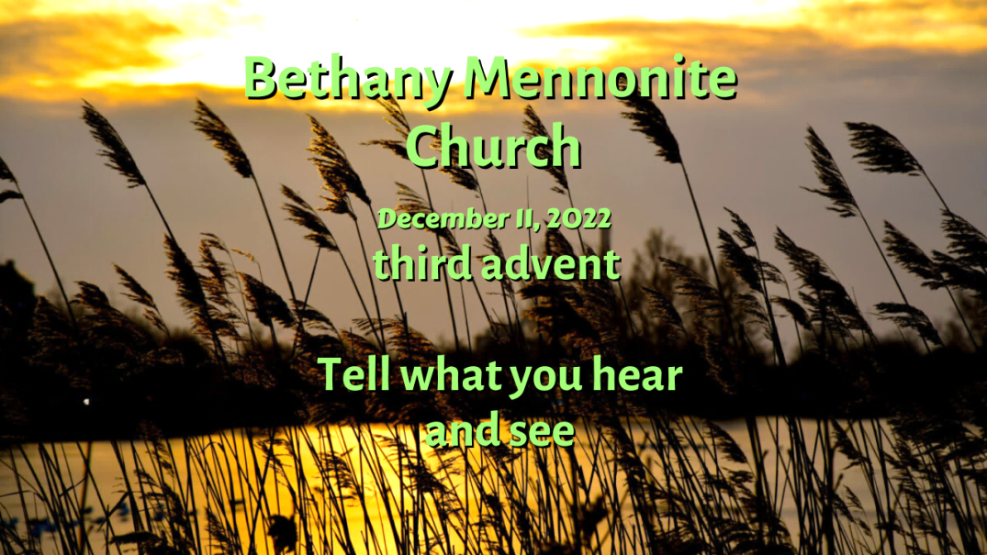

December 11, 2022
572 East & West Line
Box249
Virgil, ON L0S 1T0
905-468-3505
Email: office@bethanymennonite.ca
Website: www.bethanymennonite.ca

59 December 11, 2022 10:00 Service No. 50

third Advent

Gathering
Prelude
Welcome & Call to Worship
Song – “O Come All Ye Faithful” vs 1 & 3 #212
“Angels We Have Heard on High” vs 1 & 3 #197
Advent Candle lighting
Song – “Angels from the Realms of Glory”
Prayer

Life Together
Announcements
Ministry time
Pastoral Prayer
Song – “Holy is His Name”

Hearing the Word
Scripture – Matthew 11:2-11
Children’s Story
Message – Tell what you hear and see Herb Sawatzky

Responding
Song – “We Dream of a Turning”
Offering & Prayer

Going
Song – “Oh, How Joyfully (O Du Froeliche)” #209
Blessing

Candle lighting – The Walker family
Reader – Wendy Goertz
Musicians – Shirley Dick & Friends

Welcome here!
We’re glad you came! Your being here is a sign of God’s love for the world and encourages other Christians. We hope our worship together helps you find
A place to belong and grow in faith.

Praise and Concerns
Prayers:
- Waldy Heyder, Evelyn Hildebrand's son-in-law, in Hamilton General
- Erika Dyck as she deals with her health issues
- Dora Fisch-Willms is in St Catharines Hospital
- Sheila Gayman - friend of Reimer’s and Wiens’, undergoing cancer treatment
- Our sister church in Pereira, Colombia

The two large poinsettias are placed in loving memory of Dennis Dick on the 40th anniversary of our wedding, which took place here at Bethany on Dec. 11, 1982. Shirley Dick

Our Sister church in Pereira received the money sent to them from our Borscht sale and wanted the congregation to know how very much this was appreciated and are very thankful. They send blessings to all. Their renovation project is proceeding well and they are excited about the future of their church.
At our Christmas lunch this past week, we raised an additional $515 for their renovation project. Thank you for your contributions!
Please see 2 more letters from the Pereira Church on the bulletin board.

Bethany Announcements
Spiritual Formation Opportunities Today:
- 10:00 Worship Service
- 11:10 Adult & Children’s Sunday School

Quilting is finished for this year and will resume tentatively January 10th, 2023.Thanks to all who have served so diligently.

A silver ring was found. If you think it may belong to you, please call the office to claim it.

Bethany Christmas Worship Services:
Dec 18 @ 3:00 p.m. – Christmas Concert
Dec 24 @ 6:30 p.m. – Christmas Eve Service
Dec 25 – Merry Christmas! (No service)
Jan 1 – Memorial Service
Jan 8 - Teen challenge and New Year’s brunch

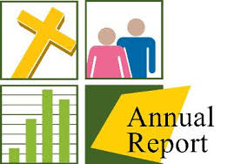
Annual Reports Yes, it’s that time of year to begin formulating a report of all your activities during the past year while slowly coming out of the pandemic. We’d love to hear about what’s been happening!

Mark your calendars! On Sunday, December 18, at 3:00 p.m., a special Christmas Choral Concert, "Joy to the World" will be hosted at Bethany Mennonite Church, featuring the Seasons Chorale, under the direction of Bert Warkentin, with choir members from many of our community churches. A prelude by the Niagara Bethany Handbell Choir will begin at 2:45 p.m. All are welcome, please join us to celebrate Christ's coming! There will be an opportunity to make a free will offering to support our local food banks as well as donations of non-perishable groceries. The Hospitality Team will be hosting a coffee time. Bakers needed! If you are able, please bring some squares or Christmas cookies to share following the concert.

Our Memorial Sunday service will be held on January 1, 2023 where we will acknowledge those who have passed away in 2022. If you would like us to remember your loved one, please submit a photo with name, birthdate, date of passing, and names of immediate family members to the office or Steve Goertz by December 24th.

A Volunteer is needed to lock up the church on Sunday mornings for the month of July. If you are able to help out in this way, please contact the office.

Local Food Bank Drive: Area food banks inform us that donations are down 30% this year while need is up 20%! Your continued support for our food drive to local food banks is much appreciated. Please drop off your donations in the food bin at the front door. Foods and snacks for breakfasts and school lunches are especially appreciated.

Our Donations Touching Lives
As you reflect on the blessings of the past year and contemplate sharing those blessings with the community, we encourage you to remember Bethany.

You can make your offering to Bethany by:
• E-transfer to office@bethanymennonite.ca
• Mail to church at Box 249, Virgil, ON L0S 1T0
• Drop in the mailbox beside the front door on Wednesdays or Thursdays 8:30-3:30 and let Marianne know.
• Canada Helps button on www.bethanymennonite.ca. CanadaHelps charges 3.75% of the donation, but you will be receipted for full amount.

Prayers:
Mennonite Church Eastern Canada
- Please pray for The First Mennonite Church in Vineland, ON. Craig Janzen Neufeld provides pastoral leadership for the congregation. Pray for this small and friendly congregation as they worship God and together seek to follow Jesus’ example.

- Congratulations to Craig Janzen Neufeld (Pastor at The First Mennonite Church in Vineland) and his wife Christine, on the birth of their daughter Chloe Noelle Janzen Neufeld, who was born on November 22, 2022. Both mother and child are doing well. They are slowly adjusting to being a family of three, and they are so delighted, enthralled and are completely in love with her. To pass along your best wishes, you can reach Craig and Christine at pastor.craig.j.n@gmail.com.

- Pray for the leadership of the Meserete Kristos Church in Ethiopia as they work with communities affected by ethnic conflicts and drought. Pray for Werner and Joanne De Jong, Witness workers at the Meserete Kristos Seminary, as they work to grow spiritual leaders from diverse regions in Ethiopia.

- Rejoice with Witness workers Bock Ki Kim and Sook Kyoung Park and pray for Peace Journal Plan P, the 10th issue in their 2-year history (key word: “Poverty”). Give thanks they have met the criteria to apply for a grant from the Korean Magazine Association, and for placement in most public libraries.

- As you celebrate Emmanuel, God with us, this Christmas season, pray for the many small congregations and house churches in Thailand’s Friends of Grace network as they open their doors and throw parties for their neighbourhoods. Pray that these gifts to their communities will result in transformative relationships.
- Continue to pray for peace and wisdom in Ukraine, Russia and in places throughout our world where the people cry out for peace.

Mennonite Central Committee
• We are thankful that our Restorative Justice program has received a grant that will allow us to continue our reintegration projects like Circles of Support and Accountability and Guiding Good Choices.

Mennonite Church Canada
Anyone interested in the United Mennonite Home newsletter, please contact the office.

Give the gift of Anabaptist World for just $27 (save 50% off the regular rate!). Order today and we’ll send your recipients a letter announcing your thoughtful gift.

Mennonite Church congregations are invited to apply for grants of up to $5,000 from the MDS Canada Spirit of MDS Fund to serve their communities. Funding can be used for things that are a fit with MDS Canada’s two Core Values: Faith in Action and Caring Relationships. Priority for funding will be given to applications where volunteers are mobilized from a congregation. An application form can be found at https://mds.org/spirit-of-mds-fund/

MCC, MDS, MEDA
MCC Thrift Christmas Giving ornament! Proceeds from these gifts will provide fruit trees and chickens as a source of income and nutrition and clean water in homes. Plus, these ornaments are made from seed paper. Plant it, water it and watch it grow into beautiful wildflowers. Available at your local thrift shop while supplies last.

MCC Christmas Giving Guide is available on the foyer shelf. Please help yourself to a catalogue and give gifts of comfort and joy!

THIS WEEK AT BETHANY
December 11-18, 2022

Today third ADVENT
10:00 a.m. – Worship Service
11:10 a.m. – Sunday School
Monday 7:00 p.m. – Sr Youth: Murder Mystery
Tuesday 6:00 p.m. – Handbell Choir
7:30 p.m. – JuBELLation
Sunday fourth ADVENT
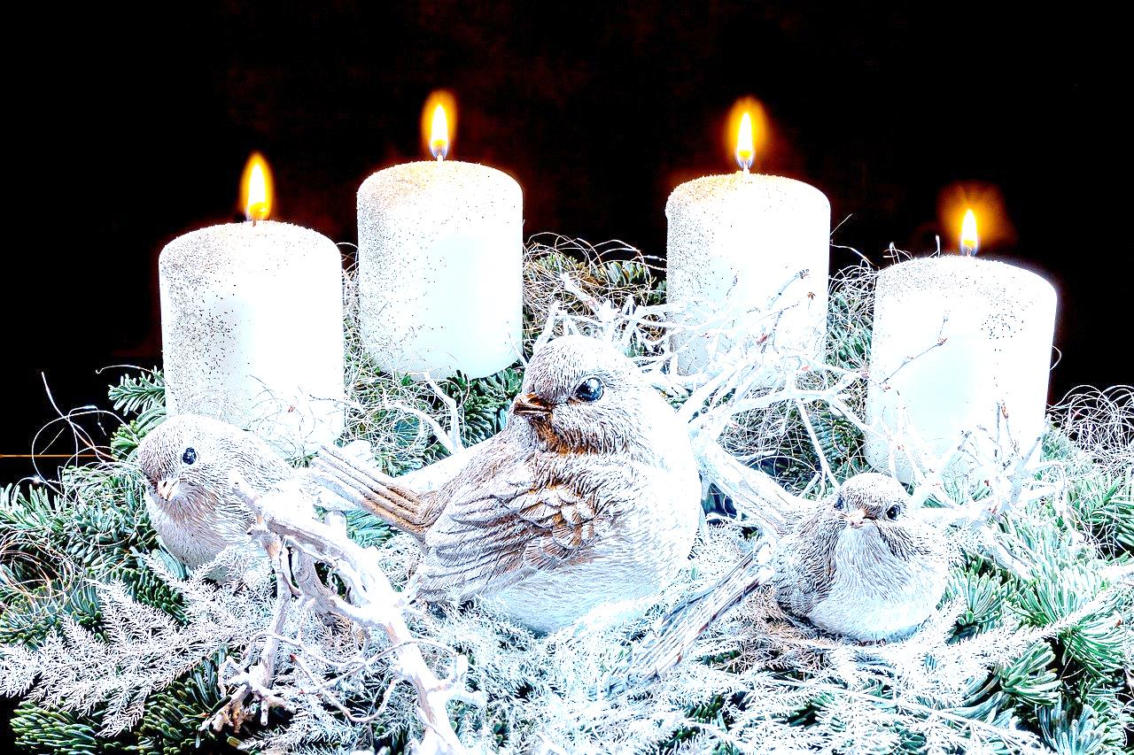
10:00 a.m. – Worship Service
11:10 a.m. – Sunday School
3:00 p.m. – Christmas Concert

Speaking: Herb Sawatzky
Scripture: Isaiah 7:10–16; Psalm 80:1–7, 17–19; Romans 1:1–7; Matthew 1:18–25
Theme: Do not be afraid

