A place to belong and grow in faith

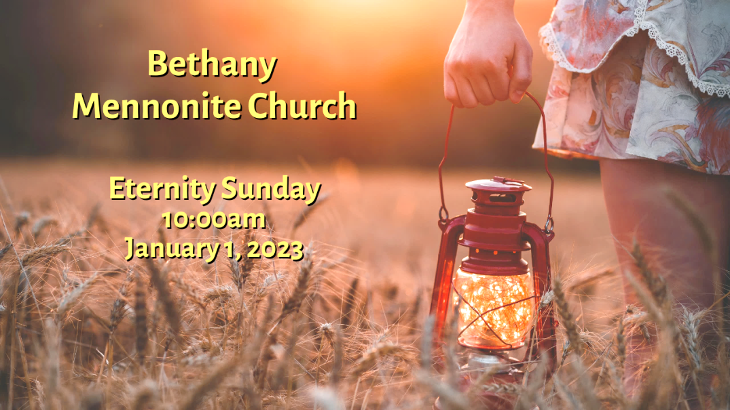

January 1, 2023
572 East & West Line
Box249
Virgil, ON L0S 1T0
905-468-3505
Email: office@bethanymennonite.ca
Website: www.bethanymennonite.ca

59 January 1, 2023 10:00 Service No. 1

Gathering
Prelude
Welcome & Call to Worship
Advent Candle lighting
Song
Prayer

Life Together
Announcements
Ministry time
Pastoral Prayer
Memorial Service
Song

Hearing the Word
Scripture – Matthew 2:1-12
Children’s Story
Message – A different road home Herb Sawatzky

Responding
Song
Offering & Prayer

Going
Song
Blessing

Candle lighting – The Andres family
Reader – Tracey Frena
Musicians – Kenton & Sheryl Janzen & Friends

Welcome here!
We’re glad you came! Your being here is a sign of God’s love for the world and encourages other Christians. We hope our worship together helps you find
A place to belong and grow in faith.

Praise and Concerns
Prayers:
- Samantha Schulz Sheridan and her family
- Waldy Heyder, at St. Catharines hospital
- Dora Fisch-Willms is at Niagara Falls Hospital
- Sheila Gayman - friend of Reimer’s and Wiens’, undergoing cancer treatment
- Our sister church in Pereira, Colombia

Thank you to everyone for your prayers and concerns. We will carry on. Erika Dyck

Bethany Announcements
Spiritual Formation Opportunities Today:
- 10:00 Worship Service
- 11:10 Adult & Children’s Sunday School

Annual Reports Yes, it’s that time of year to begin formulating a report of all your activities during the past year while slowly coming out of the pandemic. We’d love to hear about what’s been happening!

Memorial service will be held this Sunday where we will acknowledge those who have passed away in 2022.

Next week Teen Challenge will join us in our worship service. Invitations to the service are available in the Narthex from the ushers for you to give to friends, family, and neighbours.

Our annual New Year’s Potluck Brunch will be held next Sunday, January 8 immediately following the worship service. Please bring food to share.

Let’s Reconnect- Church Family Groups will begin again with the first Soup Lunch taking place on the last Sunday of January. Format for the groups will be the same as pre-Covid times. The deadline to sign up is January 15, 2023. You do not need to be able to host the meal in order to sign up. Please call or email Linda Van Bergen, Anne Litke or Patty King to register or ask questions.

Golden Coyotes - Save the Date - Progressive Euchere on January 18 - Details to follow.

Bethany Funeral Team - the Hospitality Team is compiling a list of volunteers for helping with planning and serving Funerals at Bethany. Please let Anne Litke or Linda Van Bergen know if you’d like to join the team.

Worship services are recorded live and kept on our youtube channel indefinitely. Recordings begin shortly before 10am and end after 11:04. Those who prefer not to appear in the recording are encouraged to sit near the back of the sanctuary in front of the cry room, and exit through the door on that side.

Local Food Bank Drive: Area food banks inform us that donations are down 30% this year while need is up 20%! Your continued support for our food drive to local food banks is much appreciated. Please drop off your donations in the food bin at the front door. Foods and snacks for breakfasts and school lunches are especially appreciated.

Our Donations Touching Lives

You can make your offering to Bethany by:
• E-transfer to office@bethanymennonite.ca
• Mail to church at Box 249, Virgil, ON L0S 1T0
• Drop in the mailbox beside the front door on Wednesdays or Thursdays 8:30-3:30 and let Marianne know.
• Canada Helps button on www.bethanymennonite.ca. CanadaHelps charges 3.75% of the donation, but you will be receipted for full amount.

Prayers:
Mennonite Central Committee
• Please pray for SALTers away from their families over the Christmas season, including Katie Janzen and Jeremiah McCleary from Ontario.

Mennonite Church Canada
The TogetherinWorship.net team seeks someone for a 2 hr/week job working on our site and doing communications. Please contact Bethany’s office for details.

Mennonite Burial Society Annual General Meeting (AGM) will be held both in person at Scott Street Church (www.scottstchurch.ca) and online at https://us02web.zoom.us/j/7404216638 on Saturday, January 14 at 2 pm. Agenda will be similar to past AGMs, discussing 2022 results, 2023 levies and benefit payments, and future plans. Board and committee positions are available. Further details available at www.mennoniteburialsociety.com, or Barry Boese at 905-228-1850 or email info@mennoniteburialsociety.com.

Silver Lake Mennonite Camp:
· Winter and Spring Retreats now open for registration: Come to Silver Lake in 2023 for some fun camp experiences! Coming up soon are… Dads & Kids Retreat (Jan 13-15), Winter Snowshoe Hike (Jan 20-22), Women’s Retreat (Feb 3-5), Couples Retreat (Feb 10-12). Go to SLMC Retreats & Events for more info and to register. These camp getaways make fantastic Christmas gifts!
· Employment Opportunities: Silver Lake is growing and looking to fill three year-round positions: Fundraising Manager, Program Director and Maintenance Coordinator. For more information click here: slmc.ca/about/board-of-directors/ Come make an impact that lasts a lifetime!

Mennonite Church congregations are invited to apply for grants of up to $5,000 from the MDS Canada Spirit of MDS Fund to serve their communities. Funding can be used for things that are a fit with MDS Canada’s two Core Values: Faith in Action and Caring Relationships. Priority for funding will be given to applications where volunteers are mobilized from a congregation. An application form can be found at https://mds.org/spirit-of-mds-fund/

MCC, MDS, MEDA
Training Active Bystanders Thursday, January 26, 7:00-9:30 pm, Online. If you witness a violent situation, will you know how to respond? Training Active Bystanders shows you how. Join us on Thursday, January 26 for our next workshop. Participants learn to analyze harm-doing and respond in everyday ways. For more info and to register, go to mcco.ca/events.

Rooted in right relationship: With one another and creation
March 9-11, 2023, Ottawa. In 2023, the Peace & Justice Student Seminar will return to Ottawa in person! Join university students from across Canada as we dig into what it means to be Rooted in right relationship with one another and creation.Learm more about the Peace & Justice seminar here.

MCC’s Applied Peacebuilding Skills Certificate Program
Online, January to May 2023. Learning the skills of peace is a lifelong adventure. Wherever you are in the process of learning the skills of peacemaking, the latest MCC program will help you to further develop and apply these skills within your home, work and community. Register for MCC’s nine-session program, which takes place every other Wednesday evening from mid-January to May 2023. Learn more at mcco.ca/events.

SALT of the earth: The webinar Wednesday, January 18, 2023, 1-2pm, online. Have you ever considered living and working in a different culture with an MCC partner for a year? Join us for a virtual conversation with past SALTers who will share their experiences and answer any questions you may have. Come discover some examples of SALT assignments and where in the world you could go with SALT. Go to mcco.ca/events to learn more and register today.

SALT applications now available! August 2023 - July 2024. Do you know an 18 to 30-year old looking for job experience in their field? Serving and Learning Together (SALT) is a year long service experience with one of MCC’s international partners. SALT service opportunities for 2023-2024 include placements such as tech support, community development, public health, project management, teaching, environmental care and childcare. Go to mcco.ca/salt to apply today.

Raw Carrot gourmet soup is well priced is now available at MCC Thrift Store (Christian Benefit Shop) at 254 Grantham. Flavours available: Signature Carrot, Spicyish Sausage & Cabbage, Hearty Lentil and Barley, Loaded Potato & Bacon, Mulligatawny, Veggie Mania, and Flying Noodle.

THIS WEEK AT BETHANY
January 1-8, 2023

Today 10:00 a.m. – Memorial Service
11:10 a.m. – Sunday School
Monday 7:00 p.m. – Sr Youth
Sunday 10:00 a.m. – Worship Service with Teen Challenge
11:10 a.m. – New Year’s Brunch

Speaking: Teen Challenge

