A place to belong and grow in faith

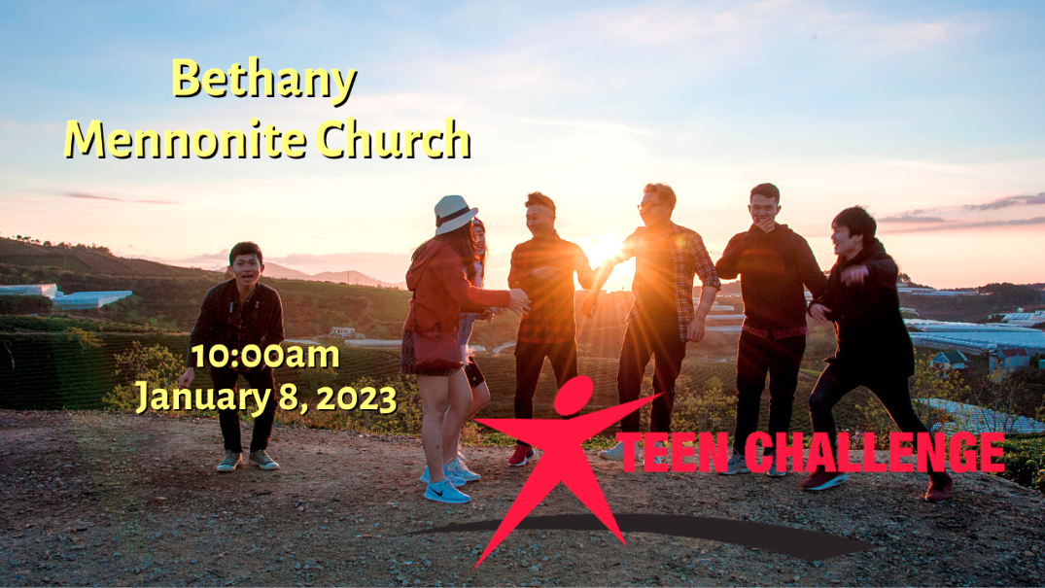

January 8, 2023
572 East & West Line
Box249
Virgil, ON L0S 1T0
905-468-3505
Email: office@bethanymennonite.ca
Website: www.bethanymennonite.ca

59 January 8, 2023 10:00 Service No. 2

Gathering
Prelude
Welcome & Call to Worship Herb Sawatzky
Song – “Still”
“Be Still and Know”
Prayer

Life Together
Announcements
Ministry time
Pastoral Prayer
Song – “Great is The Faithfulness” #327

Hearing the Word
Children’s Story
Message Teen Challenge

Responding
Song – “The Power of Your Love”
Offering & Prayer

Going
Song – “Praise God from whom all Blessings Flow” #118
Blessing

Musicians – Shirley Dick & Friends

Welcome here!
We’re glad you came! Your being here is a sign of God’s love for the world and encourages other Christians. We hope our worship together helps you find
A place to belong and grow in faith.

Praise and Concerns
Prayers:
- The family of Samantha Schulz Sheridan
- Waldy Heyder, at St. Catharines hospital
- Dora Fisch-Willms is at Niagara Falls Hospital
- Sheila Gayman - friend of Reimer’s and Wiens’, undergoing cancer treatment
- Our sister church in Pereira, Colombia

Bethany Announcements
Spiritual Formation Opportunities Today:
- 10:00 Worship Service
- 11:10 Adult Sunday School will resume on the 15th

Annual Reports are due by January 15th. Please let us know of all your activities during the past year while slowly coming out of the pandemic. We’d love to hear about what’s been happening! Annual Meeting Jan 28th.

This week Teen Challenge will join us in our worship service.

Our annual New Year’s Potluck Brunch will be held TODAY, January 8 immediately following the worship service. Please bring food to share.

Quilting will resume Tuesday, January 10 at 9 a.m.-12 noon.

Golden Coyotes - Progressive Euchre on January 18, 7 pm at the home of Linda Van Bergen. An email with details will be sent. Pre-registration will be required.

Thank you to all the volunteers who helped with the Christmas Concert on December 18, including our faithful tech team and ushers, those who helped with parking and operating the elevator, and all those who provided baked goods and coffee and punch. The concert was very well attended, and we collected donations of $1300.00 that were given to Newark Neighbours. Thank you all for going the extra mile at a very busy time of year!

Let’s Reconnect- Church Family Groups will begin again with the first Soup Lunch taking place on the last Sunday of January. Format for the groups will be the same as pre-Covid times. You do not need to be able to host the meal in order to sign up. Registration Sheet will be available at the Brunch Potluck on Sunday morning or call/email Linda Van Bergen, Anne Litke or Patty King to register or ask questions. The deadline to sign up is January 15, 2023.

Bethany Kids Club – Begins January 18th. We are combining our past Boys Club and Pioneer Girls into one Kids Club ministry, which will run the first and third Wednesday of the month until May, from 7-8:30pm. Regular Club nights will have games, activities, crafts, and a lesson, all centered on a biblical theme. Alternate nights will be for tobogganing, Bowling, movies, and Kub Kars. There may also be a camping trip in June if there is enough interest. Registration Fee is $30 per child. Volunteers are also appreciated; more volunteers mean more kids can participate. To find out more, or to register a child, email pastor@bethanymennonite.ca

Bethany Funeral Team - the Hospitality Team is compiling a list of volunteers for helping with planning and serving Funerals at Bethany. Please let Anne Litke or Linda Van Bergen know if you’d like to join the team.

The Roberts Digest is available from the office.

Worship services are recorded live and kept on our youtube channel indefinitely. Recordings begin shortly before 10am and end after 11:04. Those who prefer not to appear in the recording are encouraged to sit near the back of the sanctuary in front of the cry room, and exit through the door on that side.

Local Food Bank Drive: Area food banks inform us that donations are down 30% this year while need is up 20%! Your continued support for our food drive to local food banks is much appreciated. Please drop off your donations in the food bin at the front door. Foods and snacks for breakfasts and school lunches are especially appreciated.

Our Donations Touching Lives

You can make your offering to Bethany by:
• E-transfer to office@bethanymennonite.ca
• Mail to church at Box 249, Virgil, ON L0S 1T0
• Drop in the mailbox beside the front door on Wednesdays or Thursdays 8:30-3:30 and let Marianne know.
• Canada Helps button on www.bethanymennonite.ca. CanadaHelps charges 3.75% of the donation, but you will be receipted for full amount.

Prayers:
Mennonite Church Eastern Canada
- Please pray for Toronto Chinese Mennonite Church. Brian Quan is a part of a pastoral team for growing ministries in the English, Cantonese and Mandarin groups.
- Pray for those who have travelled to the Philippines for the Learning Tour with MC Canada International Witness from January 12-22, 2023. Pray also for Dann and Joji Pantoja as they receive guests and encouragement from Canada.
- During this Christmas season, continue to pray for peace and wisdom in Ukraine, Russia and in places throughout our world where the people cry out for peace.

Mennonite Central Committee
• Please pray for SALTers away from their families over the Christmas season, including Katie Janzen and Jeremiah McCleary from Ontario.

Mennonite Church Canada
The TogetherinWorship.net team seeks someone for a 2 hr/week job working on our site and doing communications. Please contact Bethany’s office for details.

Mennonite Burial Society Annual General Meeting (AGM) will be held both in person at Scott Street Church (www.scottstchurch.ca) and online at https://us02web.zoom.us/j/7404216638 on Saturday, January 14 at 2 pm. Agenda will be similar to past AGMs, discussing 2022 results, 2023 levies and benefit payments, and future plans. Board and committee positions are available. Further details available at www.mennoniteburialsociety.com, or Barry Boese at 905-228-1850 or email info@mennoniteburialsociety.com.

Silver Lake Mennonite Camp:
· Winter and Spring Retreats now open for registration: Come to Silver Lake in 2023 for some fun camp experiences! Coming up soon are… Dads & Kids Retreat (Jan 13-15), Winter Snowshoe Hike (Jan 20-22), Women’s Retreat (Feb 3-5), Couples Retreat (Feb 10-12). Go to SLMC Retreats & Events for more info and to register. These camp getaways make fantastic Christmas gifts!
· Employment Opportunities: Silver Lake is growing and looking to fill three year-round positions: Fundraising Manager, Program Director and Maintenance Coordinator. For more information click here: slmc.ca/about/board-of-directors/ Come make an impact that lasts a lifetime!

Mennonite Church congregations are invited to apply for grants of up to $5,000 from the MDS Canada Spirit of MDS Fund to serve their communities. Funding can be used for things that are a fit with MDS Canada’s two Core Values: Faith in Action and Caring Relationships. Priority for funding will be given to applications where volunteers are mobilized from a congregation. An application form can be found at https://mds.org/spirit-of-mds-fund/

MCC, MDS, MEDA
Training Active Bystanders Thursday, January 26, 7:00-9:30 pm, Online. If you witness a violent situation, will you know how to respond? Training Active Bystanders shows you how. Join us on Thursday, January 26 for our next workshop. Participants learn to analyze harm-doing and respond in everyday ways. For more info and to register, go to mcco.ca/events.

Rooted in right relationship: With one another and creation
March 9-11, 2023, Ottawa. In 2023, the Peace & Justice Student Seminar will return to Ottawa in person! Dig into what it means to be Rooted in right relationship with one another and creation..Learm more about the Peace & Justice seminar here.

MCC’s Applied Peacebuilding Skills Certificate Program
Online, January to May 2023. Learning the skills of peace is a lifelong adventure. Wherever you are in the process of learning the skills of peacemaking, the latest MCC program will help you to further develop and apply these skills within your home, work and community. Register for MCC’s nine-session program, which takes place every other Wednesday evening from mid-January to May 2023. Learn more at mcco.ca/events.

SALT of the earth: The webinar Wednesday, January 18, 2023, 1-2pm, online. Have you ever considered living and working in a different culture with an MCC partner for a year? Come discover some examples of SALT assignments and where in the world you could go with SALT. Go to mcco.ca/events to learn more and register today. SALT applications for August 2023 - July 2024. If you are an 18 to 30-year old looking for job experience, Serving and Learning Together (SALT) is a year-long service experience. Go to mcco.ca/salt to apply today.

Raw Carrot gourmet soup is well priced is now available at MCC Thrift Store (Christian Benefit Shop) at 254 Grantham. Flavours available: Signature Carrot, Spicyish Sausage & Cabbage, Hearty Lentil and Barley, Loaded Potato & Bacon, Mulligatawny, Veggie Mania, and Flying Noodle.

THIS WEEK AT BETHANY
January 8-15, 2023

Today 10:00 a.m. – Worship Service with Teen Challenge
11:10 a.m. – New Year’s Brunch
Tuesday 9:00 a.m. – Quilting
Sunday 10:00 a.m. – Worship Service
11:10 a.m. – Adult Sunday School

Speaking: Herb Sawatzky
Scripture: Luke 10:34-35
Theme: A Man with an Attitude

