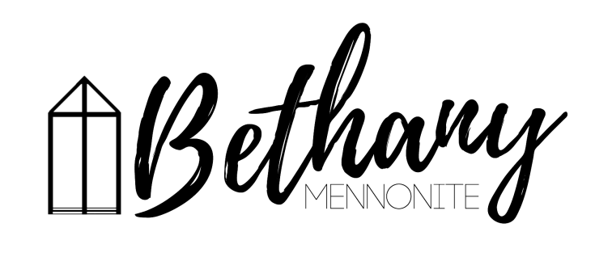
A place to belong and grow in faith

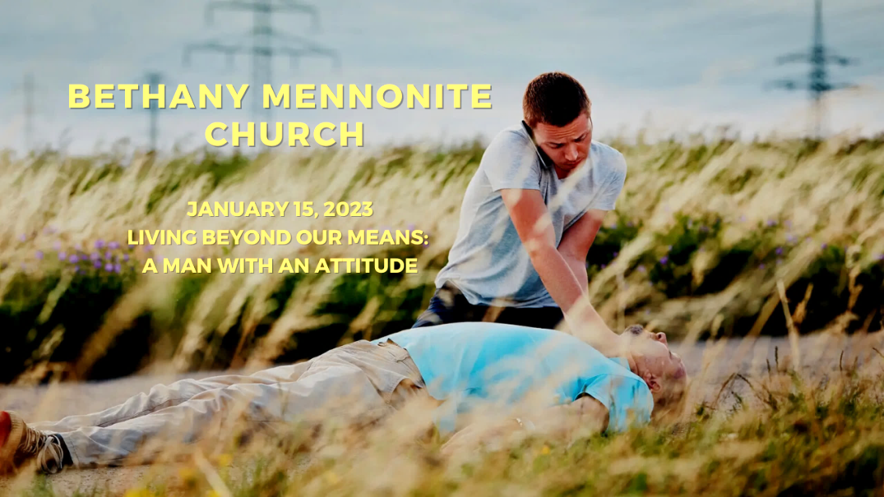

January 15, 2023
572 East & West Line
Box249
Virgil, ON L0S 1T0
905-468-3505
Email: office@bethanymennonite.ca
Website: www.bethanymennonite.ca

59 January 15, 2023 10:00 Service No. 3

Gathering
Prelude
Welcome & Call to Worship Herb Sawatzky
Song – “Be Unto Your Name”
“In My Life, Lord, Be Glorified”
Prayer

Life Together
Announcements
Ministry time
Pastoral Prayer
Song – “Take My Life and Let It Be” #389

Hearing the Word
Scripture – Luke 10:34-35
Children’s Story
Message – A Man with an Attitude Herb Sawatzky

Responding
Song – “Grant Us, God, the Grace of Giving” #388
Offering & Prayer

Going
Song – “Sending Song”
Blessing

Musicians – Gayle Neufeld & Friends

Welcome here!
We’re glad you came! Your being here is a sign of God’s love for the world and encourages other Christians. We hope our worship together helps you find
A place to belong and grow in faith.

Praise and Concerns
Prayers:
- Jake Penner as he heads into surgery on Jan 18
- Christine Read recovering from surgery at St. Catharines hospital
- Waldy Heyder, at St. Catharines hospital
- Dora Fisch-Willms is at Niagara Falls Hospital
- Sheila Gayman - friend of Reimer’s and Wiens’, undergoing cancer treatment
- Our sister church in Pereira, Colombia

Bethany Announcements
Spiritual Formation Opportunities Today:
- 10:00 Worship Service
- 11:10 Sunday School

Annual Reports are due by January 15th. I will be printing beginning on Wednesday, so please hand yours in on time! We’d love to hear about what’s been happening! Annual Meeting will be held Jan 28th.

Golden Coyotes - Progressive Euchre will take place this Saturday at 7 pm at the home of Linda Van Bergen. Please email Linda Van Bergen to register.

Let’s Reconnect- Church Family Groups will begin again with the first Soup Lunch taking place on the last Sunday of January. You do not need to be able to host the meal in order to sign up. Registration Sheet will be available in the gym this morning or call/email Linda Van Bergen, Anne Litke or Patty King to register or ask questions. The deadline to sign up is TODAY.

Bethany Kids Club – Begins January 25th. We are combining our past Boys Club and Pioneer Girls into one Kids Club ministry, which will run the first and third Wednesday of the month until May, from 7-8:30pm. Regular Club nights will have games, activities, crafts, and a lesson, all centered on a biblical theme. Alternate nights will be for tobogganing, Bowling, movies, and Kub Kars. There may also be a camping trip in June if there is enough interest. Registration Fee is $30 per child. Volunteers are also appreciated; more volunteers mean more kids can participate. To find out more, or to register a child, email pastor@bethanymennonite.ca

Local Food Bank Drive: Area food banks inform us that donations are down 30% this year while need is up 20%! Your continued support for our food drive to local food banks is much appreciated. Please drop off your donations in the food bin at the front door. Foods and snacks for breakfasts and school lunches are especially appreciated.

Our Donations Touching Lives

You can make your offering to Bethany by:
• E-transfer to office@bethanymennonite.ca
• Mail to church at Box 249, Virgil, ON L0S 1T0
• Drop in the mailbox beside the front door on Wednesdays or Thursdays 8:30-3:30 and let Marianne know.
• Canada Helps button on www.bethanymennonite.ca. CanadaHelps charges 3.75% of the donation, but you will be receipted for full amount.

Prayers:
Mennonite Church Eastern Canada
- Please pray for Toronto Mennonite New Life Church. Pray for this congregation as they fix their eyes not on what is seen, but on what is unseen, since what is seen is temporary, but what is unseen is eternal (2 Corinthians 4:18).
- Glenda Ribey Rozomiak will be Licensed toward Ordination at Stirling Avenue Mennonite Church on January 15, 2023. Pray for Glenda and the congregation as they celebrate her calling to ministerial leadership. To share your words of encouragement and support with Glenda, you can reach her at glenda@stirlingmennonite.ca.
- Pray for those who have travelled to the Philippines for the Learning Tour with MC Canada International Witness from January 12-22, 2023. Pray also for Dann and Joji Pantoja as they receive guests and encouragement from Canada.
- Continue to pray for peace and wisdom in Ukraine, Russia and in places throughout our world where the people cry out for peace. Lord, hear our prayers.

Mennonite Central Committee
• We are thankful that our Restorative Justice program has received a grant that will allow us to continue our reintegration projects like Circles of Support and Accountability and Guiding Good Choices.
• Please pray for SALTers as they continue the second half of their overseas assignment, including Katie Janzen and Jeremiah McCleary from Ontario.

Mennonite Church Canada
Hold in Common – Join us for the first virtual gathering of the CMU Hold in Common project, a candid look at the place CMU and other institutions have in today’s society. Share your perspectives—your hopes and your misgivings—on what’s at stake with institutions that are shared and held collectively by diverse, grassroots communities. Whether you are closely invested or more distantly connected to CMU, you are welcome. Monday, January 16, 7:00-8:30 PM (CST). Details at cmu.ca/holdincommon.

Grebel Gallery | Your Wall Can (Not) Divide Us Opening Wednesday, January 25, 7:00 pm This interactive exhibition at Conrad Grebel University College includes photos of street art pieces from a range of conflict-affected societies and an opportunity to leave your own ‘mark’ on the gallery walls. More information at: uwaterloo.ca/centre-peace-advancement/grebel-gallery

Sawatsky Lecture | The Power of Misfitting: Disrupting Sinner, Saint, and Super Crip Controlling Images Thursday, February 2, 7:30 pm. Dr. Darla Schumm will identify prevalent controlling images that religious communities ascribe to people with disabilities, and will offer ‘misfitting’ as a deliciously disruptive concept against the existing controlling imagery. Register to attend at: grebel.ca/sawatsky

Call for German Mennonite Poetry Do you or your relatives have self-composted German Mennonite poetry that you're interested in sharing with the community? Brubacher House Artists-in-Residence are collecting previously untranslated German language poems for a bilingual collection of German Mennonite poetry from the Waterloo Region. Email submissions to brubacherpoetryproject@gmail.com. More information at uwaterloo.ca/brubacher-house

MCC, MDS, MEDA
SALT of the earth: The webinar Wednesday, January 18, 2023, 1-2pm, online. Have you ever considered living and working in a different culture with an MCC partner for a year? Come discover some examples of SALT assignments and where in the world you could go with SALT. Go to mcco.ca/events to learn more and register today. SALT applications for August 2023 - July 2024. If you are an 18 to 30-year old looking for job experience, Serving and Learning Together (SALT) is a year-long service experience. Go to mcco.ca/salt to apply today.

NHMRS Feature Quilt Reveal January 23 at 9:30 am at 50 Kent Ave, Kitchener or Online. Each year, a talented individual or team creates the feature quilt for the New Hamburg Mennonite Relief Sale. Feature quilts have depicted historical churches, the play of colour and light across fabric and a journey through Africa, among other innovative designs. On January 23, the curtain will be removed and the 2023 feature quilt will be revealed. Go to mcco.ca/events for more info.

Training Active Bystanders Thursday, January 26, 7:00-9:30 pm, Online. If you witness a violent situation, will you know how to respond? Training Active Bystanders shows you how. Join us on Thursday, January 26 for our next workshop. Participants learn to analyze harm-doing and respond in everyday ways. For more info and to register, go to mcco.ca/events.

Rooted in right relationship: With one another and creation
March 9-11, 2023, Ottawa. In 2023, the Peace & Justice Student Seminar will return to Ottawa in person! Dig into what it means to be Rooted in right relationship with one another and creation..Learm more about the Peace & Justice seminar here.

MCC’s Applied Peacebuilding Skills Certificate Program
Online, January to May 2023. Learning the skills of peace is a lifelong adventure. Wherever you are in the process of learning the skills of peacemaking, the latest MCC program will help you to further develop and apply these skills within your home, work and community. Register for MCC’s nine-session program, which takes place every other Wednesday evening from mid-January to May 2023. Learn more at mcco.ca/events.

THIS WEEK AT BETHANY
January 15-22, 2023

Today 10:00 a.m. – Worship Service
11:10 a.m. – Sunday School
Tuesday 9:00 a.m. – Quilting
6:00 p.m. – Handbell Choir
7:30 p.m. - JuBELLation
Sunday 10:00 a.m. – Worship Service
11:10 a.m. – Sunday School

Speaking: Herb Sawatzky
Scripture: Luke 14:12-24
Theme: Party On

Worship services are recorded live and kept on our youtube channel indefinitely. Recordings begin shortly before 10am and end after 11:04. Those who prefer not to appear in the recording are encouraged to sit near the back of the sanctuary in front of the cry room, and exit through the door on that side.

