A place to belong and grow in faith

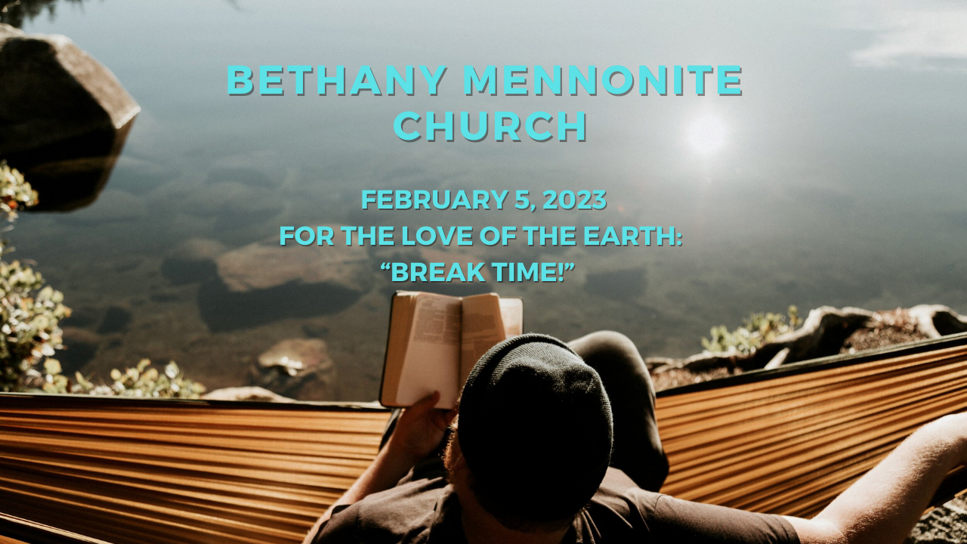

February 5, 2023
572 East & West Line
Box249
Virgil, ON L0S 1T0
905-468-3505
Email: office@bethanymennonite.ca
Website: www.bethanymennonite.ca

59 February 5, 2023 10:00 Service No. 6

Gathering
Prelude
Welcome & Call to Worship Herb Sawatzky
Song – “For the Beauty of the Earth” #89
“At the Dawn of Your Creation”
Prayer

Life Together
Announcements
Ministry time
Pastoral Prayer
Song – “Flow to You”

Hearing the Word
Scripture – Genesis 2:1-3, Matthew 11:28-29, Hebrews 4:9-11a
Children’s Story
Message – “Break Time!” Herb Sawatzky

Responding
Song – “Come Away from Rush and Hurry”
Offering & Prayer

Going
Song – “The Peace of the Earth Be With You”
Blessing

Musicians – Gayle Neufeld & Friends

Welcome here!
We’re glad you came! Your being here is a sign of God’s love for the world and encourages other Christians. We hope our worship together helps you find
A place to belong and grow in faith.

Praise and Concerns
Prayers:
- Ed Epp at St. Catharines Hospital
- Jake Penner as he recovers from surgery
- Waldy Heyder, at Shaver Hospital
- Dora Fisch-Willms is at Niagara Falls Hospital
- Sheila Gayman - undergoing cancer treatment
- Our sister church in Pereira, Colombia

Congratulations to Erika Dyck, who will celebrate her 80th birthday on February 11th! May God bless you with energy as you celebrate this milestone.

Jake Penner would like to thank everyone for your prayers and cards during his recovery from surgery.

Bethany Announcements
Spiritual Formation Opportunities Today:
- 10:00 Worship Service
- 11:10 Sunday School

The First Mennonite Church in Vineland is hosting a Portable CMU from February 3-5. Gerald Gerbrandt is coming from Winnipeg to speak to us about “The Art of Reading Scripture.” Join us! See the poster on the bulletin board for details.

Silver Foxes – Save the date! Wed. Feb. 15. We invite you to join us for a movie at the Community Centre in the morning (no cost), and then drive to Caroline Cellars for lunch (individual lunch cost). Please contact Ted and Syl Wiens or Bud and Ella Andres by Feb. 8 so reservations can be made. (289 868-9068, tedandsyl@gmail.ca; 905 468-2669, bandres@cogeco.ca)

Directory updates are welcome at this time. Please call the office with any changes.

The Upper Room is a devotional ordered by many from our congregation. We received 2 shipments this month, so please help yourself to a copy in the narthex. If you would like to subscribe for $17 a year (depending on exchange rate), please contact the office.

Local Food Bank Drive: Area food banks inform us that donations are down 30% this year while need is up 20%! Your continued support for our food drive to local food banks is much appreciated. Please drop off your donations in the food bin at the front door. Foods and snacks for breakfasts and school lunches are especially appreciated.

Our Donations Touching Lives

You can make your offering to Bethany by:
• E-transfer to office@bethanymennonite.ca
• Mail to church at Box 249, Virgil, ON L0S 1T0
• Drop in the mailbox beside the front door on Wednesdays or Thursdays 8:30-3:30 and let Marianne know.
• Canada Helps button on www.bethanymennonite.ca. CanadaHelps charges 3.75% of the donation, but you will be receipted for full amount.

Prayers:
Mennonite Church Eastern Canada
- Please pray for Valleyview Mennonite Church, London, ON. Marv Friesen provides pastoral leadership for the congregation. Pray for this family of faith as they worship God and to strive to live out and into the Gospel of Jesus Christ together.
- Amos Chin of the Bible Missionary Church asks you to pray for the people of Myanmar who face extreme challenges in teaching peace amid food shortages and violent injustice.

- Pray for the participants of the ongoing Learning Tour in Thailand as they unpack what they are seeing and learning. Pray for tour hosts Tom and Christine Poovong who are integral to Friends of Grace Church Association, a network of nearly 100 worshiping communities.
- Pray for students Ochan (Peter) Lual and Khan (Isaac) Gatkuoth from south Sudan as they begin their second semester studies at Meserete Kristos Seminary in Ethiopia. Pray also for Witness workers Werner and Joanne DeJong who are offering them specialized supports.
- The Manitoba Mennonite Coalition for Indigenous Solidarity (MCIS) invites prayers for the families of Missing and Murdered Indigenous Women and Girls in mourning the loss of their loved ones and for collective solidarity in their calls for all levels of government to commit to healing and ending the ongoing national crisis.
- Pray for Garry Janzen, Kevin Barkowsky, Nhien Pham as they prepare to teach at a conference in Vietnam and Jeanette Hanson as she prepares to make connections to the wider Mennonite Church. Pray that the Holy Spirit would move, and churches in Vietnam and Cambodia would be encouraged and strengthened in Christ.
- Continue to pray for peace and wisdom in Ukraine, Russia and in places throughout our world where the people cry out for peace. Lord, hear our prayers.

Mennonite Central Committee
• Please pray for our Training Active Bystanders program as we continue to create training partnerships for building peace with various sectors like the education system.

Mennonite Church Canada
United Mennonite Home will be hosting a Ladies Auxiliary Meeting on Wednesday February 8th at 10am. If you are interested in becoming a member of this Auxiliary and representing your congregation or would like additional information, please contact Jodi Thompson – Programs Manager at jthompson@umh.ca or (905) 562-7385 ext. 5004.

Silver Lake Mennonite Camp
- Summer Camp Registration Opens on February 1 at 7am: Visit the SLMC website for more details about overnight camps, outtrips and day camps. New this year – March Break Day Camp in Kitchener (Mar 13-17). Click here for Camp Info and Registration

Church-to-Church Conversation: Meserete Kristos Church/MC Canada - Register for this online conversation between President Desalegn Abebe of Meserete Kristos Church and Doug Klassen Executive Minister of Mennonite Church Canada. This will be an opportunity to hear updates from Ethiopia on ministry collaboration and the current political climate. You will have an opportunity to share questions via the chat in this Zoom call. This is a Canada-wide invitation, hosted by MCEC and MC Canada on February 15, 2023, 12 p.m. EST. More information and to register for the Zoom link.

Walking Together: Intercultural Stories of Love and Acceptance Book Study - Join the MCEC Truth and Reconciliation Working Group in this online 4-part book study, Walking Togther: Intercultural Stories of Love and Acceptance. We will begin our study with Edith and Neill von Gunten, the authors, on Wednesday, February 15. Walking Together invites the church to grapple with questions of racism and Christian supremacy in order to see that all peoples and cultures bear Creator’s beauty and gifts, and that our reconciliation—even our salvation—depends upon embracing that truth. More information and to register.

Grade 10 Family Night at Grebel and UWaterloo is back! On Thursday, February 23rd at 5PM, Conrad Grebel University College invites all Grade 10 students and their families to share a meal at Grebel before attending the University of Waterloo's annual Grade 10 Family Night. The Grebel tour starts at 5pm, followed by dinner at 5:30pm. The UWaterloo presentation begins at 6:30, followed by an academic and student life Information Fair. Lean about a world-renowned academic institution, as well as the supportive residence environment that Grebel, a close-knit and faith-based community, can provide for students. Email grebelstudentservices@uwaterloo.ca by Wednesday February 8 to register for supper.

MCC, MDS, MEDA
In our January edition of On the Level learn how MDS Canada is responding in Cape Breton, Nova Scotia; Nick Hamm reflects on how God shares His goodness even during disasters; and Director of Operations Ross Penner reminds us that MDS work continues long after the headlines have disappeared. Where will you volunteer this year? Click on this link to read more: https://conta.cc/3QOHgCA

THIS WEEK AT BETHANY
February 5-12, 2023

Today 10:00 a.m. – Worship Service
11:10 a.m. – Sunday School
Tuesday 9:00 a.m. – Quilting
6:00 p.m. – Handbell Choir
7:30 p.m. – JuBELLation
Sunday 10:00 a.m. – Worship Service
11:10 a.m. – Sunday School

Speaking: Herb Sawatzky
Scripture: Genesis 24b-20
Theme: “The Name Game”

Worship services are recorded live and kept on our youtube channel indefinitely. Recordings begin shortly before 10am and end after 11:04. Those who prefer not to appear in the recording are encouraged to sit near the back of the sanctuary in front of the cry room, and exit through the door on that side.

