A place to belong and grow in faith

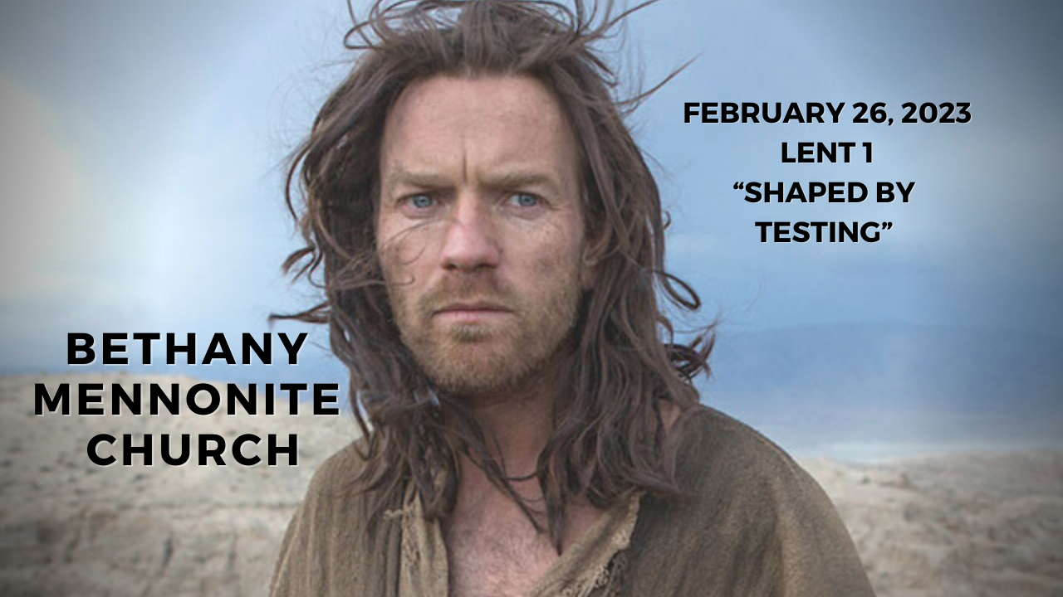

February 26, 2023
572 East & West Line
Box249
Virgil, ON L0S 1T0
905-468-3505
Email: office@bethanymennonite.ca
Website: www.bethanymennonite.ca

59 February 26, 2023 10:00 Service No. 9

Gathering
Prelude
Welcome Herb Sawatzky
Call to Worship
Song – “We Praise You, O God”
“Open My Eyes, Lord”
Confession & Assurance
Prayer

Life Together
Announcements
Ministry time
Pastoral Prayer
Song – “Lord, I Need You”

Hearing the Word
Scripture – Genesis 3:1-7; Matthew 4:1-11
Children’s Story
Message – “Shaped by testing” Herb Sawatzky

Responding
Song – “Jesus, Tempted in the Desert”
Faith Story
Song
Offering & Prayer

Going
Song – “Lead Me, Guide Me”
Blessing

Musicians – Gayle Neufeld & Friends
Scripture Reader – Sylvia Wiens

Welcome here!
We’re glad you came! Your being here is a sign of God’s love for the world and encourages other Christians. We hope our worship together helps you find
A place to belong and grow in faith.

Praise and Concerns
Prayers:
- Ed Epp in Hamilton
- Waldy Heyder, at Shaver Hospital
- Dora Fisch-Willms is at Niagara Falls Hospital
- Sheila Gayman - undergoing cancer treatment
- Our sister church in Pereira, Colombia

Bethany Announcements
Spiritual Formation Opportunities Today:
- 10:00 Worship Service
- 11:10 Kid’s Sunday School – Room 11
- 11:10 Sr Youth & Young Adults Sunday School – Youth room
- 11:10 Adult Sunday School in the Library

Sheryl Janzen will be in the office this week on Tuesday, Feb 28 and Friday, March 3 while Marianne is away.

Donation Receipts were emailed out. Those who have chosen a printed copy, please find them in your mailboxes. If you have any questions, please contact Marianne in the office.

We are looking for volunteers to learn how to work the sound board as well as the video. There will be on the job training available. Please contact Matt King if you are willing to learn one or both of these jobs.

Directory updates are welcome at this time. Please call the office with any changes.

Golden Coyotes – Games Night at Steve & Wendy Goertz’s place on March 11 at 7:00 pm. RSVP requested to Steve & Wendy or Kenton & Sheryl.

It’s time for a Pastoral/Congregational Review! You will have received an email with the review attached or paper copies are available in the narthex. Please complete the form by March 12th and return them to the office or to Shirley Dick. E-copies can be emailed to either.

Silver Foxes Our next event is a tour of The Niagara Christian Gleaners Facility in Smithville on the morning of April 12, followed by lunch at Laki’s Family Restaurant. The lunch choices are: Lasagna or Chicken Marsala (please state your choice when registering), Rolls, Garden Salad, Coffee or Tea, Baklava or Rice Pudding for dessert. The total cost for the bus, tour and lunch is only $55.00 per person to be paid by Mar. 29 to hold your seat. After that, a waiting list will be made. Please register with Ted and Syl Wiens or Paul and Joanne Thiessen.

Local Food Bank Drive: Area food banks inform us that donations are down 30% this year while need is up 20%! Your continued support for our food drive to local food banks is much appreciated. Please drop off your donations in the food bin at the front door. Foods and snacks for breakfasts and school lunches are especially appreciated.

Our Donations Touching Lives

You can make your offering to Bethany by:
• E-transfer to office@bethanymennonite.ca
• Mail to church at Box 249, Virgil, ON L0S 1T0
• Drop in the mailbox beside the front door on Wednesdays or Thursdays 8:30-3:30 and let Marianne know.
• Canada Helps button on www.bethanymennonite.ca. CanadaHelps charges 3.75% of the donation, but you will be receipted for full amount.

Prayers:
Mennonite Church Eastern Canada
- Please pray for Warden Underground. Jordan Thoms and Jon Folkeringa provide pastoral leadership for this unique expression of church located in a South Scarborough Government Housing neighbourhood called Warden Woods.

- Continue to pray for peace and wisdom in Ukraine, Russia and in places throughout our world where the people cry out for peace. Lord, hear our prayers.

Mennonite Central Committee
- Please pray for our Training Active Bystanders program as we continue to create training partnerships for building peace with various sectors like the education system.

Mennonite Church Canada
Video now available! Church-to-Church Conversation: Meserete Kristos Church and Mennonite Church Canada - A conversation between President Desalegn Abebe, Meserete Kristos Church and Doug Klassen, Executive Minister, Mennonite Church Canada. Listen in on this rich exchange between sister-congregations about social justice and evangelism, leadership training, culture of call and partnership.. Discover the history, strategy and challenges of MKC. Download the video for this encouraging conversation.

Film Screening | Zwingli: Der Reformator (The Reformer. Zwingli: A Life's Portrait), hosted by the Institute of Anabaptist and Mennonite Studies at Conrad Grebel University College. The MCEC church community is invited to watch and discuss Swiss filmmaker Stephan Haupt's award-winning 2019 depiction of the early Reformation in Zurich. Dr. David Neufeld will provide a brief introduction to the film and lead a post-screening discussion with attendees on Monday, February 27, 7:00pm - 8:30pm, room 2202. grebel.ca/events

Silver Lake Mennonite Camp Winter and Spring Retreats Come to Silver Lake in 2023 for some fun camp experiences!
- Winter Camp for Grown-Ups (Mar 3-5), March Break Family Getaway (Mar 14-17). Go to SLMC Retreats & Events for more info and to register.
- Summer Camp Registration is now Open: Visit the SLMC website for more details about overnight camps, outtrips and day camps. Click here for Camp Info and Registration
- Come enjoy a Silver Lake Online Campfire! Feb 26 (day camps), March 26 (outtrips), April 23 (overnight), May 28 (general) @ 7pm. A great chance to meet some staff and ask questions. Click here for campfire details and link!

Resisting Christian Nationalism with the Gospel of Peace Online short course • April 12 – May 9, 2023. Gain strategies for challenging Christian nationalism by joining Drew Strait, PhD, Assistant Professor of New Testament and Christian Origins at AMBS, for this four-week online short course. No papers, no tests — just quality conversations and deep insights. Early registration: $300 USD per course. Register at CLC Short Courses 2022-2023 (wufoo.com)

Join Diana Butler Bass: “American Saints in a Cynical Age” and John Dominic Crossan: “Easter Stories-a visual lecture series” online this Lent and Easter season. The online Lenten group with Diana and the visual lecture series with Dom are both open learning opportunities for individuals and groups.

MCC, MDS, MEDA
Türkiye and Syria Earthquake Response MCC is accepting donations to support people affected by the Feb. 6 earthquake in Türkiye and Syria. You can share God’s love and compassion with our global neighbours by providing a gift online at mcccanada.ca/earthquake, by calling 888-622-6337 or by sending a cheque marked for “Syria and Türkiye earthquake” to 203-50 Kent Ave., Kitchener, ON, N2G 3R1.

The Raw Carrot is excited to announce that our soup is available for sale at your local thrift shop! The Raw Carrot provides a compassionate workplace to people on long term disability. Our staff are “stirring up” change with their delicious, handcrafted gourmet soup!” Learn more at mcco.ca.

Rooted in right relationship: With one another and creation
March 9-11, 2023, Ottawa. In 2023, the Peace & Justice Student Seminar will return to Ottawa in person! Join university students from across Canada as we dig into what it means to be Rooted in right relationship with one another and creation. Learn more about the Peace & Justice seminar here.

Broader Community
Recharging Caregivers Group – Thursdays beginning February 23 from 1:00-2:00 p.m., Niagara-on-the-Lake Community Palliative Care is excited to offer this supportive program that aims to be a safe space for individuals who care for others. Free registration required.

Wells of Hope “Taste and See” Food & Wine Tasting and Silent Auction is set to take place on Friday, March 3rd from 7-10:00 p.m. at the Grand Olympia Hospitality & Convention Centre in Stoney Creek. $75 tickets are available at www.wellsofhope.com/events/, emailing water@wellsofhope.com, or calling 289-313-7109.

Some seats are still left for July's Russlaender 100: Memories of Migration Tour. More information is available at the TourMagination website at: https://tourmagination.com/tour/cross-canada-russlaender-centenary-tour/.

THIS WEEK AT BETHANY
February 26-March 5, 2023

Today 10:00 a.m. – Worship Service
11:10 a.m. – Sunday School
Tuesday 9:00 a.m. – Quilting
6:00 p.m. – Handbell Choir
7:30 p.m. – JuBELLation
Sunday 10:00 a.m. – Worship Service
11:10 a.m. – Sunday School

Speaking: Herb Sawatzky
Scripture: Genesis 12:1–4a; Psalm 121; Romans 4:1–5, 13–17; John 3:1–17
Theme: Shaped by new birth

Worship services are recorded live and kept on our youtube channel indefinitely. Recordings begin shortly before 10am and end after 11:04. Those who prefer not to appear in the recording are encouraged to sit near the back of the sanctuary in front of the cry room, and exit through the door on that side.

