A place to belong and grow in faith

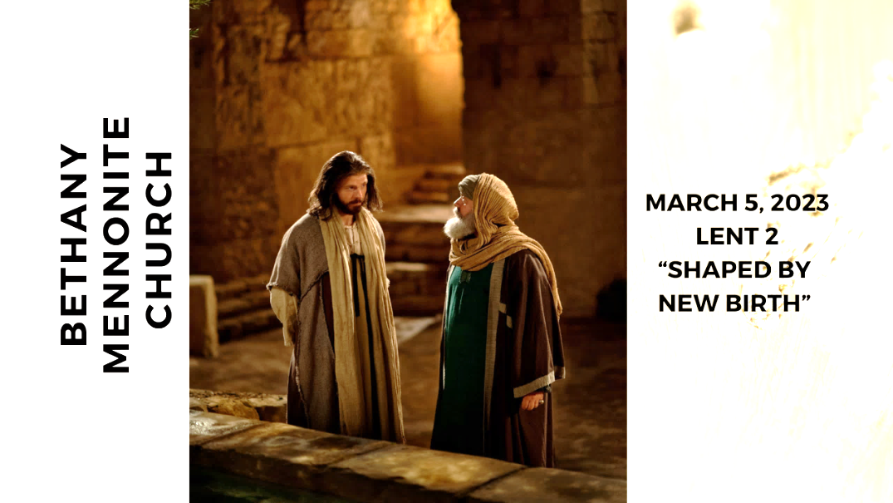

March 5, 2023
572 East & West Line
Box249
Virgil, ON L0S 1T0
905-468-3505
Email: office@bethanymennonite.ca
Website: www.bethanymennonite.ca

59 March 5, 2023 10:00 Service No. 10

Gathering
Prelude
Welcome Herb Sawatzky
Call to Worship
Song – “We Will Walk with God”
“Great is Thy Faithfulness”
Confession & Assurance
Prayer

Life Together
Announcements
Ministry time
Pastoral Prayer
Song – “Here I am, Lord”

Hearing the Word
Scripture – John 3:1-17 Children’s Story
Message – “Shaped by new birth” Herb Sawatzky

Responding
Song – “Breathe on Me, Breath of God”
Faith Story
Song
Offering & Prayer

Going
Song – “The Lord Lift You Up”
Blessing

Musicians – Kenton & Sheryl Janzen & Friends
Scripture Reader – Patty King

Welcome here!
We’re glad you came! Your being here is a sign of God’s love for the world and encourages other Christians. We hope our worship together helps you find
A place to belong and grow in faith.

Praise and Concerns
Prayers:
- Shirley Neufeld in St. Catharines General Hospital
- Ed Epp in Hamilton
- Waldy Heyder, at Shaver Hospital
- Dora Fisch-Willms is at Niagara Falls Hospital
- Sheila Gayman - undergoing cancer treatment
- Our sister church in Pereira, Colombia

Bethany Announcements
Spiritual Formation Opportunities Today:
- 10:00 Worship Service
- 11:10 Kid’s Sunday School – Room 11
- 11:10 Sr Youth & Young Adults Sunday School – Youth room
- 11:10 Adult Sunday School in the Library

Our best wishes to Henry Reimer, who will be celebrating her 85th birthday on March 11th – Happy Birthday, Henry!

Donation Receipts were emailed out. Those who have chosen a printed copy, please find them in your mailboxes. If you have any questions, please contact Marianne in the office.

We are looking for volunteers to learn how to work the sound board as well as the video. There will be on the job training available. Please contact Matt King if you are willing to learn one or both of these jobs.

Directory – We’re nearing the printing stage. Please get your changes in as soon as possible.

Local Food Bank Drive: Area food banks inform us that donations are down 30% this year while need is up 20%! Your continued support for our food drive to local food banks is much appreciated. Please drop off your donations in the food bin at the front door. Foods and snacks for breakfasts and school lunches are especially appreciated.

Golden Coyotes – Games Night at Steve & Wendy Goertz’s place on March 11 at 7:00 pm. RSVP requested to Steve & Wendy or Kenton & Sheryl.

It’s time for a Pastoral/Congregational Review! You will have received an email with the review attached or paper copies are available in the narthex. Please complete the form by March 12th and return them to the office or to Shirley Dick. E-copies can be mailed to shirleym.dick@icloud.com.

Silver Foxes Our next event is a tour of The Niagara Christian Gleaners Facility in Smithville on the morning of April 12, followed by lunch at Laki’s Family Restaurant. The lunch choices are: Lasagna or Chicken Marsala (please state your choice when registering), Rolls, Garden Salad, Coffee or Tea, Baklava or Rice Pudding for dessert. The total cost for the bus, tour and lunch is only $55.00 per person to be paid by Mar. 29 to hold your seat. After that, a waiting list will be made. Please register with Ted and Syl Wiens or Paul and Joanne Thiessen

Our Donations Touching Lives

You can make your offering to Bethany by:
• E-transfer to office@bethanymennonite.ca
• Mail to church at Box 249, Virgil, ON L0S 1T0
• Drop in the mailbox beside the front door on Wednesdays or Thursdays 8:30-3:30 and let Marianne know.
• Canada Helps button on www.bethanymennonite.ca. CanadaHelps charges 3.75% of the donation, but you will be receipted for full amount.

Prayers:
Mennonite Church Eastern Canada
- Each week we pray for a faith community within the MCEC community of congregations. This week we pray for Waterloo North Mennonite Church. Gordon Allaby, Carmen Brubacher and Kendra Whitfield Ellis provide pastoral leadership for this congregation in North Waterloo. Pray for them as they continue to seek God's direction for their family of faith and for their communities and neighbourhoods.

- Daniel Tela and Yosief Abraham will be Licensed Toward Ordination at Shalom Worship and Healing Centre on March 5, 2023. Pray for Daniel, Yosief, and the congregation as they celebrate their calling to ministerial leadership. To share your words of encouragement and support with Daniel, you can reach him at setit17@gmail.com and Yosief at dissepe02@yahoo.com.

- Thank God for the safety of Fanosie Legesse, MCEC intercultural mission minister, and Norm Dyck, MCEC mission minister, and leaders of Meserete Kristos Church, including President Desalegn, as they visited the Tigray region of Ethiopia where violence related to civil war has destroyed lives, churches and homes. Together, they worked to build peace within the Mennonite church and support and encourage pastors in the area.

- Pray for Sarah Wood, Mennonite Church Canada Witness intern, as she concludes her term of service in Thailand on March 10. Pray that these final days connecting with the school and church community in Loei will be rich, and that her transition back to life in Canada will enriched by the experience.

- Continue to pray for peace and wisdom in Ukraine, Russia and in places throughout our world where the people cry out for peace. Lord, hear our prayers.
Mennonite Central Committee
• We give praise for how the Restorative Justice program's focus on social inclusion is changing the lives of participants who are reintegrating into the community after time in prison.

Mennonite Church Canada
Video now available! Church-to-Church Conversation: Meserete Kristos Church and Mennonite Church Canada - A conversation between President Desalegn Abebe, Meserete Kristos Church and Doug Klassen, Executive Minister, Mennonite Church Canada. Listen in on this rich exchange between sister-congregations about social justice and evangelism, leadership training, culture of call and partnership.. Discover the history, strategy and challenges of MKC. Download the video for this encouraging conversation.

Silver Lake Mennonite Camp Winter and Spring Retreats Come to Silver Lake in 2023 for some fun camp experiences!
- Winter Camp for Grown-Ups (Mar 3-5), March Break Family Getaway (Mar 14-17). Go to SLMC Retreats & Events for more info and to register.
- Summer Camp Registration is now Open: Visit the SLMC website for more details about overnight camps, outtrips and day camps. Click here for Camp Info and Registration
- Come enjoy a Silver Lake Online Campfire! Feb 26 (day camps), March 26 (outtrips), April 23 (overnight), May 28 (general) @ 7pm. A great chance to meet some staff and ask questions. Click here for campfire details and link!

Church-to-Church Conversation: Myanmar Ministry Partners & Mennonite Church Canada, March 22, 2023, 10 a.m. EST. Register for the Zoom link and join a conversation between Myanmar Ministry Partners and MC Canada: This will be an opportunity to hear updates from Myanmar on ministry collaboration and the current political climate. During a time of violence and unrest in Myanmar, two groups of Anabaptist Christians have asked for Mennonite Church Canada to support them in leadership development and peace theology training. Mennonite Church Canada supports leadership formation and training events, as well as the development needs of this emerging Anabaptist network of congregations.

MCEC Annual Church Gathering, April 28 & 29, 2023, Rockway Mennonite Collegiate, Kitchener, ON. Transformed. Inspired. Called. Join new and now friends as we grow, learn and serve together as a community of faith. Fanosie Legesse, MCEC Intercultureal Mission Minister, will encourage and challenge us on Friday night at a Mass Intercultural Worship Service. Followed by a Saturday filled with celebration, learning, much discussion and worship. All are welcome! How might we embrace and live as people who are transformed, inspired and called? What difference does that make in our lives? In our communities? When we worship and pray togther, we become grounded in God's love and conected to the Spirit's movement. Come and gather as God's people across MCEC.

MCC, MDS, MEDA
Türkiye and Syria Earthquake Response MCC is accepting donations to support people affected by the Feb. 6 earthquake in Türkiye and Syria. You can share God’s love and compassion with our global neighbours by providing a gift online at mcccanada.ca/earthquake, by calling 888-622-6337 or by sending a cheque marked for “Syria and Türkiye earthquake” to 203-50 Kent Ave., Kitchener, ON, N2G 3R1.

The Raw Carrot is excited to announce that our soup is available for sale at your local thrift shop! The Raw Carrot provides a compassionate workplace to people on long term disability. Our staff are “stirring up” change with their delicious, handcrafted gourmet soup!” Learn more at mcco.ca.

Looking for household donations! Have you been meaning to clear out household items that you no longer use, but haven't gotten around to it yet? Well, now's the time to do it! Our MCC thirft shops are in need of household donations to keep supplies strong on the sales floor. Tim Albrecht – the General Manager of (what we used to call) the Christian Benefit Shop – especially welcomes kitchen supplies and home décor. Pack up some boxes and head over to your local thrift shop today!

Rooted in right relationship: With one another and creation
March 9-11, 2023, Ottawa. In 2023, the Peace & Justice Student Seminar will return to Ottawa in person! Join university students from across Canada as we dig into what it means to be Rooted in right relationship with one another and creation. Learn more about the Peace & Justice seminar here.

Stitching and Stories Mar 18 and 25 10 am-12:30 pm, 50 Kent Ave, Kitchener, N2G 3R1 Join our Indigenous Neighbours team for a time of storytelling and stitching as Niska artisan Lucie Iserhoff teaches us how to bead a simple pin. A kit will be mailed to you with sewing materials. Register by March 6th, 2023 at 12pm to ensure the arrival of your sewing kit before the event begins. All proceeds from this event will go toward supporting the Niska program and future workshops. To learn more and to register, go to mcco.ca/events.

Broader Community
Recharging Caregivers Group – Thursdays beginning February 23 from 1:00-2:00 p.m., Niagara-on-the-Lake Community Palliative Care is excited to offer this supportive program that aims to be a safe space for individuals who care for others. Free registration required.

Some seats are still left for July's Russlaender 100: Memories of Migration Tour. More information is available at the TourMagination website at: https://tourmagination.com/tour/cross-canada-russlaender-centenary-tour/.
THIS WEEK AT BETHANY
March 5-12, 2023

Today 10:00 a.m. – Worship Service
11:10 a.m. – Sunday School
Tuesday 9:00 a.m. – Quilting
6:00 p.m. – Handbell Choir
7:30 p.m. – JuBELLation
Sunday 10:00 a.m. – Worship Service
11:10 a.m. – Sunday School

Speaking: Herb Sawatzky
Scripture: Exodus 17:1–7; Psalm 95; Romans 5:1–11; John 4:5–42
Theme: Shaped through thirst

