A place to belong and grow in faith

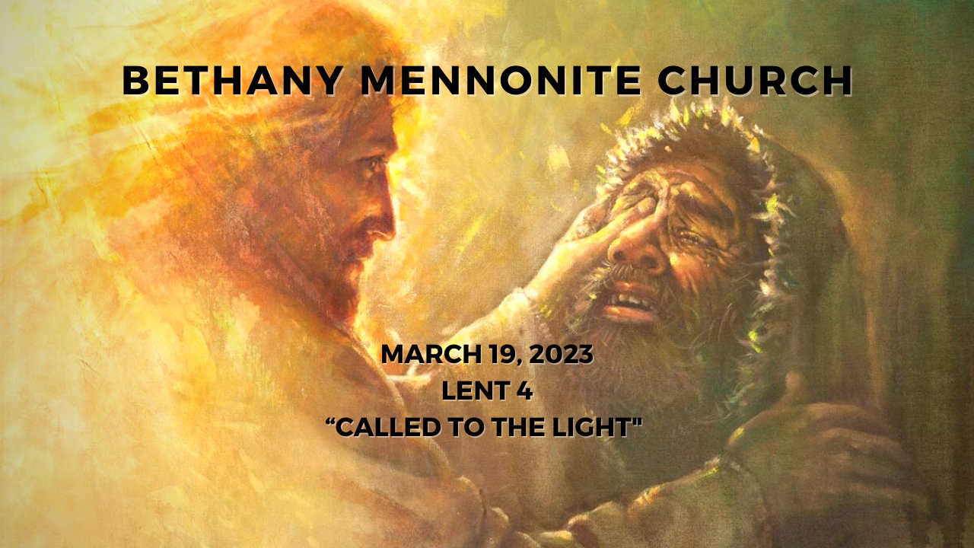

March 19, 2023
572 East & West Line
Box249
Virgil, ON L0S 1T0
905-468-3505
Email: office@bethanymennonite.ca
Website: www.bethanymennonite.ca

59 March 19, 2023 10:00 Service No. 12

Gathering
Prelude
Welcome Herb Sawatzky
Call to Worship
Song – “Shepherd Me, O God” #519
“Gentle Shepherd, Come and Lead Us” #352
Confession & Assurance
Prayer

Life Together
Announcements
Ministry time
Pastoral Prayer
Song – “Let There Be Light” #371

Hearing the Word
Scripture – John 9:1-41
Children’s Story
Message – “Called to the light” Herb Sawatzky

Responding
Song – “Open the Eyes of My Heart”
Faith Story Janet Warkentin
Song – “Shine, Jesus shine”
Offering & Prayer

Going
Blessing

Musicians – Gayle Neufeld & Friends
Scripture Reader – Paul Klassen

Welcome here!
We’re glad you came! Your being here is a sign of God’s love for the world and encourages other Christians. We hope our worship together helps you find
A place to belong and grow in faith.

Praise and Concerns
Prayers:
- Shirley Neufeld at home
- Ed Epp has come home
- Waldy Heyder, at Shaver Hospital
- Dora Fisch-Willms is at Niagara Falls Hospital
- Sheila Gayman - undergoing cancer treatment
- Our sister church in Pereira, Colombia

Our best wishes to Ron Reimer who is turning 80 today! May God bless you as you celebrate with family and friends.

Ron Reimer will be having vascular surgery on his leg on Monday, March 20, at 11 a.m. at the NHS St. Catharines Site. Please pray that all goes well.

Bethany Announcements
Spiritual Formation Opportunities Today:
- 10:00 Worship Service
- 11:10 Kid’s Sunday School – Room 11
- 11:10 Sr Youth & Young Adults Sunday School – Youth room
- 11:10 Adult Sunday School in the Library

Please find the new 2023 Directory in your mailboxes.

Music is an important aspect of the worship service and everyone has songs that are especially significant to them. For the service on Sunday, April 9th, the Worship Team will highlight these special songs from people in the congregation. We invite you to let us know one of your favorite pieces of music, along with a brief write-up as to why it is important to you. If possible, we would invite you to share that story with the congregation just prior to singing the song.

Silver Foxes Our next event is a tour of The Niagara Christian Gleaners Facility in Smithville on the morning of April 12, followed by lunch at Laki’s Family Restaurant. The lunch choices are: Lasagna or Chicken Marsala (please state your choice when registering), Rolls, Garden Salad, Coffee or Tea, Baklava or Rice Pudding for dessert. The total cost for the bus, tour and lunch is only $55.00 per person to be paid by Mar. 29 to hold your seat. After that, a waiting list will be made. Please register with Ted and Syl Wiens or Paul and Joanne Thiessen.

Local Food Bank Drive: Area food banks inform us that donations are down 30% this year while need is up 20%! Your continued support for our food drive to local food banks is much appreciated. Please drop off your donations in the food bin at the front door. Foods and snacks for breakfasts and school lunches are especially appreciated.

Our Donations Touching Lives

You can make your offering to Bethany by:
• E-transfer to office@bethanymennonite.ca
• Mail to church at Box 249, Virgil, ON L0S 1T0
• Drop in the mailbox beside the front door on Wednesdays or Thursdays 8:30-3:30 and let Marianne know.
• Canada Helps button on www.bethanymennonite.ca. CanadaHelps charges 3.75% of the donation, but you will be receipted for full amount.

Prayers:
Mennonite Church Eastern Canada
- Please pray for Waters Mennonite Church, Lively, ON. Leadership is collaborative. Pray for them as they live life together and lean into the mystery of what God is wanting to do in their lives individually and also as a congregation.

- Mennonite Church USA invites Mennonite Church Canada to prayer on March 19-21. The San Carlos Apache people will testify at a court challenge against the use of a two-mile swath of sensitive land proposed for a copper mine in Arizona. More information.

- Pray for Witness workers Werner and Joanne De Jong as they teach and mentor students in the Meserete Kristos Seminary in Ethiopia.

- Pray for God’s guidance for Colombian Mennonite Church (IMCOL) and presenter Henk Stenvers, MWC president, as they gather on March 16-18 for planning and decision making at their annual assembly.

- Pray for peace in Mindanao, Philippines, as Witness workers Dann and Joji Pantoja, continue to bring people together. Praise God for that the local military is listening to their perspective on justice-based peacebuilding.

- Continue to pray for peace and wisdom in Ukraine, Russia and in places throughout our world where the people cry out for peace. Lord, hear our prayers.

Mennonite Central Committee
• We give praise for how the Restorative Justice program's focus on social inclusion is changing the lives of participants who are reintegrating into the community after time in prison.

An updated letter from the Pereira Church is posted on the bulletin board.

Mennonite Church Canada
Hidden Acres Mennonite Camp's 39th Annual Bowlathon is happening again this year on Saturday, March 25 at 4:00pm at New Hamburg Lanes (formerly Riverside Lanes).! This is one of the camp’s main annual fundraising events with last year’s Bowlathon raising over $30,000! You can show your support by donating on-line at hiddenacres.ca/donate, and select “Annual Bowlathon” from the list.

Church-to-Church Conversation: Myanmar Ministry Partners & Mennonite Church Canada, March 22, 2023, 10 a.m. EST. Register for the Zoom link and join a conversation between Myanmar Ministry Partners and MC Canada: This will be an opportunity to hear updates from Myanmar on ministry collaboration and the current political climate. During a time of violence and unrest in Myanmar, two groups of Anabaptist Christians have asked for Mennonite Church Canada to support them in leadership development and peace theology training.

Living the Gospel as a Diverse Group of Believers MCEC Workshop, Apr 18th, 2023, 6:30 - 8:00 p.m. Online. A workshop on cultural integration:As a denomination and as individuals, we want to become learners of our cultural and disciplinary identities to lead respectful, inclusive and culturally appropriate dialogues. Fanoise Legesse, MCEC Intercultural Mission Minister, will lead us as we explore questions around overcoming barriers, integration of ethnic traditions in new cultural context and the gifts we all bring as a diverse body of Christ. Register by April 11, 2023.

MCEC Annual Church Gathering, April 28 & 29, 2023, Rockway Mennonite Collegiate, Kitchener, ON. Transformed. Inspired. Called. Fanosie Legesse, MCEC Intercultural Mission Minister, will encourage and challenge us on Friday night at a Mass Intercultural Worship Service, followed by a Saturday filled with celebration, learning, much discussion and worship. All are welcome! How might we embrace and live as people who are transformed, inspired and called? What difference does that make in our lives? in our communities? When we worship and pray together, we become grounded in God's love and connected to the Spirit's movement. Come and gather as God's people across MCEC.

MCC, MDS, MEDA
The March MDS Newsletter, On the Level is available from the office.

Türkiye and Syria Earthquake Response MCC is accepting donations to support people affected by the Feb. 6 earthquake in Türkiye and Syria. You can share God’s love and compassion with our global neighbours by providing a gift online at mcccanada.ca/earthquake, by calling 888-622-6337 or by sending a cheque marked for “Syria and Türkiye earthquake” to 203-50 Kent Ave., Kitchener, ON, N2G 3R1.

Looking for household donations! Have you been meaning to clear out household items that you no longer use, but haven't gotten around to it yet? Well, now's the time to do it! Our MCC thirft shops are in need of household donations to keep supplies strong on the sales floor. Tim Albrecht – the General Manager of (what we used to call) the Christian Benefit Shop – especially welcomes kitchen supplies and home décor. Pack up some boxes and head over to your local thrift shop today!

THIS WEEK AT BETHANY
March 19-26, 2023

Today 10:00 a.m. – Worship Service
11:10 a.m. – Sunday School
Tuesday 9:00 a.m. – Quilting
6:00 p.m. – Handbell Choir
7:30 p.m. – JuBELLation
Sunday 10:00 a.m. – Worship Service
11:10 a.m. – Sunday School

Speaking: Herb Sawatzky
Scripture: Ezekiel 37:1–14; Psalm 130; Romans 8:6–11; John 11:1–45
Theme: Called to life

Worship services are recorded live and kept on our youtube channel indefinitely. Recordings begin shortly before 10am and end after 11:04. Those who prefer not to appear in the recording are encouraged to sit near the back of the sanctuary in front of the cry room, and exit through the door on that side.

