A place to belong and grow in faith

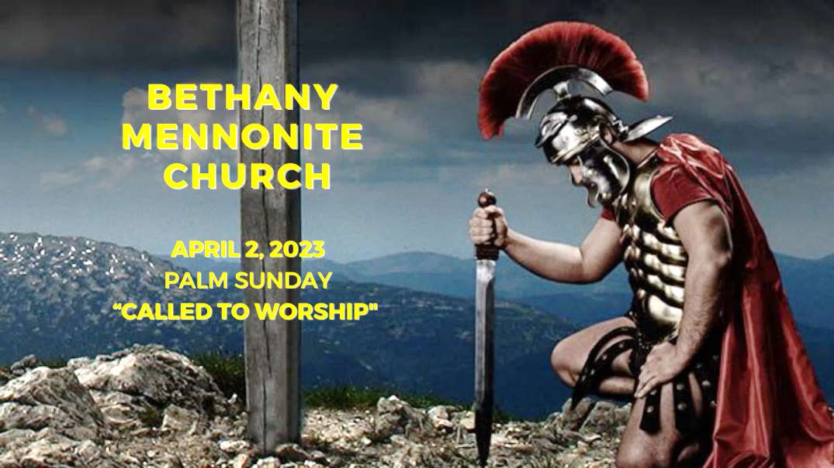

April 2, 2023
572 East & West Line
Box249
Virgil, ON L0S 1T0
905-468-3505
Email: office@bethanymennonite.ca
Website: www.bethanymennonite.ca

59 April 2, 2023 10:00 Service No. 14

Gathering
Prelude Handbell Choir
Welcome Herb Sawatzky
Call to Worship
Songs Handbell Choir
Confession & Assurance
Prayer

Life Together
Announcements
Ministry time
Pastoral Prayer
Song – “Hosanna, Loud Hosanna”

Hearing the Word
Scripture – Matthew 21:1-11
Children’s Story
Message – “Called to worship” Herb Sawatzky

Responding
Song – “Here I Am To Worship”
Faith Story Patty & Matt King
Song – “I Feel the Winds of God Today”
Offering & Prayer

Going
Blessing

Musicians – Gayle Neufeld & Friends
Scripture Reader – Ted Wiens

Welcome here!
We’re glad you came! Your being here is a sign of God’s love for the world and encourages other Christians. We hope our worship together helps you find
A place to belong and grow in faith.

Praise and Concerns
Prayers:
- Erika Dyck in St. Catharines Hospital
- Shirley Neufeld at home
- Ed Epp has come home
- Dora Fisch-Willms is at Niagara Falls Hospital
- Sheila Gayman - undergoing cancer treatment
- Our sister church in Pereira, Colombia

Bethany Announcements
Spiritual Formation Opportunities Today:
- 10:00 Worship Service
- 11:10 Kid’s Sunday School – Room 11
- 11:10 Sr Youth & Young Adults Sunday School – Youth room
- 11:10 Adult Sunday School in the Library

Good Friday, April 7:
10:00 a.m. Morning Worship Service and Communion
3:00 p.m. Concert featuring Seasons Chorale and Handbell Choirs

Easter Morning, April 9:
9:00 a.m. Morning Worship Service
followed by Paska Breakfast

Mark your calendars! On Friday, April 7, at 3:00 p.m., a special Good Friday Choral Concert, "Celebrating the Extravagant Love of God" will be hosted at Bethany featuring the Seasons Chorale, under the direction of Bert Warkentin, with choir members from many of our community churches. A prelude by the Handbell Choir will begin at 2:45 p.m. All are welcome. (There will be an opportunity to make a free will offering to support our local food banks. Donations of non-perishable groceries are also welcomed.)
EASTER SUNDAY BREAKFAST – We are hosting breakfast after our Easter Sunday morning service on April 9th. Please bring your contributions of Paska, raisin bread, or any other breakfast food. We would appreciate your pre-sliced Paska and other food items brought to the kitchen before the service on Easter Sunday. If you’d like to help with set up Good Friday after the morning worship service or clean up after breakfast, please join us in the kitchen.

Music is an important aspect of the worship service and everyone has songs that are especially significant to them. For the service on Sunday, April 16th, the Worship Team will highlight these special songs from people in the congregation. We invite you to let us know one of your favorite pieces of music, along with a brief write-up as to why it is important to you. If possible, we would invite you to share that story with the congregation just prior to singing the song.

The Robert’s Digest is available from the office.

Our Donations Touching Lives

You can make your offering to Bethany by:
• E-transfer to office@bethanymennonite.ca
• Mail to church at Box 249, Virgil, ON L0S 1T0
• Drop in the mailbox beside the front door on Wednesdays or Thursdays 8:30-3:30 and let Marianne know.
• Canada Helps button on www.bethanymennonite.ca. CanadaHelps charges 3.75% of the donation, but you will be receipted for full amount.

Prayers:
Mennonite Church Eastern Canada
- Please pray for West Hills Fellowship. Craig Stephens provides pastoral leadership to this congregation. Pray for this group of families who worship together in the Town of Baden, Ontario.
- Pray for Erma Bauman and her family as they grieve the loss of Gordon Bauman, retired MCEC pastor, who died on March 23, 2023Funeral service to follow at Tavistock Mennonite Church at 3 p.m. The funeral will be livestreamed on https://www.tavistockmennonitechurch.ca/ at Watch the Service.
- Mennonites in Burkina Faso ask us to pray for them as they discern how best to work for peace and discern how to care for the approx. 1.5 million displaced people in their country. Violence from terrorist groups that have taken over regions of the country has disrupted many lives.
- Pray for the Mennonite Community of the Congo (CMCo) as the church prepares conference assemblies to elect conference leaders. Pray for good discernment and wisdom as leaders are chosen.
- Continue to pray for places throughout our world where the people cry out for peace - Myanmar, Ukraine, Russia, Ethiopia, Colombia, Burkina Faso, Benin, DR Congo, Tanzania, Haiti and more.
Mennonite Central Committee
- We give praise for how the Restorative Justice program's focus on social inclusion is changing the lives of participants who are reintegrating into the community after time in prison.

Local Food Bank Drive: Area food banks inform us that donations are down 30% this year while need is up 20%! Your continued support for our food drive to local food banks is much appreciated. Please drop off your donations in the food bin at the front door. Foods and snacks for breakfasts and school lunches are especially appreciated.

Mennonite Church Canada
Registration is open for Ontario Mennonite Music Camp (OMMC), running August 13 - 15 at Conrad Grebel University College. OMMC provides an exciting camp adventure for 12- to 17-year-olds, pairing exceptional musical instruction with traditional camp activities. Campers will find a safe and supportive community to explore their love of music, strengthen their leadership skills, and deepen their faith. Register by April 15 for the early bird discount: grebel.ca/ommc

Living the Gospel as a Diverse Group of Believers MCEC Workshop, Apr 18th, 2023, 6:30 - 8:00 p.m. Online. A workshop on cultural integration:As a denomination and as individuals, we want to become learners of our cultural and disciplinary identities to lead respectful, inclusive and culturally appropriate dialogues. Fanoise Legesse, MCEC Intercultural Mission Minister, will lead us as we explore questions around overcoming barriers, integration of ethnic traditions in new cultural context and the gifts we all bring as a diverse body of Christ. Register by April 11, 2023.

MCEC Pre-Annual Church Gathering Financials Zoom Conversation In order to ensure you have the opportunity to affirm and/or ask questions of clarification surrounding the Spending Plan endorsed at last year's Annual Church Gathering, we welcome anyone to attend an additional meeting to discuss MCEC Financials on Wednesday, April 26, 2023 at 7 p.m. via zoom. This conversation is open to anyone. Zoom link is on the ACG online registration form.

MCEC Church Planter's Workshop, April 28, 2023 at First Hmong Mennonite Church, Kitchener, ON. Join Derek Suderman in this afternoon workshop looking at how the Gospels describe the Gospel, and explore how Jesus both draws upon and reinterprets Old Testament Scripture. As Mennonite Christians, what does this teach us about what it means to follow after Jesus as his disciples? Registration opens next week!

MCEC Annual Church Gathering, April 28 & 29, 2023, Rockway Mennonite Collegiate, Kitchener, ON. Transformed. Inspired. Called. Fanosie Legesse, MCEC Intercultural Mission Minister, will encourage and challenge us on Friday night at a Mass Intercultural Worship Service, followed by a Saturday filled with celebration, learning, much discussion and worship. All are welcome! How might we embrace and live as people who are transformed, inspired and called? What difference does that make in our lives? in our communities? When we worship and pray together, we become grounded in God's love and connected to the Spirit's movement. Come and gather as God's people across MCEC.

Silver Lake Mennonite Camp:
• Youth Camp (May 12-14): A fun-filled weekend for teens! Join us at camp for a relaxed weekend and participate in waterfront activities, campfires, games, and more! Youth can come with or without a sponsor. Click here for Youth Camp Details
• Summer Camp Registration is now Open: Visit the SLMC website for more details about overnight camps, outtrips and day camps. Click here for Camp Info and Registration

MCC, MDS, MEDA
Türkiye and Syria Earthquake Response MCC is accepting donations to support people affected by the Feb. 6 earthquake in Türkiye and Syria. You can share God’s love and compassion with our global neighbours by providing a gift online at mcccanada.ca/earthquake, by calling 888-622-6337 or by sending a cheque marked for “Syria and Türkiye earthquake” to 203-50 Kent Ave., Kitchener, ON, N2G 3R1.

THIS WEEK AT BETHANY
April 2-9, 2023

Today Palm Sunday
10:00 a.m. – Worship Service
11:10 a.m. – Sunday School
Tuesday 6:00 p.m. – Handbell Choir
7:30 p.m. – JuBELLation
Friday 10:00 a.m. – Good Friday Service & Communion
Sunday Happy Easter
9:00 a.m. – Worship Service
10:00 a.m. – Easter Breakfast

Speaking: Herb Sawatzky
Scripture: Psalm 118:21–24; Colossians 3:1–4; Acts 10:34–43; Matthew 28:1–10
Theme: Fully alive in Christ

Worship services are recorded live and kept on our youtube channel indefinitely. Recordings begin shortly before 10am and end after 11:04. Those who prefer not to appear in the recording are encouraged to sit near the back of the sanctuary in front of the cry room, and exit through the door on that side.

