A place to belong and grow in faith

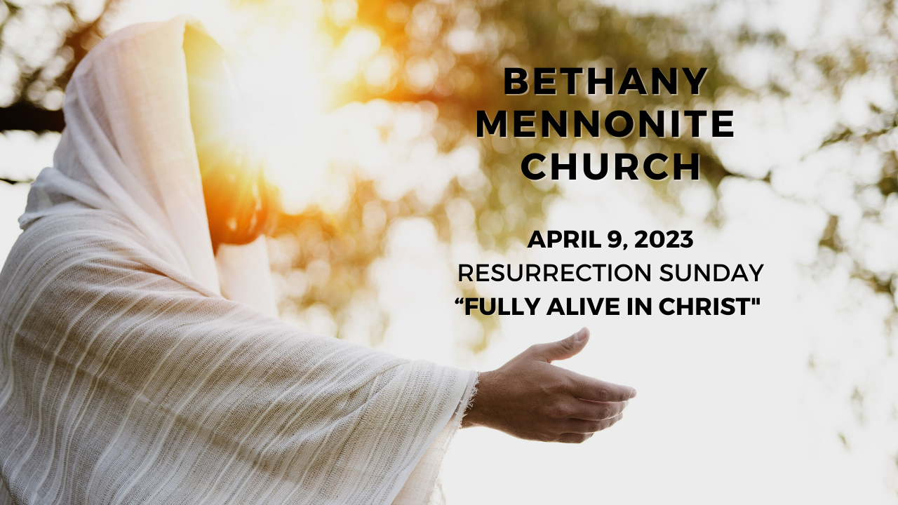

April 9, 2023
572 East & West Line
Box249
Virgil, ON L0S 1T0
905-468-3505
Email: office@bethanymennonite.ca
Website: www.bethanymennonite.ca

59 April 9, 2023 10:00 Service No. 15

Gathering
Prelude
Welcome Herb Sawatzky
Call to Worship
Songs – “Christ the Lord is Risen Today” vs 1-4 #280
“Low in the Grave He lay” #273
Confession & Assurance
Prayer
JuBELLation Handbell Choir

Life Together
Announcements
Ministry time
Pastoral Prayer
Child Dedication – Lilly Grace Legere
Song – “Jesus Loves Me”

Hearing the Word
Scripture – Matthew 28:1–10
Children’s Story
Message – “Gospel in Chairs” Herb Sawatzky

Responding
Song – “Thank you, Jesus, for the Blood”
Offering & Prayer

Going
Blessing
Song – “Crown Him with many Crowns” vs 1 & 2 #116

Musicians – Shirley Dick & Friends
Scripture Reader – Lorrie Sawatzky

Welcome here!
We’re glad you came! Your being here is a sign of God’s love for the world and encourages other Christians. We hope our worship together helps you find
A place to belong and grow in faith.

Praise and Concerns
Prayers:
- Erika Dyck in St. Catharines Hospital
- Ed Epp
- Dora Fisch-Willms is at Niagara Falls Hospital
- Sheila Gayman - undergoing cancer treatment
- Our sister church in Pereira, Colombia

Our prayers and sympathies are extended to the family of Shirley Neufeld who passed away April 3 to be with her Lord. Visitation will take place on Sunday, April 9 3:00-5:00 and 7:00-8:30 p.m. The funeral service will be held Monday, April 10th at 11:00 a.m. We pray for comfort and strength for Vic and the family during this time.

Bethany Announcements
EASTER SUNDAY BREAKFAST – We are hosting breakfast after our Easter Sunday morning service on April 9th. Please bring your contributions of Paska, raisin bread, or any other breakfast food. We would appreciate your pre-sliced Paska and other food items brought to the kitchen before the service on Easter Sunday. If you’d like to help with set up Good Friday after the morning worship service or clean up after breakfast, please join us in the kitchen.

For the service on Sunday, April 16th, the Worship Team will highlight special songs from people in the congregation. We invite you to contact Kenton & Sheryl Janzen and share your favorite pieces of music, along with a brief write-up as to why it is important to you. If possible, we would invite you to share that story with the congregation just prior to singing the song.

Local Food Bank Drive: Area food banks inform us that donations are down 30% this year while need is up 20%! Your continued support for our food drive to local food banks is much appreciated. Please drop off your donations in the food bin at the front door. Foods and snacks for breakfasts and school lunches are especially appreciated.

Blanket Exercise – May 5th, 7pm, at Bethany Mennonite Church.
The blanket exercise is an interactive educational program that teaches the history of Indigenous and Settler people in Canada from an Indigenous perspective. Participants stand on blankets representing lands inhabited by Indigenous Peoples. A facilitator tells the story of first contact, moving and removing blankets to show the way land was taken and peoples relocated, and to illustrate the impact of disease, war, and extinction. The exercise concludes with the participants discussing the experience in groups. To register please email office@bethanymennonite.ca. Participation is free.

Our Donations Touching Lives

You can make your offering to Bethany by:
• E-transfer to office@bethanymennonite.ca
• Mail to church at Box 249, Virgil, ON L0S 1T0
• Drop in the mailbox beside the front door on Wednesdays or Thursdays 8:30-3:30 and let Marianne know.
• Canada Helps button on www.bethanymennonite.ca. CanadaHelps charges 3.75% of the donation, but you will be receipted for full amount.

Prayers:
Mennonite Church Eastern Canada
- Please pray for Westview Christian Fellowship. Vic Ratzlaff & Erika Klassen provide leadership to this congregation as lay ministers. Pray for this group of believers in the Queenston Neighbourhood in St. Catharines, ON.

- Continue to pray for places throughout our world where the people cry out for peace - Myanmar, Ukraine, Russia, Ethiopia, Colombia, Burkina Faso, Benin, DR Congo, Tanzania, Haiti and more. Lord, hear our prayers.

Mennonite Central Committee
- We give praise for how the Restorative Justice program's focus on social inclusion is changing the lives of participants who are reintegrating into the community after time in prison.

Mennonite Church Canada
Due to increased violence in the Chin State of Myanmar that is affecting Mennonite congregations in the area, Mennonite Church Canada is sending an emergency relief gift of $5000 to Bible Missionary Church (Mennonite) to help with medical supplies and food aid in the affected area. Donations are welcome to help support this effort. You can respond via MCEC designating your gift to “Myanmar Emergency Relief.” Funds received in excess of this amount will be used for ongoing support of these siblings in faith including a planned Youth Peace Conference April 13-17.

Registration is open for Ontario Mennonite Music Camp (OMMC), running August 13 - 15 at Conrad Grebel University College. OMMC provides an exciting camp adventure for 12- to 17-year-olds, pairing exceptional musical instruction with traditional camp activities. Campers will find a safe and supportive community to explore their love of music, strengthen their leadership skills, and deepen their faith. Register by April 15 for the early bird discount: grebel.ca/ommc

Living the Gospel as a Diverse Group of Believers MCEC Workshop, Apr 18th, 2023, 6:30 - 8:00 p.m. Online. A workshop on cultural integration:As a denomination and as individuals, we want to become learners of our cultural and disciplinary identities to lead respectful, inclusive and culturally appropriate dialogues. Fanoise Legesse, MCEC Intercultural Mission Minister, will lead us as we explore questions around overcoming barriers, integration of ethnic traditions in new cultural context and the gifts we all bring as a diverse body of Christ. Register by April 11, 2023.

MCEC Pre-Annual Church Gathering Financials Zoom Conversation In order to ensure you have the opportunity to affirm and/or ask questions of clarification surrounding the Spending Plan endorsed at last year's Annual Church Gathering, we welcome anyone to attend an additional meeting to discuss MCEC Financials on Wednesday, April 26, 2023 at 7 p.m. via zoom. This conversation is open to anyone. Zoom link is on the ACG online registration form.

MCEC Church Planter's Workshop, April 28, 2023 at First Hmong Mennonite Church, Kitchener, ON. Join Derek Suderman in this afternoon workshop looking at how the Gospels describe the Gospel, and explore how Jesus both draws upon and reinterprets Old Testament Scripture. As Mennonite Christians, what does this teach us about what it means to follow after Jesus as his disciples? Registration opens next week!

MCEC Annual Church Gathering, April 28 & 29, 2023, Rockway Mennonite Collegiate, Kitchener, ON. Transformed. Inspired. Called. Fanosie Legesse, MCEC Intercultural Mission Minister, will encourage and challenge us on Friday night at a Mass Intercultural Worship Service, followed by a Saturday filled with celebration, learning, much discussion and worship. All are welcome! How might we embrace and live as people who are transformed, inspired and called? What difference does that make in our lives? in our communities? When we worship and pray together, we become grounded in God's love and connected to the Spirit's movement. Come and gather as God's people across MCEC.

Silver Lake Mennonite Camp:
• Youth Camp (May 12-14): A fun-filled weekend for teens! Join us at camp for a relaxed weekend and participate in waterfront activities, campfires, games, and more! Youth can come with or without a sponsor. Click here for Youth Camp Details
• Summer Camp Registration is now Open: Visit the SLMC website for more details about overnight camps, outtrips and day camps. Click here for Camp Info and Registration

MCC, MDS, MEDA
Türkiye and Syria Earthquake Response MCC is accepting donations to support people affected by the Feb. 6 earthquake in Türkiye and Syria. You can share God’s love and compassion with our global neighbours by providing a gift online at mcccanada.ca/earthquake, by calling 888-622-6337 or by sending a cheque marked for “Syria and Türkiye earthquake” to 203-50 Kent Ave., Kitchener, ON, N2G 3R1.

Broader Church & Community
Do you want peace in Ukraine? Grace Mennonite Church (677 Niagara Street) invites you to join other Niagara historic peace churches—UM, MB, BIC, and Quaker—on Saturday May 6th at 2:00 p.m. in the church hall to hear a catalyst talk from Ernie Regehr, Peace and Conflict Studies at Conrad Grebel University College. The topic will be “War in Ukraine: When Peace Cannot be won on the Battlefield.” Focused discussion to follow. Bring a friend!

THIS WEEK AT BETHANY
April 9-16, 2023

Today Happy Easter!
9:00 a.m. – Worship Service
10:00 a.m. – Easter Breakfast
Tuesday 6:00 p.m. – Handbell Choir
7:30 p.m. – JuBELLation
Sunday 10:00 a.m. – Worship Service
11:10 a.m. – Sunday School

Theme: Music Sunday

Worship services are recorded live and kept on our youtube channel indefinitely. Recordings begin shortly before 10am and end after 11:04. Those who prefer not to appear in the recording are encouraged to sit near the back of the sanctuary in front of the cry room, and exit through the door on that side.

