A place to belong and grow in faith

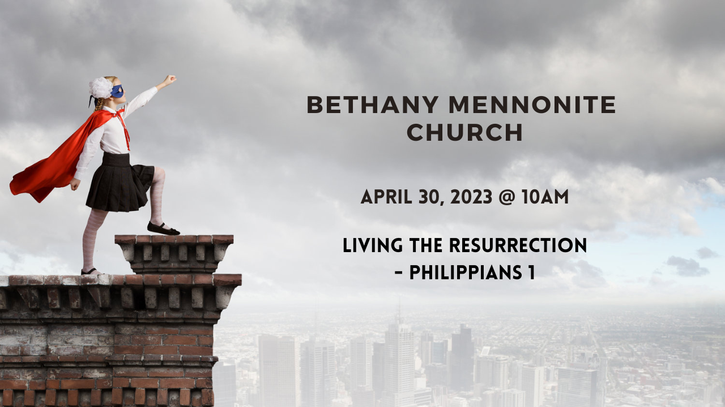

April 30, 2023
572 East & West Line
Box249
Virgil, ON L0S 1T0
905-468-3505
Email: office@bethanymennonite.ca
Website: www.bethanymennonite.ca

59 April 30, 2023 10:00 Service No. 18

Gathering
Prelude
Welcome & Call to Worship Herb Sawatzky
Song – “Come, we that love the Lord” vs 1, 2, 4 #14
“Oh, how I love Jesus”
Prayer

Life Together
Announcements
Ministry time
Pastoral Prayer
Song – “Build your kingdom here”

Hearing the Word
Scripture – Philippians 1:3-11
Children’s Story
Message – “God finishes what God starts” Herb Sawatzky

Responding
Song – “I then shall live”
Offering & Prayer

Going
Song – “Christ liveth in me”
Blessing

Scripture Reader – Wendy Goertz
Musicians – Shirley Dick & Friends

Welcome here!
We’re glad you came! Your being here is a sign of God’s love for the world and encourages other Christians. We hope our worship together helps you find
A place to belong and grow in faith.

Praise and Concerns
Prayers:
- Erika Dyck at home
- Ed Epp at home
- Dora Fisch-Willms is at Niagara Falls Hospital
- Sheila Gayman - undergoing cancer treatment
- Our sister church in Pereira, Colombia

Bethany Announcements
Spiritual Formation Opportunities Today:
- 10:00 Worship Service
- 11:10 Kid’s Sunday School – Room 11
- 11:10 Sr Youth & Young Adults Sunday School

There will be a Membership Meeting immediately following the worship service today, to vote on the following motion from the Church Board: "That Bethany Mennonite Church extend the calling of Pastor Herb Sawatzky for a further 3 year term commencing April 1, 2023.” Please plan to attend, and if you are unable to attend, please consider giving someone your proxy (available in the narthex).

The youth of our sister church in Pereira sent us some bracelets to sell, to raise money for their ongoing building renovations. Thank you for your generous support after church last Sunday! We will be selling the remaining bracelets after church today in the foyer, prior to our membership meeting, for $1 each. Further donations are welcome! Thank you!

Local Food Bank Drive: Area food banks inform us that donations are down 30% this year while need is up 20%! Your continued support for our food drive to local food banks is much appreciated. Please drop off your donations in the food bin at the front door. Foods and snacks for breakfasts and school lunches are especially appreciated.

A May Birthday list is available on the bench by the mailboxes. Please help yourself to a copy.

Compassion Canada was a part of our service last week. If you wish to sponsor a Compassion Child, please take a child's profile from the table in the foyer and then phone or mail Compassion Canada when you get home. The contact info is on the profile.

Visioning Meetings: The Church Board wishes to thank everyone who participated in the Pastoral/Congregational Review. We are now preparing to hold several meetings to begin the visioning process. Please join us on these dates:
Sunday, May 7, 2023, 11:00 a.m. - 1:00p.m.
Wednesday, May 24, 2023, 6:00 - 8:00 p.m.
Sunday, June 4, 2023, 11 a.m. - 1:00p.m.

Blanket Exercise – May 5th, 7pm, at Bethany Mennonite Church.
The blanket exercise is an interactive educational program that teaches the history of Indigenous and Settler people in Canada from an Indigenous perspective. Participants stand on blankets representing lands inhabited by Indigenous Peoples. A facilitator tells the story of first contact, moving and removing blankets to show the way land was taken and peoples relocated, and to illustrate the impact of disease, war, and extinction. The exercise concludes with the participants discussing the experience in groups. To register please email office@bethanymennonite.ca. Participation is free.

Our Donations Touching Lives

You can make your offering to Bethany by:
• E-transfer to office@bethanymennonite.ca
• Mail to church at Box 249, Virgil, ON L0S 1T0
• Drop in the mailbox beside the front door on Wednesdays or Thursdays 8:30-3:30 and let Marianne know.
• Canada Helps button on www.bethanymennonite.ca. CanadaHelps charges 3.75% of the donation, but you will be receipted for full amount.

Prayers:
Mennonite Church Eastern Canada
- Please pray for Windsor Mennonite Fellowship. Rielly McLaren provides leadership to this congregation of intergenerational Jesus-followers.

Mennonite Central Committee
• Though upfront work in the Migration and Resettlement program presents its challenges, we celebrate and rejoice with the newcomers who make Canada home. As you read this, 13 sponsors have already received a total of 37 refugees with many more to come this year! We are so thankful for the incredible work of the team!

Mennonite Church Canada
All who attend Bethany may receive a subscription to Canadian Mennonite for free. The biweekly magazine is delivered by mail and email. Subscriptions are paid for by MCEC. To start a new subscription or to change your delivery preferences (to receive print, digital or both), please contact Marianne in the office.

Silver Lake Mennonite Camp:
- Grand Paddle & Hike Fundraiser 2023: Join us for SLMC’s annual fundraiser! Participants/families can do an activity in their own community or come out to one of the group hikes/bikes/paddles planned in Kitchener, Waterloo, Elmira and Toronto on the May 12-14 weekend. To sign up or donate, visit our Fundraising Site!
- SLMC AGM: May 13 at 11:30am on Zoom. Visit www.slmc.ca for info.
- Youth Camp (May 12-14): A fun-filled weekend for teens to relax and participate in waterfront activities, campfires, games, and more! Youth can come with or without a sponsor. Click here for Youth Camp Details
- Summer Camp Registration: Visit the SLMC website for more details about overnight camps, outtrips and day camps. Camp Info and Registration

MCC, MDS, MEDA
Summer Job Posting at the Christian Benefit Thrift Shop. Candidates for the “Associate, Retail” position must meet the requirements of the Canada Summer Jobs program (youth, ages 15-30). Start date: Mon. June 5, End Date: Sat. Sep. 2. For information about the job posting, and to apply online, please visit the Christian Benefit Thrift Shop website (https://mccthriftontario.com/stcatharines/) or Facebook page.

Türkiye and Syria Earthquake Response MCC is accepting donations to support people affected by the Feb. 6 earthquake in Türkiye and Syria. You can share God’s love and compassion with our global neighbours by providing a gift online at mcccanada.ca/earthquake, by calling 888-622-6337 or by sending a cheque marked for “Syria and Türkiye earthquake” to 203-50 Kent Ave., Kitchener, ON, N2G 3R1.

The April edition of On the Level is available from the office.

Broader Church & Community
Employment Opportunity: Youth Worker. St. Catharines United Mennonite Church is seeking an enthusiastic, passionate Christian adult to serve as a part-time Youth Worker with responsibilities for mid-week evening program delivery for kids and youth in our church and community. The job description and application details can be found by visiting https://scumc.ca/ under the Employment tab.

Do you want peace in Ukraine? Grace Mennonite Church (677 Niagara Street) invites you to join other Niagara historic peace churches—UM, MB, BIC, and Quaker—on Saturday May 6th at 2:00 p.m. in the church hall to hear a catalyst talk from Ernie Regehr, Peace and Conflict Studies at Conrad Grebel University College. The topic will be “War in Ukraine: When Peace Cannot be won on the Battlefield.” Focused discussion to follow. Bring a friend!

Arthur Boers, who grew up in St. Catharines, just published his coming-of-age and coming-to-faith story. Shattered: A Son Picks Up the Pieces of His Father's Rage explores being the son of immigrants (English was his second language, he could not even pronounce his Canadian name), the lively faith and mystical experiences he had as a child, and dealing with his father's PTSD that eventually circled dangerously onto Arthur. The book includes an appreciate description of how he chose to become Mennonite. Christian Heritage Book is hosting Arthur for book a reading and signing on Saturday, 13 May, 2-4 p.m.

THIS WEEK AT BETHANY
April 30-May 7, 2023

Today 9:00 a.m. – Worship Service
11:10 a.m. – Sunday School
Tuesday 6:00 p.m. – Handbell Choir
7:30 p.m. – JuBELLation
Sunday 10:00 a.m. – Worship Service
11:10 a.m. – Sunday School

Speaking: Herb Sawatzky
Theme: Living the Resurrection
Scripture: Philippians 2:1-18

Worship services are recorded live and kept on our youtube channel indefinitely. Recordings begin shortly before 10am and end after 11:04. Those who prefer not to appear in the recording are encouraged to sit near the back of the sanctuary in front of the cry room, and exit through the door on that side.

