A place to belong and grow in faith

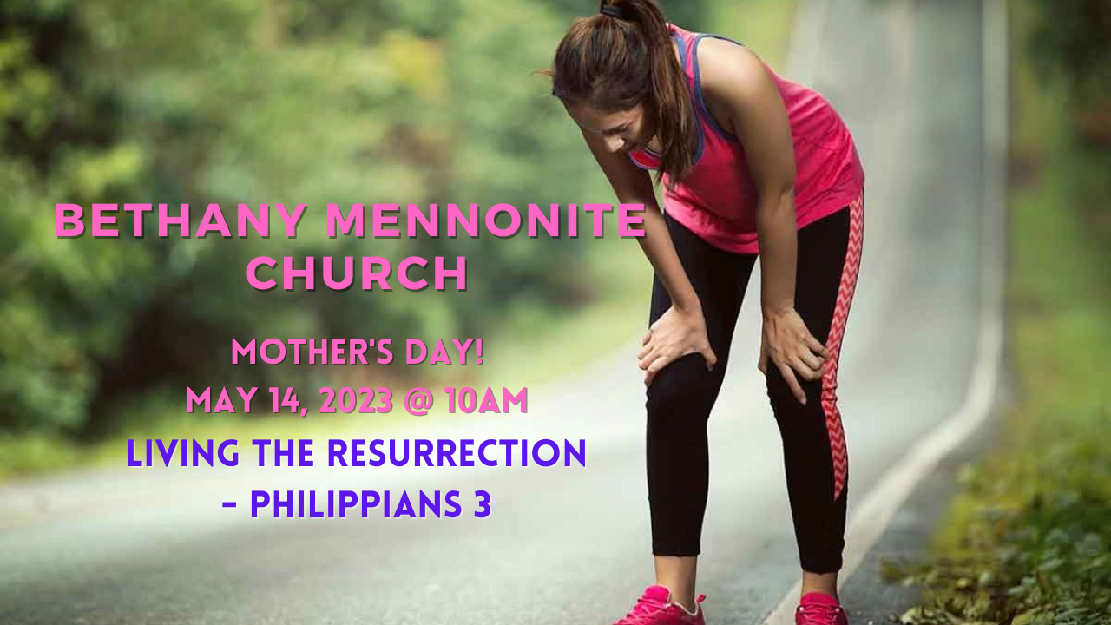

May 14, 2023
572 East & West Line
Box249
Virgil, ON L0S 1T0
905-468-3505
Email: office@bethanymennonite.ca
Website: www.bethanymennonite.ca

59 May 14, 2023 10:00 Service No. 20

Happy Mother’s Day!

Gathering
Prelude
Welcome & Call to Worship Herb Sawatzky
Song – “God of the Bible”
“Lord, I am Fondly, Earnestly Longing”
Prayer

Life Together
Announcements
Ministry time
Pastoral Prayer
Song – “Like a Mother Who Has Borne Us”

Hearing the Word
Scripture – Philippians 3:7-12
Children’s Story
Message – “Pressing on, Taking hold” Herb Sawatzky

Responding
Song – “Lord, I Want to be a Christian”
Offering & Prayer

Going
Song – “We Will Follow”
Blessing

Scripture Reader – Julia Klassen
Musicians – Kenton & Sheryl Janzen & Friends

Welcome here!
We’re glad you came! Your being here is a sign of God’s love for the world and encourages other Christians. We hope our worship together helps you find
A place to belong and grow in faith.

Praise and Concerns
Prayers:
- Erika Dyck at home
- Ed Epp at home
- Sheila Gayman - undergoing cancer treatment
- Our sister church in Pereira, Colombia

Congratulations to Bill and Irene Goertz who will celebrate their 70th wedding anniversary on May 18^{th!}

Dora Fisch-Willms is very happy that she has found a new home at Garden City Manor. She has moved to room 211 in the Montebello Unit on May 12.

Our prayers and sympathies are extended to Henry Berg on the death of Henry’s brother, Art Berg on April 30. Art was a member of Bethany for many years and he still had many friends and family here.

Love and sympathy are also extended to Marianne and Ed Enns on the death of Marianne’s father, Henry Harder on May 7. The funeral was held at St. Catharines United Mennonite Church on Friday May 12.

Bethany Announcements
Spiritual Formation Opportunities Today:
- 10:00 Worship Service
- 11:10 Sr Youth & Young Adults Sunday School – Youth room
- 11:10 Adult Sunday School in the Library

Visioning Meetings: The Church Board wishes to thank everyone who participated in the Pastoral/Congregational Review. We are now preparing to hold several meetings to begin the visioning process. Please join us on these dates:
Wednesday, May 24, 2023, 6:00 - 8:00 p.m.
Sunday, June 4, 2023, 11 a.m. - 1:00p.m.

Lawn Cutters needed! If you are able to help out with cutting Bethany’s lawn, please call Mike Frena to volunteer.

Mother Daughter Tea - Monday May 15th at 7 pm at Bethany. All women are invited to enjoy Cake and Tea while learning about the Nyanyas of Niagara (Grandmothers helping Grandmothers) a local campaign supporting African grandmothers who are raising their grandchildren. Donations collected at the Tea will be given to this project. If you would like to bake a cake for the event, please let Anne Litke, Patty King or Linda Van Bergen know.

New Hamburg MCC Relief Sale is on May 26 & 27. Those who are interested in helping out at the Pork-on-a-bun on Friday evening or Saturday morning, please contact Kenton or Sheryl Janzen

Baptism service - on May 28th, Pentecost Sunday, we will celebrate the Baptism of Jamie Denney, Julia King and Ellery Sawatzky and a Communion service. A Potluck Lunch will follow. Please bring a salad or ‘ready to serve’ main dish, and a small dessert. Please refrain from using peanuts and/or peanut products. If you have any questions, please contact Patty King or Linda Van Bergen.

We raised just over $200 to send to Pereira, with the sale of the bracelets. There are a few bracelets remaining, which I left on the shelf behind the tech booth, along with some other "Pereira items".

Bethany Mennonite Church is going to a ball game again! We have tickets to a Welland Jackfish baseball game, on Sat. Aug. 19, at 6:05 p.m.
We have reserved the "Dock" seating area, and each ticket includes all-you-can-eat ballpark food, from "gates open" to the 3rd inning. After that, the regular menu is available. Tickets also include unlimited Pepsi products, water and popcorn. Dessert treats are included as well. There will be fireworks after the game. The Dock has tables and chairs, which seat 3 to a table, comfortably, with a great view of the field. There are 20 tickets available, at $40 each (the cost is slightly more than last year, but you get more!). We can get 10 more tickets, if there is interest. Please contact Patty King, to reserve your tickets and to arrange payment. Carpooling can be arranged for those who may be interested.

Our Donations Touching Lives

You can make your offering to Bethany by:
• E-transfer to office@bethanymennonite.ca
• Mail to church at Box 249, Virgil, ON L0S 1T0
• Drop in the mailbox beside the front door on Wednesdays or Thursdays 8:30-3:30 and let Marianne know.
• Canada Helps button on www.bethanymennonite.ca. CanadaHelps charges 3.75% of the donation, but you will be receipted for full amount.

Local Food Bank Drive: Area food banks inform us that donations are down 30% this year while need is up 20%! Your continued support for our food drive to local food banks is much appreciated. Please drop off your donations in the food bin at the front door. Foods and snacks for breakfasts and school lunches are especially appreciated.

Prayers:
Mennonite Church Eastern Canada
- We pray for Agape Fellowship. Please pray for this faith community who meets at Valleyview Mennonite Church in London, ON.

- Please pray that the woods, waters and open spaces of our summer campgrounds are filled with God’s glory and that those who enter into them will understand their interconnectedness with creation in new ways! (Prayer from Sandy Plett, MC Canada Climate Action Coordinator)

- Continue to pray for Derek Suderman who is teaching the leadership of the Friends of Grace church network in Thailand. MC Canada International Witness workers, Tom and Christine Poovong, helped to found and lead the Friends of Grace and their leaders have asked for Biblical teaching from an Anabaptist perspective.
Mennonite Central Committee
• Though upfront work in the Migration and Resettlement program presents its challenges, we celebrate and rejoice with the newcomers who make Canada home. As you read this, 13 sponsors have already received a total of 37 refugees with many more to come this year! We are so thankful for the incredible work of the team!

Mennonite Church Canada
Climate Action for Peace - Launch Event - Wednesday, May 17 at 7:30 pm, online. Climate change is making difficult situations even worse, creating resource scarcity and heightening tensions in areas suffering from the negative impacts of climate change. Join us to learn about how people around the world, with the help of MCC’s partners, are taking action to respond to the impacts of climate change and how you can get involved. Go to mcco.ca/events to register.

United Mennonite Home is excited to welcome back its Annual Spring Bazaar! Join us on Saturday June 3rd from 10am-12:30pm at 4024 Twenty-Third St. Vineland. Festivities consist of a Bake Sale, Penny Sale, Raffle, Silent Auction, BBQ, and Entertainment. Raffle prizes include a Handmade Quilt, Webber Travel BBQ, and a $150 Shaw Festival Gift Certificate. Advanced ticket sales are available weekday afternoons at the UMH volunteer reception desk. For more information, please contact Jodi Thompson – Programs Manager at (905) 562-7385 ext. 5004 or jthompson@umh.ca.

Being a Restorative Church - Creating Brave and Accessible Space, June 3, 2023, 8:30 a.m. - 12:00 noon - Join pastors, chaplains and congregational leaders for this time of learning and discussion with Betty Pries, Rielly McLaren and Mike Williamson. Our presenters will challenge us on how to be a loving and embracing community in midst of the challenges which might be presented to us. Contact the office for more details.

All who attend Bethany may receive a subscription to Canadian Mennonite for free. The biweekly magazine is delivered by mail and email. Subscriptions are paid for by MCEC. To start a new subscription or to change your delivery preferences (to receive print, digital or both), please contact Marianne in the office.

On June 30-July2 Hidden Acres is hosting our annual Family Camping Weekend! Bring your family to enjoy the outdoors, go swimming, canoeing and climbing on our outdoor climbing tower. Contact the camp to reserve a cabin space at info@hiddenacres.ca. First come, first served for camping spots. More information can be found on our website at www.hiddenacres.ca See you there!

MCC, MDS, MEDA
New Hamburg Mennonite Relief Sale - May 26-27, 2023 at the New Hamburg Fairgrounds & Arena. Join the fun and support MCC at the 57th annual New Hamburg Mennonite Relief Sale. Come along and bid on some quilts, furniture or even a tractor! Join us for the Voices Together Community Hymn Sing, buy a pie and enjoy some good old-fashioned Mennonite food. More info can be found at mcco.ca/events.

Summer Job Posting at the Christian Benefit Thrift Shop. Candidates for the “Associate, Retail” position must meet the requirements of the Canada Summer Jobs program (youth, ages 15-30). Start date: Mon. June 5, End Date: Sat. Sep. 2. For information about the job posting, and to apply online, please visit the Christian Benefit Thrift Shop website (https://mccthriftontario.com/stcatharines/) or Facebook page.

Broader Church & Community
Everyone is warmly invited to a Free concert with The Wiebes at Niagara United Mennonite Church on Sunday, May 28th at 7 pm. Covenant Award winners Shane & Angela Wiebe will be sharing songs of God’s faithfulness and love. A freewill offering will be taken to help build a school in Honduras at the White Dove Mennonite School, a partner school of Generation Rising. For more information about the event, please visit www.genrising.org/concert.

St. Catharines United Mennonite Church German Worship Ministry Celebration and Conclusion of 78 years is Sunday, June 4, at 9:15 am. Come and enjoy a video depicting the very beginning of the German Worship services as far back as 1947, poems, and a choir program. All are welcome!

Learn how to strengthen your intercultural behaviors and address systemic oppression in Indigenous Cultural Safety: Working authentically across difference with Harley Eagle at the Canadian School of Peacebuilding, June 5-9. Registration deadline is May 29. For more information, visit csop.cmu.ca.

The Niagara on the Lake Days for Girls Team is a group of people who have been sewing and distributing hygiene kits that go to women around the World. In the last year alone, they have sewn and distributed 325 complete kits plus 1200 individual components. On Friday June 16, they are hosting their first dinner fundraiser and silent auction. To help them you can donate an item for the silent auction or buy tickets and attend the dinner. Tickets for dinner are, Adults (age 13+) $15, Child (age 3 to 12) $10, Children under 3 are free. For more information, contact NUMC office at office@redbrickchurch.ca.

THIS WEEK AT BETHANY
May 14-21, 2023

Today 9:00 a.m. – Worship Service
11:00 a.m. – Church Visioning Conversation
Tuesday 6:00 p.m. – Handbell Choir
7:30 p.m. – JuBELLation
Sunday 10:00 a.m. – Worship Service
11:10 a.m. – Sunday School

Speaking: Herb Sawatzky
Theme: Living the Resurrection
Scripture: Philippians 4:4-8

Worship services are recorded live and kept on our youtube channel indefinitely. Recordings begin shortly before 10am and end after 11:04. Those who prefer not to appear in the recording are encouraged to sit near the back of the sanctuary in front of the cry room, and exit through the door on that side.

