A place to belong and grow in faith

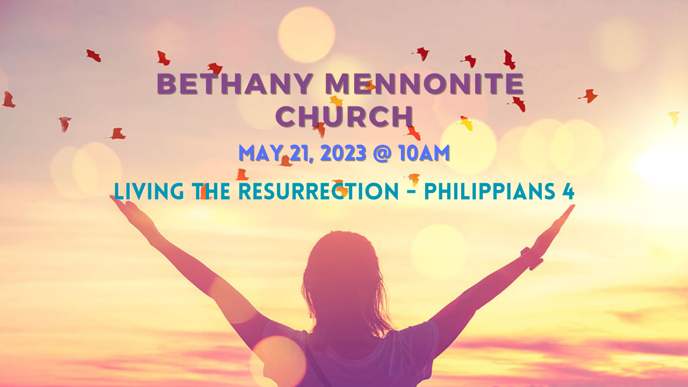

May 21, 2023
572 East & West Line
Box249
Virgil, ON L0S 1T0
905-468-3505
Email: office@bethanymennonite.ca
Website: www.bethanymennonite.ca

59 May 21, 2023 10:00 Service No. 21

Gathering
Prelude
Welcome & Call to Worship Herb Sawatzky
Song – “Praise Him, Praise Him!” #100
“In the Lord I'll Be Ever Thankful”
Prayer

Life Together
Announcements
Ministry time
Pastoral Prayer
Song – “Build My Life”

Hearing the Word
Scripture – Philippians 4:4-8
Children’s Story
Message – “Living the Resurrection, with prayer and thanks” Herb Sawatzky

Responding
Song – “Whatever Is True”
Offering & Prayer

Going
Song – “As You Go Out From Here”
Blessing

Musicians – Gayle Neufeld & Friends

Welcome here!
We’re glad you came! Your being here is a sign of God’s love for the world and encourages other Christians. We hope our worship together helps you find
A place to belong and grow in faith.

Praise and Concerns
Prayers:
- Erika Dyck at home
- Sheila Gayman - undergoing cancer treatment
- Our sister church in Pereira, Colombia

Our prayers and sympathies are extended to the family of Ed Epp who passed away on May 17th. Visitation will take place on Tuesday, May 23 from 6:00-8:00 and the funeral will be held on Wednesday, May 24th at 11:00 a.m. We pray for comfort and strength for them during this time.

Bethany Announcements
Spiritual Formation Opportunities Today:
- 10:00 Worship Service
- 11:10 Adult Sunday School in the Library

Visioning Meetings: The Church Board wishes to thank everyone who participated in the Pastoral/Congregational Review. We are now preparing to hold several meetings to begin the visioning process. Please join us on these dates:
Wednesday, May 24, 2023, 6:00 - 8:00 p.m.
Sunday, June 4, 2023, 11 a.m. - 1:00p.m.

Ask the Pastor Anything - In June Herb will do his best to answer any questions that you might have about faith and following Jesus Christ. Feel free to email Herb your questions, or drop them off at the office.

Volunteers needed for New Hamburg MCC Relief Sale is on May 26 & 27. Those who are interested in helping out at the Pork-on-a-bun on Friday evening or Saturday morning, please contact Kenton or Sheryl Janzen at 905-468-2345.

Baptism service - on May 28th, Pentecost Sunday, we will celebrate the Baptism of Jamie Denney, Julia King and Ellery Sawatzky and a Communion service. A Potluck Lunch will follow. Please bring a salad or ‘ready to serve’ main dish, and a small dessert. Please refrain from using peanuts and/or peanut products. If you have any questions, please contact Patty King or Linda Van Bergen.

Lawn Cutters needed! If you are able to help out with cutting Bethany’s lawn, please call Mike Frena to volunteer.

We raised just over $200 to send to Pereira, with the sale of the bracelets. There are a few bracelets remaining, which I left on the shelf behind the tech booth, along with some other "Pereira items". An update on their renovations is on the bulletin board.

Our Donations Touching Lives
Budget Donations for May 11-17: $4,705

You can make your offering to Bethany by:
• E-transfer to office@bethanymennonite.ca
• Mail to church at Box 249, Virgil, ON L0S 1T0
• Drop in the mailbox beside the front door on Wednesdays or Thursdays 8:30-3:30 and let Marianne know.
• Canada Helps button on www.bethanymennonite.ca. CanadaHelps charges 3.75% of the donation, but you will be receipted for full amount.

Local Food Bank Drive: Area food banks inform us that donations are down 30% this year while need is up 20%! Your continued support for our food drive to local food banks is much appreciated. Please drop off your donations in the food bin at the front door. Foods and snacks for breakfasts and school lunches are especially appreciated.

Prayers:
Mennonite Church Eastern Canada
- Please pray for Avon Church. Troy Watson and Stephen Kennedy provide pastoral care for this congregation. Please pray for them as they seek to make a difference in their community and the world.
Mennonite Central Committee
• Though upfront work in the Migration and Resettlement program presents its challenges, we celebrate and rejoice with the newcomers who make Canada home. As you read this, 13 sponsors have already received a total of 37 refugees with many more to come this year! We are so thankful for the incredible work of the team!
Mennonite Church Canada
United Mennonite Home is excited to welcome back its Annual Spring Bazaar! Join us on Saturday June 3rd from 10am-12:30pm at 4024 Twenty-Third St. Vineland. Festivities consist of a Bake Sale, Penny Sale, Raffle, Silent Auction, BBQ, and Entertainment. Raffle prizes include a Handmade Quilt, Webber Travel BBQ, and a $150 Shaw Festival Gift Certificate. Advanced ticket sales are available weekday afternoons at the UMH volunteer reception desk. For more information, please contact Jodi Thompson – Programs Manager at (905) 562-7385 ext. 5004 or jthompson@umh.ca.

Hidden Acres is hosting their 56th Annual Chicken BBQ & 15th Annual Pie Auction Fundraiser on Tuesday, June 13 from 5 - 7 pm. Come and enjoy our delicious chicken dinner that thousands of people have come to know and love. Along with the chicken, your meal includes potato salad, coleslaw, veggies, pickles, a fresh roll, chips and an apple or fresh baked donut. $18 Small meal (1 piece of chicken) / $22 Regular meal (2 pieces of chicken). Please visit hiddenacres.ca for more details and to order your tickets. Tickets need to be purchased in advance.

On June 30-July2 Hidden Acres is hosting our annual Family Camping Weekend! Bring your family to enjoy the outdoors, go swimming, canoeing and climbing on our outdoor climbing tower. Contact the camp to reserve a cabin space at info@hiddenacres.ca. First come, first served for camping spots. More information can be found on our website at www.hiddenacres.ca See you there!

MCC, MDS, MEDA
New Hamburg Mennonite Relief Sale - May 26-27, 2023 at the New Hamburg Fairgrounds & Arena. Join the fun and support MCC at the 57th annual New Hamburg Mennonite Relief Sale. Come along and bid on some quilts, furniture or even a tractor! Join us for the Voices Together Community Hymn Sing, buy a pie and enjoy some good old-fashioned Mennonite food. More info can be found at mcco.ca/events.

MEDA Niagara Network Hub – Join for an in-person breakfast at the Grand Oak Culinary Market, 4600 Victoria Ave, Vineland Station on Wednesday, June 7th at 8:00 a.m. The speaker will be Katelynn Alida Folkerts, Manager of Global Program Operations. Cost is $25. Please register at https://engage.meda.org/page/128134/event/1.

Summer Job Posting at the Christian Benefit Thrift Shop. Candidates for the “Associate, Retail” position must meet the requirements of the Canada Summer Jobs program (youth, ages 15-30). Start date: Mon. June 5, End Date: Sat. Sep. 2. For information about the job posting, and to apply online, please visit the Christian Benefit Thrift Shop website (https://mccthriftontario.com/stcatharines/) or Facebook page.

Broader Church & Community
Everyone is warmly invited to a Free concert with The Wiebes at Niagara United Mennonite Church on Sunday, May 28th at 7 pm. Covenant Award winners Shane & Angela Wiebe will be sharing songs of God’s faithfulness and love. A freewill offering will be taken to help build a school in Honduras at the White Dove Mennonite School, a partner school of Generation Rising. For more information about the event, please visit www.genrising.org/concert.

The Festival of Praise – St. Andrew’s Presbyterian Church invites you to a splendid spring evening of music and singing on Sunday May 28th at 7:00 p.m. featuring the St. Andrew’s Chancel Choir and The Choir of Knox Presbyterian Church.

Learn how to strengthen your intercultural behaviors and address systemic oppression in Indigenous Cultural Safety: Working authentically across difference with Harley Eagle at the Canadian School of Peacebuilding, June 5-9. Registration deadline is May 29. For more information, visit csop.cmu.ca.

St. Catharines United Mennonite Church German Worship Ministry Celebration and Conclusion of 78 years is Sunday, June 4, at 9:15 am. Come and enjoy a video depicting the very beginning of the German Worship services as far back as 1947, poems, and a choir program. All are welcome!

The Niagara on the Lake Days for Girls Team is a group of people who have been sewing and distributing hygiene kits that go to women around the World. In the last year alone, they have sewn and distributed 325 complete kits plus 1200 individual components. On Friday June 16, they are hosting their first dinner fundraiser and silent auction. To help them you can donate an item for the silent auction or buy tickets and attend the dinner. Tickets for dinner are, Adults (age 13+) $15, Child (age 3 to 12) $10, Children under 3 are free. For more information, contact NUMC office at office@redbrickchurch.ca.

THIS WEEK AT BETHANY
May 21-28, 2023

Today 10:00 a.m. – Worship Service - Pentecost
11:00 a.m. – Adult Sunday School
Tuesday 6:00 p.m. – Ed Epp Visitation
Wednesday 11:00 a.m. – Ed Epp Funeral
Sunday 10:00 a.m. – Worship Service
11:10 a.m. – Adult Sunday School

Speaking: Herb Sawatzky
Theme: Baptism & Communion
Scripture: Philippians 4:12-13

BETHANY MENNONITE CHURCH
WORSHIP SERVICES – 10:00 a.m.

Herb Sawatzky, Lead Pastor 736-2029
pastor@bethanymennonite.ca
Church Chair: Shirley Dick 359-7737
shirleym.dick@icloud.com

Pastoral Care Team:
Gayle Neufeld 468-2105
Irene Schellenberg 289-868-8775
Joanne Thiessen 468-7392
Wallace Wiens 289-868-8986

Office Hours – Wednesdays & Thursdays 8:30–3:30
Pastor’s office hours – Tuesday-Thursday or by appointment

For the Prayer Chain, please call the office during office hours or Herb after hours.

Worship services are recorded live and kept on our youtube channel indefinitely. Recordings begin shortly before 10am and end after 11:04. Those who prefer not to appear in the recording are encouraged to sit near the back of the sanctuary in front of the cry room, and exit through the door on that side.

