A place to belong and grow in faith

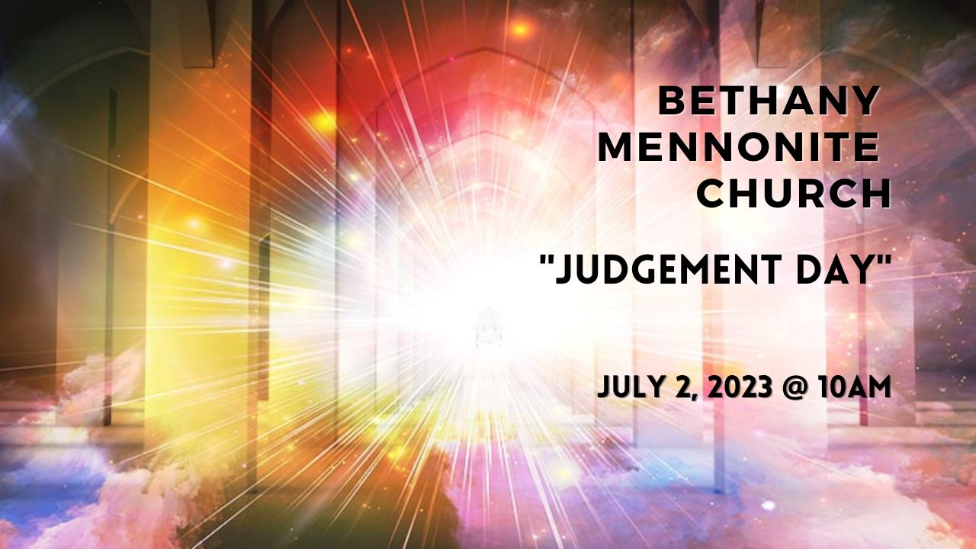

July 2, 2023
572 East & West Line
Box249
Virgil, ON L0S 1T0
905-468-3505
Email: office@bethanymennonite.ca
Website: www.bethanymennonite.ca

59 July 2, 2023 10:00 Service No. 27

Gathering
Prelude
Welcome & Call to Worship Herb Sawatzky
Songs – “You Are Exalted”
“I Love You, Lord”
Prayer

Life Together
Announcements
Ministry time
Pastoral Prayer
Song – “How Firm a Foundation” #567

Hearing the Word
Scripture – Malachi 2:17-3:5
Message – “Seeking and Desiring" Herb Sawatzky

Responding
Song – “Refiner's Fire”
Offering & Prayer

Going
Song – “Benediction”
Blessing

Scripture Reader – Patty King
Musicians – Gayle Neufeld & Friends

Welcome here!
We’re glad you came! Your being here is a sign of God’s love for the world and encourages other Christians. We hope our worship together helps you find
A place to belong and grow in faith.

Praise and Concerns
Prayers:
- Helen Andres as she recovers from surgery
- Jason Wiebe as he deals with his cancer diagnosis
- Erika Dyck at home
- Sheila Gayman - undergoing cancer treatment
- Our sister church in Pereira, Colombia

Our best wishes to Mary Ann Janzen, who is celebrating her 80th birthday today. We wish you God’s continued blessings as you celebrate this milestone.

Congratulations to Hielke De Jong, who is celebrating his 90th birthday today! May God bless you as you celebrate with family and friends.

Please join us for cake as we celebrate Hielke De Jong’s birthday. All are welcome to join downstairs after the service.

Bethany Announcements
Monthly Prayer Breakfast - if you are willing to be one of 2-4 people who would coordinate a Monthly Prayer Breakfast (8-9 times a year), please contact pastor Herb Sawatzky at pastor@bethanymennonite.ca. The Coordinating Team will not do the work themselves, but bring in others to help and participate.

Attention all Coyotes, Badgers, Millennials, etc. We are hoping to do mid-week gatherings throughout the summer and we are looking for people to volunteer to host on Tuesday or Wednesday nights. If interested in hosting, please contact Kenton or Sheryl. We will be hosting the first one on July 5th at our home at 728 Line 2 at 7 pm. Please bring a dessert to share.

Looking for a home for a grand piano! “My husband had a passion for music but no one near me has a room for the piano at this time.” Please call the office if you would like to have a piano or know anyone who would appreciate the instrument.

Local Food Bank Drive: Area food banks inform us that donations are down 30% this year while need is up 20%! Your continued support for our food drive to local food banks is much appreciated. Please drop off your donations in the food bin at the front door. Foods and snacks for breakfasts and school lunches are especially appreciated.

Our Donations Touching Lives

You can make your offering to Bethany by:
• E-transfer to office@bethanymennonite.ca
• Mail to church at Box 249, Virgil, ON L0S 1T0
• Drop in the mailbox beside the front door on Wednesdays or Thursdays 8:30-3:30 and let Marianne know.
• Canada Helps button on www.bethanymennonite.ca. CanadaHelps charges 3.75% of the donation, but you will be receipted for full amount.

Prayers:
Mennonite Church Eastern Canada
- Pray for those who are living in an area impacted by war. May we learn to be channels of God's peace.
- Please pray for Bloomingdale Mennonite Church. Zac Klassen provides pastoral leadership for this congregation. Pray for this congregation as this summer they intentionally focus on seeking peace together and learn what it means to be a people of God's peace.

- Pray for Pastor Onesiphore Kiota from Centre Béthésda Mennonite de Québec, who lost his mother at home in Congo (Africa). Alongside his congregation, we offer a hand of mercy to the family. Please pray for Pastor Kiota and his family.

Mennonite Central Committee
- Please pray for the people in communities on the James Bay Coast in northern Ontario who are facing evacuation, health concerns and possible loss of electricity due to increasingly dangerous forest fires. The community of Fort Albany has already evacuated most residents and the nearby communities of Kashechewan and Attawapiskat face threats to the lines that provide power to their communities. The Cree people of James Bay region are strong, and they have survived many challenges – and they need our prayers right now.
Mennonite Church Canada
Ontario Mennonite Music Camp takes place at Conrad Grebel University College in Waterloo, ON from August 13 to 25. OMMC is open to students of all musical abilities. It costs $1400 to attend camp for two weeks, but there are bursaries available based on need. Applications will be accepted until August 1. Please register at: https://uwaterloo.ca/grebel/2023-ommc-registration-form

Silver Lake Mennonite Camp
Fall Retreats – Registration now open for a wide variety of fun retreats coming up this fall including: Labour Day Weekend Retreat (Sep 1-3), Men’s Retreat (Sep 15-17), Bruce Trail Hike (Sep 18-21), Fall Hike Retreat (Sep 29-Oct 1), Fall Work Weekend (Oct 27-29). Click here for more info… slmc.ca/retreats
Overnight Camps – There are still spots available for SLMC overnight camps and outtrips and we welcome last minute registrations! Go to slmc.ca/summer-camp to see what’s available.
Stay Connected – Follow SLMC on Instagram (@silverlakemennonite) and Facebook to stay up to date on what’s happening at camp and see recent photos!

MCC, MDS, MEDA
The June version of On the Level, an MDS Newsletter, is available from the office.

Broader Church & Community
Glenridge Bible Church at 310 Scott Street invites you to their Sunday, July 9th “Divinity Trio” concert at 6:30 p.m. Pie and coffee is served in the Fireside Room at 5:30 if interested.

THIS WEEK AT BETHANY
July 2-9, 2023

Today 10:00 a.m. – Worship Service
Sunday 10:00 a.m. – Worship Service

Speaking: Herb Sawatzky
Scripture: Malachi 3:6-17
Theme: Robbing God

Worship services are recorded live and kept on our youtube channel indefinitely. Recordings begin shortly before 10am and end after 11:04. Those who prefer not to appear in the recording are encouraged to sit near the back of the sanctuary in front of the cry room, and exit through the door on that side.

