A place to belong and grow in faith

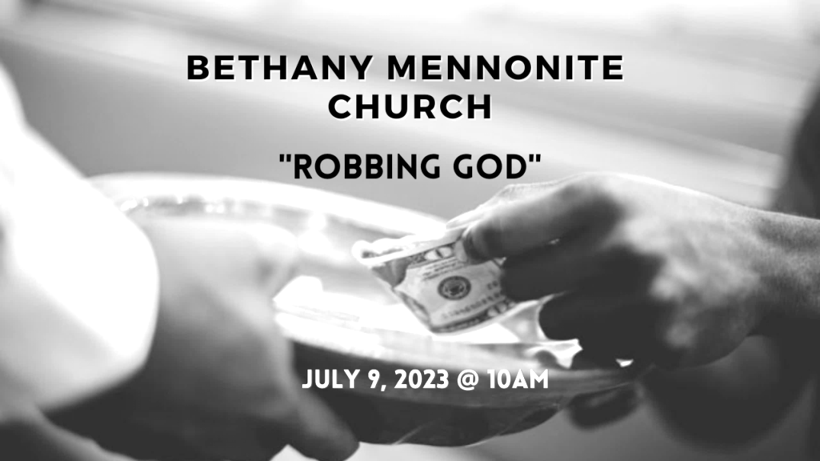

July 9, 2023
572 East & West Line
Box249
Virgil, ON L0S 1T0
905-468-3505
Email: office@bethanymennonite.ca
Website: www.bethanymennonite.ca

59 July 9, 2023 10:00 Service No. 28

Gathering
Prelude
Welcome & Call to Worship Herb Sawatzky
Songs – “Praise to the Lord, the Almighty”
Solo – “O, How I love Jesus”
“Down by the Riverside”
Prayer

Life Together
Announcements
Ministry time
Pastoral Prayer
Solo – “Were you there”
“My Tribute”

Hearing the Word
Scripture – Malachi 3:6-4:5
Solo – “Through it all”
Message – “Robbing God " Herb Sawatzky

Responding
Offering & Prayer

Going
Song – “Great is Thy Faithfulness”
Blessing

Scripture Reader – James Sawatzky
Guest Musicians – Jeremiah Sparks & Susan McVean

Welcome here!
We’re glad you came! Your being here is a sign of God’s love for the world and encourages other Christians. We hope our worship together helps you find
A place to belong and grow in faith.

Praise and Concerns
Prayers:
- Jason Wiebe as he deals with his cancer diagnosis
- Erika Dyck at home
- Sheila Gayman - undergoing cancer treatment
- Our sister church in Pereira, Colombia

A special welcome to our guest singer this morniig, Jeremiah Sparks.

Pastor Herb will be on vacation from July 10-28. Craig Frere will provide crisis Pastoral care. Please contact one of the Pastoral Spiritual Care Team or the office for Craig’s contact info or any concerns.

Bethany Announcements
Monthly Prayer Breakfast - if you are willing to be one of 2-4 people who would coordinate a Monthly Prayer Breakfast (8-9 times a year), please contact pastor Herb Sawatzky at pastor@bethanymennonite.ca. The Coordinating Team will not do the work themselves, but bring in others to help and participate.

Bethany Mennonite Church is going to a ball game again! We have tickets to a Welland Jackfish baseball game, on Sat. Aug. 19, at 6:05 p.m. Please contact Patty King, to reserve your tickets and to arrange payment. Carpooling can be arranged for those who may be interested.

Local Food Bank Drive: Area food banks inform us that donations are down 30% this year while need is up 20%! Your continued support for our food drive to local food banks is much appreciated. Please drop off your donations in the food bin at the front door. Foods and snacks for breakfasts and school lunches are especially appreciated.

Our Donations Touching Lives

You can make your offering to Bethany by:
• E-transfer to office@bethanymennonite.ca
• Mail to church at Box 249, Virgil, ON L0S 1T0
• Drop in the mailbox beside the front door on Wednesdays or Thursdays 8:30-3:30 and let Marianne know.
• Canada Helps button on www.bethanymennonite.ca. CanadaHelps charges 3.75% of the donation, but you will be receipted for full amount.

Prayers:
Mennonite Church Eastern Canada
- Pray with the Bible Missionary Church (Mennonite) in Myanmar as they continue to face many difficulties in daily life including access to health care. Pray for healing, wisdom, and peace for Amos Chin, chair of BMC and his family.

- Join us in praying with the Kimia congregation in Kinshasa (part of the Mennonite Community of the Congo). City authorities destroyed part of its sanctuary after deciding to bulldoze buildings in the area. The decision came despite the congregation holding legal documents showing its purchase of the land and permission to build. Pray that God will touch the hearts of the government authorities who are handling this situation and that they will recognize the congregation's legal right to its land and building.

- Pray for Anika Reynor (Home Street Mennonite, MB) as she embarks on a summer fieldwork project, a critical initiative with potential to advance efforts at building connections between Maya Indigenous and Mennonite Settler communities on the Yucatán Peninsula.

- Pray for those who are living in an area impacted by war. May we learn to be channels of God's peace.

Mennonite Central Committee
- Please pray for the people in communities on the James Bay Coast in northern Ontario who are facing evacuation, health concerns and possible loss of electricity due to increasingly dangerous forest fires. The community of Fort Albany has already evacuated most residents and the nearby communities of Kashechewan and Attawapiskat face threats to the lines that provide power to their communities. The Cree people of James Bay region are strong, and they have survived many challenges – and they need our prayers right now.

Mennonite Church
The temporary "What they Carried" exhibit commemorating the 100th anniversary of the immigration of the Russlaender Mennonites to Ontario in the 1920s will be available for viewing next week from Tuesday July 11 to Thursday July 13 at the Milton Good Library at Conrad Grebel University College, 8:30 am - 4:30 pm. The exhibit features artefacts of that time from various family collections. For more information, contact Archivist Laureen Harder-Gissing, lharderg@uwaterloo.ca.

Ontario Mennonite Music Camp takes place at Conrad Grebel University College in Waterloo, ON from August 13 to 25. OMMC is open to students of all musical abilities. It costs $1400 to attend camp for two weeks, but there are bursaries available based on need. Applications will be accepted until August 1. Please register at: https://uwaterloo.ca/grebel/2023-ommc-registration-form

The Abner Martin Music Scholarship ($4,000 value last year) is awarded annually by Menno Singers to a student who: 1) will be enrolled in a full-time music major or minor program at the undergraduate or graduate level in 2023-2024); 2) is affiliated with an MCEC congregation; and 3) has demonstrated involvement and proficiency in musical activities in church and community. Application deadline is September 15, 2023. For more information and/or an application form contact Lewis Brubacher, lbrubacher@sympatico.ca.

Silver Lake Mennonite Camp
Fall Retreats – Registration now open for a wide variety of fun retreats coming up this fall including: Labour Day Weekend Retreat (Sep 1-3), Men’s Retreat (Sep 15-17), Bruce Trail Hike (Sep 18-21), Fall Hike Retreat (Sep 29-Oct 1), Fall Work Weekend (Oct 27-29). Click here for more info… slmc.ca/retreats
Overnight Camps – There are still spots available for SLMC overnight camps and outtrips and we welcome last minute registrations! Go to slmc.ca/summer-camp to see what’s available.
Stay Connected – Follow SLMC on Instagram (@silverlakemennonite) and Facebook to stay up to date on what’s happening at camp and see recent photos!

Broader Church & Community
Glenridge Bible Church at 310 Scott Street invites you to their Sunday, July 9th “Divinity Trio” concert at 6:30 p.m. Pie and coffee is served in the Fireside Room at 5:30 if interested.

THIS WEEK AT BETHANY
July 9-16, 2023

Today 10:00 a.m. – Worship Service
Sunday 10:00 a.m. – Worship Service

Speaking: Diamond Tam
Special guests: Soli Deo Gloria Choir

Worship services are recorded live and kept on our youtube channel indefinitely. Recordings begin shortly before 10am and end after 11:04. Those who prefer not to appear in the recording are encouraged to sit near the back of the sanctuary in front of the cry room, and exit through the door on that side.

