A place to belong and grow in faith

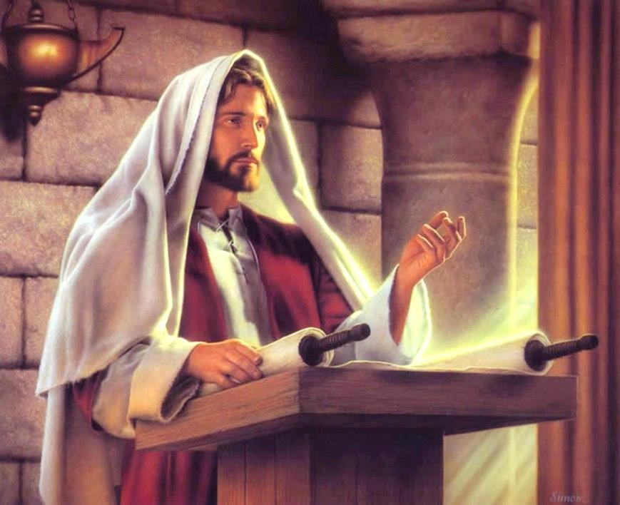

July 30, 2023
572 East & West Line
Box249
Virgil, ON L0S 1T0
905-468-3505
Email: office@bethanymennonite.ca
Website: www.bethanymennonite.ca

59 July 30, 2023 10:00 Service No. 31

Gathering
Prelude
Welcome & Call to Worship Kenton Janzen
Songs – Mountain of God
Wonderful Grace of Jesus
Prayer

Life Together
Announcements
Ministry time
Pastoral Prayer
Song – Seek Ye First

Hearing the Word
Scripture – Matthew 6:33, Luke 4: 16-21
Message – “Kingdom Priorities: First Things First”
Dave Roberts

Responding
Song – Build Your Kingdom Here
Offering & Prayer

Going
Song – Will You Come and Follow Me
Blessing

Scripture – Helmut Weier
Musicians – Kenton & Sheryl Janzen & friends

Welcome here!
We’re glad you came! Your being here is a sign of God’s love for the world and encourages other Christians. We hope our worship together helps you find
A place to belong and grow in faith.

Praise and Concerns
Prayers:
- Kim Salierno as she deals with breast cancer
- Jason Wiebe as he recovers at home
- Erika Dyck at home
- Sheila Gayman - undergoing cancer treatment
- Our sister church in Pereira, Colombia

Our prayers and sympathies are extended to the family of Nestor Chemerika who passed away July 25.

Bethany Announcements
Office Hours: Marianne is on vacation this week. Sheryl Janzen will be in the office on Tuesday and Friday from 8:30-3:00.

Attention all Coyotes, Badgers, Millennials, etc. We will be meeting throughout the summer months at the following locations. Please bring a dessert and join us at 7:00pm at the home of Brian Collins and Amanda Demers on August 9th for an evening of lawn games (croquet, pétanque, bocce, Mölkky), traditional accompanying beverages, and music from the ‘80s and ‘90s, at Linda Van Bergen’s on August 24th, and Mike & Tracey Frena’s on August 30^{th.}

Midsummer Gathering at Church. The entire congregation is invited to come for an evening of fellowship and desserts on the church lawn on August 16 at 6:30 pm. (In case of rain, we will move inside). Please bring a dessert to share and a lawn chair. Drinks will be provided. Propane fire pits are also welcome.

Monthly Prayer Breakfast - if you are willing to be one of 2-4 people who would coordinate a Monthly Prayer Breakfast (8-9 times a year), please contact pastor Herb Sawatzky at pastor@bethanymennonite.ca. The Coordinating Team will not do the work themselves, but bring in others to help and participate.

Local Food Bank Drive: Area food banks inform us that donations are down 30% this year while need is up 20%! Your continued support for our food drive to local food banks is much appreciated. Please drop off your donations in the food bin at the front door. Foods and snacks for breakfasts and school lunches are especially appreciated.

Calling All Treble Voices!
Hello, Bethany Friends! We’re looking forward to our joint worship service at NUMC on Sunday August 13th. We’re putting together a ladies choir for the 13th, and we’d love to have you join us! Mark your calendars for the rehearsal on Thursday August 10th at 7:00 in the sanctuary at Niagara. We look forward to an energizing and joy-filled evening rehearsal! Hope to see you there!
-Rachael (Pellitteri) Peters and Ruth Willms

Friends of the Mennonite Centre Ukraine Newsletter Summer 2023 is on the bulletin board in the Foyer.

New letter from church in Pereira is on the bulletin board in the Foyer.

You can make your offering to Bethany by:
• E-transfer to office@bethanymennonite.ca
• Mail to church at Box 249, Virgil, ON L0S 1T0
• Drop in the mailbox beside the front door on Wednesdays or Thursdays 8:30-3:30 and let Marianne know.
• Canada Helps button on www.bethanymennonite.ca. CanadaHelps charges 3.75% of the donation, but you will be receipted for full amount.

Prayers:
Mennonite Church Eastern Canada
- Join the Africa Inter-Mennonite Mission group of churches in praying for the Evangelical Mennonite Church of Burkina Faso. Violent attacks and political unrest continue in the country. Pray that our brothers and sisters there will know how best to create space for peace in their local communities, especially in the Kénédougou region. Thank God for their witness and for God's provision and protection during this challenging time.

- The MC Canada Palestine-Israel Network calls us to pray. The last weeks in the Israeli-occupied West Bank have been marked by a rise in violence due to growing Israeli settlements and military control. Pray for the safety of Palestinians who live in fear of attacks and harassment. Pray too for the minority Christian communities of the land, that they may be strong and united in their witness to the hope, justice, and peace of the gospel.

- Continue to pray for those who are living in areas impacted by war. We pray using the words of Psalm 13: "How long O Lord? Will you forget me forever? But I have trusted in your steadfast love; my heart shall rejoice in your salvation."

Mennonite Central Committee
- Please pray for MCC SALTers, Katie Janzen & Jeremiah McCleary, as they are preparing to return from their overseas placements this month. Pray as they navigate the journey of processing their experience and discovering what’s next. Pray for wisdom and peace as they find ways to communicate their growth and learnings to those back home.

• We are thankful that, when leaving prison, our restorative justice participants have been able to find housing, employment and connections in the community to feel they belong.

Mennonite Church
Join the MCC team! New! We're hiring for three positions - an Associate Retail at the Care & Share Thrift Shop in Stouffville, a Production Manager at Thrift on Mill in Leamington and a Restorative Communities and Supportive Housing Team Lead in Kitchener. Learn more about these positions at mcco.ca/serve.

Resettlement info session: Welcoming the stranger
August 15, 2023 from 7:00pm to 8:00pm, Online
Our Blended Visa Office-Referred (BVOR) program allows friends, family, churches and community groups the opportunity to resettle refugees into their communities with financial assistance from the government. You’re invited to learn more about the BVOR program and the profound impact you could have in welcoming the stranger in the upcoming information session. To register, visit mcco.ca/events for details.

Broader Church & Community
Virtual Worship Service - Worship with CMU: “Bless the Lord, O My Soul” is now available for download, to be used for church worship services or personal devotion. It includes a personal, moving sermon by Dan Epp-Thiessen, who weaves together his personal journey with cancer and deep hardship with the praise of Psalm 103. View the service at youtu.be/KkONjAvlb4Y.

THIS WEEK AT BETHANY
July 30-August 6, 2023

Today 10:00 a.m. – Worship Service
Sunday 10:00 a.m. – Worship Service

Speaking: Herb Sawatzky
Theme: Emancipation Day Weekend

Worship services are recorded live and kept on our youtube channel indefinitely. Recordings begin shortly before 10am and end after 11:04. Those who prefer not to appear in the recording are encouraged to sit near the back of the sanctuary in front of the cry room, and exit through the door on that side.

