A place to belong and grow in faith

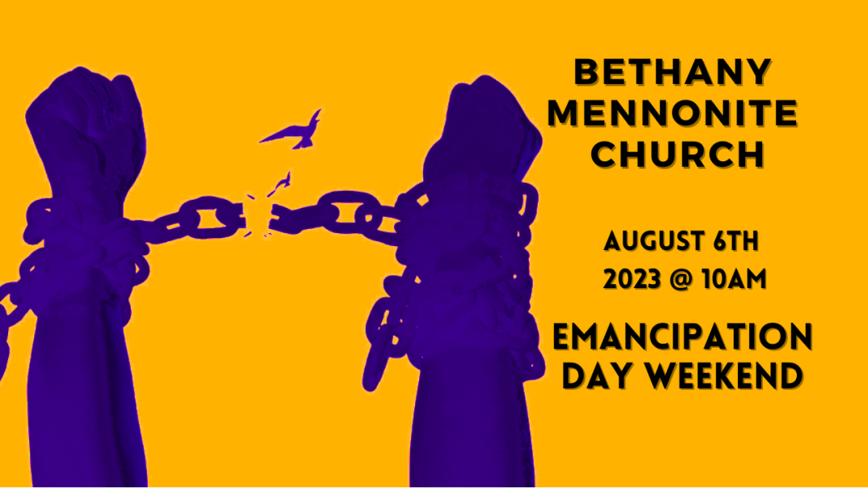

August 6, 2023
572 East & West Line
Box249
Virgil, ON L0S 1T0
905-468-3505
Email: office@bethanymennonite.ca
Website: www.bethanymennonite.ca

59 August 6, 2023 10:00 Service No. 32

Gathering
Prelude
Welcome & Call to Worship Herb Sawatzky
Songs – Goodness of God
God is So Good
Prayer

Life Together
Announcements
Ministry time
Pastoral Prayer
Song – For God so Loved Us #167

Hearing the Word
Scripture – Genesis 1:27; Proverbs 31:8-9
Message – The Story of William Wilbeforce

Responding
Song – Yet not I, but through Christ in Me
Offering & Prayer

Going
Song – All Hail the Power Of Jesus’ Name # 285 v 1, 2, 4
Blessing

Scripture – Lorrie Sawatzky
Musicians – Shirley Dick and Friends

Welcome here!
We’re glad you came! Your being here is a sign of God’s love for the world and encourages other Christians. We hope our worship together helps you find
A place to belong and grow in faith.

Praise and Concerns
Prayers:
- Kim Salierno as she deals with breast cancer
- Jason Wiebe as he recovers at home
- Erika Dyck at home
- Sheila Gayman - undergoing cancer treatment
- Our sister church in Pereira, Colombia

Our prayers and sympathies are extended to the family of Nestor Chemerika who passed away July 25. The funeral will be held on Friday, August 11. The visitation will be from 10 am to 12 pm followed by the funeral at 12 pm. After the Interment at the cemetery, there will be a light lunch at church.

Bethany Announcements
Pastor Herb will be taking some time off this week (although he will be preparing for and leading the funeral on Friday).

Attention all Coyotes, Badgers, Millennials, etc. We will be meeting throughout the summer months at the following locations. Please bring a dessert and join us at 7:00pm at the home of Brian Collins and Amanda Demers on August 9th for an evening of lawn games (croquet, pétanque, bocce, Mölkky), traditional accompanying beverages, and music from the ‘80s and ‘90s, at Linda Van Bergen’s on August 23th, and Mike & Tracey Frena’s on August 30^{th.}

Midsummer Gathering at Church. The entire congregation is invited to come for an evening of fellowship and desserts on the church lawn on August 16 at 6:30 pm. (In case of rain, we will move inside). Please bring a dessert to share and a lawn chair. Drinks will be provided. Propane fire pits are also welcome.

Silver Foxes - Save the date: Wed. Aug.23. More details to follow.

Bethany Mennonite Church is going to a ball game! We have already purchased 20 tickets to a Welland Jackfish baseball game, for Saturday August 19, at 6:05 p.m. Please contact Patty King, to reserve your tickets and to arrange payment of $40 per ticket. Your ticket includes food, beverages and fireworks. Come join the fun! Carpooling can be arranged for those who may be interested.

Local Food Bank Drive: Area food banks inform us that donations are down 30% this year while need is up 20%! Your continued support for our food drive to local food banks is much appreciated. Please drop off your donations in the food bin at the front door. Foods and snacks for breakfasts and school lunches are especially appreciated.

Calling All Treble Voices!
Hello, Bethany Friends! We’re looking forward to our joint worship service at NUMC on Sunday August 13th. We’re putting together a ladies choir for the 13th, and we’d love to have you join us! Mark your calendars for the rehearsal on Thursday August 10th at 7:00 in the sanctuary at Niagara. We look forward to an energizing and joy-filled evening rehearsal! Hope to see you there!
-Rachael (Pellitteri) Peters and Ruth Willms

A copy of the latest Robert’s Digest is available in the church office.

A new letter from our Sister Church in Pereira is on the bulletin board in the foyer.

Our Donations Touching Lives

You can make your offering to Bethany by:
• E-transfer to office@bethanymennonite.ca
• Mail to church at Box 249, Virgil, ON L0S 1T0
• Drop in the mailbox beside the front door on Wednesdays or Thursdays 8:30-3:30 and let Marianne know.
• Canada Helps button on www.bethanymennonite.ca. CanadaHelps charges 3.75% of the donation, but you will be receipted for full amount.

Prayers:
Mennonite Church Eastern Canada
- As Mennonite Church Canada Witness workers Tom and Christine Poovong begin the AMBS Journey program, they will work hard to translate, mentor and study with 15 participants from Thailand and Laos. Pray for wisdom and perseverance in this two-and-a-half-year course and God will build these participants into the next generation of Friends of Grace leaders.

- Pray with Mennonite Church Canada Witness workers Joanne and Werner De Jong as they go through their annual visa/residence permit renewal. Pray for patience, joy and relationship building opportunities in this process. They are spending the next month before seminary courses begin in preparing classes and responding to invitations for short term training and preaching.

- Continue to pray for those who are living in areas impacted by war. We pray using the words of Psalm 13: "How long O Lord? Will you forget me forever? But I have trusted in your steadfast love; my heart shall rejoice in your salvation."

Mennonite Central Committee
- Please pray for MCC SALTers, Katie Janzen & Jeremiah McCleary, as they are preparing to return from their overseas placements this month. Pray as they navigate the journey of processing their experience and discovering what’s next. Pray for wisdom and peace as they find ways to communicate their growth and learnings to those back home.

• We are thankful that, when leaving prison, our restorative justice participants have been able to find housing, employment and connections in the community to feel they belong.

Mennonite Church
Join the MCC team! New! We're hiring for three positions - an Associate Retail at the Care & Share Thrift Shop in Stouffville, a Production Manager at Thrift on Mill in Leamington and a Restorative Communities and Supportive Housing Team Lead in Kitchener. Learn more about these positions at mcco.ca/serve.

Resettlement info session: Welcoming the stranger
August 15, 2023 from 7:00pm to 8:00pm, Online
Our Blended Visa Office-Referred (BVOR) program allows friends, family, churches and community groups the opportunity to resettle refugees into their communities with financial assistance from the government. You’re invited to learn more about the BVOR program and the profound impact you could have in welcoming the stranger in the upcoming information session. To register, visit mcco.ca/events for details.

MCEC
MCEC Seeks an Operations and Finance Director. Are you a strategic and collaborative leader with experience leading Finance and at least one of the other key Operations functions of general Operations, Human Resources, Risk Management, Information Technology and/or Communications? Join the MCEC staff team in Kitchener, ON. More information at mcec.ca.

Join the MCEC Video Challenge! How are you or your congregation being transformed? Where is your inspiration coming from? What do you feel called into? Make your own short video sharing what you and your congregation are excited about. More information at mcec.ca.

MCEC Pastor's Retreat, September 28, 2023, 9 a.m to 3:30 p.m., Ingersoll, ON. A day for pastors and chaplains to set aside for retreat, encouragement and rejuvenation. Consider gifting this day to your pastor or chaplain. Registration is open at mcec.ca.

MCEC Urban Anabaptist Church Planters Workshop, September 30, 2023, 10 a.m. to 4 p.m., Ottawa, ON. Tent making: Opportunities and Challenges for Developing Congregations with James Watson. A day of worship and prayer for church planters and pastors focused on tent making or multi-vocational ministry. Registration is open at mcec.ca.

Mennonite Church Canada announces an Emissions Reduction Grant available to all MC Canada congregations. MC Canada will provide grants to congregations wishing to upgrade their facilities with the goal of reducing greenhouse gas emissions (GHG). Applications for up to 50% (to a max. of $6000) of the cost of reducing their church building’s carbon footprint are now being accepted. More info and application available at https://www.mennonitechurch.ca/mc-canada-emissions-reduction-grant. Application Deadline: September 30.

Broader Church & Community
Virtual Worship Service - Worship with CMU: “Bless the Lord, O My Soul” is now available for download, to be used for church worship services or personal devotion. It includes a personal, moving sermon by Dan Epp-Thiessen, who weaves together his personal journey with cancer and deep hardship with the praise of Psalm 103. View the service at youtu.be/KkONjAvlb4Y.

Update Grow Hope Niagara - This year we are not planning a field tour. You are welcome to do a drive by on Tintern road and Bethesda road, near Campden. You will see the sign there identifying the farm. But, there is an event being planned for October 15 - "Celebrating 40 Years of CFGB" – at Vineland United Mennonite Church 4024 23rd street, Vineland. This will be a celebration evening and fund raising event. It will begin at 5:30 with a simple meal indicative of modest food supplies abroad, hopefully a pie auction, and some comments from the executive director of Canadian Food Grains Bank, Andy Harrington. Some of these details will be further refined as we plan but you can mark this on your calendars for the 40 year CFGB commemorations. See bulletin board in foyer for more information and pictures.

THIS WEEK AT BETHANY
August 6 – 13, 2023

Today 10:00 a.m. – Worship Service
Sunday 10:00 a.m. – Joint Worship Service at Niagara United Mennonite Church

Worship services are recorded live and kept on our youtube channel indefinitely. Recordings begin shortly before 10am and end after 11:04. Those who prefer not to appear in the recording are encouraged to sit near the back of the sanctuary in front of the cry room, and exit through the door on that side.

