A place to belong and grow in faith

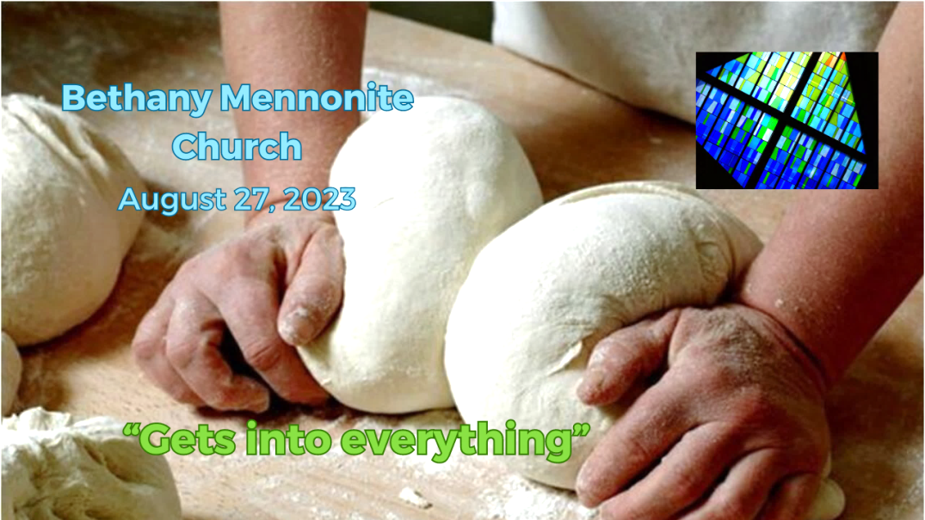

August 27, 2023

572 East & West Line
Box249
Virgil, ON L0S 1T0
905-468-3505
Email: office@bethanymennonite.ca
Website: www.bethanymennonite.ca

59 August 27, 2023 10:00 Service No. 35

Gathering
Prelude
Welcome & Call to Worship Herb Sawatzky
Songs – “How Great is Our God”
“We Praise You, Oh God”
Prayer

Life Together
Announcements
Ministry time
Pastoral Prayer
Song – “Lord, You Sometimes Speak”

Hearing the Word
Scripture – Matthew 13:31-33
Message – “Gets into everything”” Herb Sawatzky

Responding
Song – “We Walk by Faith”
Offering & Prayer

Going
Song – “You Are the Salt of the Earth”
Blessing

Scripture Reader – Denise Horne
Musicians – Kenton & Sheryl Janzen & friends

Welcome here!
We’re glad you came! Your being here is a sign of God’s love for the world and encourages other Christians. We hope our worship together helps you find
A place to belong and grow in faith.

Praise and Concerns
Prayers:
- Dawson King who has a blood clot in his leg
- Kim Salierno daughter to Ted & Syl, as she deals with breast cancer
- Sheila Gayman - undergoing cancer treatment
- Our sister church in Pereira, Colombia

All are invited to join in for cake after the service to celebrate Paul & Joanne Thiessen’s 50th Anniversary!

Bethany Announcements
Office Hours – Sheryl will be in the office for the next two weeks.

Pleasant Manor residents who would like to watch Bethany's worship services online together on Sunday mornings can do so in the Chapel. Pleasant Manor has arranged for the chapel TV to be tuned to Bethany's worship service on Youtube, on Sunday mornings at 10 am.

Attention all Coyotes, Badgers, Millennials, etc. This Wednesday August 30th we are at Mike & Tracey Frena’s at 7:00 p.m. Please bring a dessert.

Local Food Bank Drive: Area food banks inform us that donations are down 30% this year while need is up 20%! Your continued support for our food drive to local food banks is much appreciated. Please drop off your donations in the food bin at the front door. Foods and snacks for breakfasts and school lunches are especially appreciated.

Our Donations Touching Lives

You can make your offering to Bethany by:
• E-transfer to office@bethanymennonite.ca
• Mail to church at Box 249, Virgil, ON L0S 1T0
• Drop in the mailbox beside the front door on Wednesdays or Thursdays 8:30-3:30 and let Marianne know.
• Canada Helps button on www.bethanymennonite.ca. CanadaHelps charges 3.75% of the donation, but you will be receipted for full amount.

Prayers:
Mennonite Church Eastern Canada
- Urgent prayer request from our sister church in Burkina Faso: With the recent coup in Niger, there is threat of war in the Sahel region of Africa. Please join us in praying that this escalation will stop, that peaceful forms of resolution will be found to the crisis in Niger and the other Sahel countries, and that peace will return to this region.

- Iglesia Cristiana Menonita de Colombia celebrated its 75th anniversary in March 2023. Pray that God will continue to lead them into pathways of peace and service for their communities and their country.

- Pray for Community Peacemaker Team's Turtle Island Solidarity Network arrived in Winnipeg, August 15, in anticipation of a 10-member delegation visit to to the Asubpeeschoseewagong Netum Anishinabek (Grassy Narrows First Nation). Pray for important connections and community to be built through this delegation.

Mennonite Central Committee
• Please pray for MCC SALTers heading to their overseas placements this month. Serving and Learning Together (SALT) is a one year overseas service experience for young Christian adults from Canada. This year, Adrian Berrio Klassen will be serving in Guatemala as a Communications and Promotional Assistant with our partner organization Anadesa. Pray that they will be blessed deeply by this opportunity for personal, professional and spiritual growth.

• We are thankful that, when leaving prison, our restorative justice participants have been able to find housing, employment and connections in the community to feel they belong.

Mennonite Church
MCEC Sprout: Stories of Transformation. Have you seen the most recent edition of Sprout? Hard copies are in your mailbox! Discover how God has transformed lives of those in MCEC and around the world. Read about Rachel Demosthene, one of MCEC's newest pastors/church planters. Follow the unexpected paths on which God has led Bock Ki Kim and Sook Kyoung Park, MC Canada Witness workers. Take a glimpse into MCEC Annual Church Gathering this past spring. Download your copy today at mcec.ca.

Silver Lake Mennonite Camp
Registration now open for a wide variety of fun retreats coming up this fall. Click here for more info about the retreats below… slmc.ca/retreats
Labour Day Weekend Retreat (Sep 1-3) – A few rooms still available for this long weekend getaway.
Men’s Retreat (Sep 15-17) – A relaxing weekend away to connect with others and enjoy a variety of fun camp activities. Saturday features a Russian Mennonite dinner with many favourite traditional dishes. Stories and reflections presented by host Mike Schmidt. Contact Don Neufeld if you are interested in going and we can car pool.
Bruce Trail Hike (Sep 18-21) – Join us for a series of short-loop hikes near Owen Sound and learn about the cultural and natural history of the Niagara Escarpment. Accommodations and meals at Silver Lake.
Fall Hike Retreat (Sep 29-Oct 1) – Stay at camp and enjoy a Bruce Trail hike on the Saturday. Everyone welcome, including families.
Fall Work Weekend (Oct 27-29) – Help get camp ready for the winter season!
Stay Connected – Follow SLMC on Instagram @silverlakemennonite and Facebook to stay up to date and see photos from Summer 2023!

MCC, MDS, MEDA
The MDS August edition of On the Level is available from the office.

Broader Church & Community
FIDA Fall Fundraiser for Haiti – Join FIDA at Trevor Falk’s Farm on Wednesday, September 13th from 5:30-9:30 pm. For $100 per person, join host Joe Pillitteri and special guest Lawrence Hill for some wine/beer tasting, a buffet dinner and a live Auction. Reserve your tickets by calling Betsy Wall at 519-588-7967 or email betsy.wall@fida-pch.org.

Wells of Hope presents “Passion Food & Wine Tasting” Fundraiser for Guatemala at Chateau des Charmes on Friday, September 22 from 6:30-10:00 pm. Enjoy good food, wine, beer, music, dancing silent auction and prizes for $100 per person. Purchase tickets at www.niagarapassion.com.

Grow Hope Niagara Update - On October 15 we are celebrating 40 Years of CFGB at Vineland United Mennonite Church, 4024 23rd Street. This will be a celebration evening and fund-raising event. It will begin at 5:30 with a simple meal indicative of modest food supplies abroad, hopefully a pie auction, and some comments from the executive director of Canadian Food Grains Bank, Andy Harrington. More details to come. Please donate at https://donate.mcccanada.ca/cause/ontario-grow-hope-niagara . All donations to Grow Hope Niagara are matched by the Federal Government 4:1.

THIS WEEK AT BETHANY
August 27-September 3, 2023

Today 10:00 a.m. – Worship Service
Wednesday 7:00 p.m. – Coyotes, Badgers, Millennials @ Mike &
Tracey Frena’s house
Sunday 10:00 a.m. – Worship Service

Speaking: Herb Sawatzky
Theme: Hiding treasure; finding pearls
Scripture: Matthew 13:44-45

Worship services are recorded live and kept on our youtube channel indefinitely. Recordings begin shortly before 10am and end after 11:04. Those who prefer not to appear in the recording are encouraged to sit near the back of the sanctuary in front of the cry room, and exit through the door on that side.

