A place to belong and grow in faith

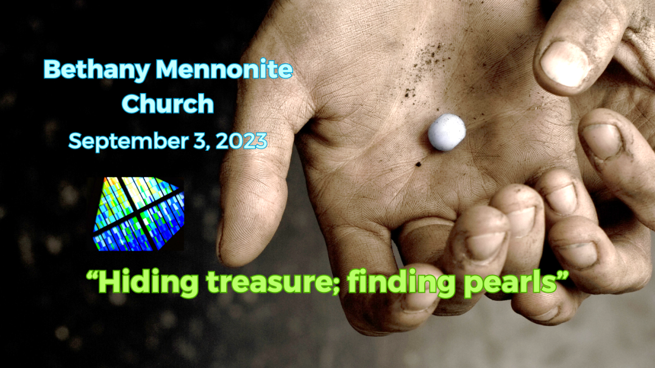

September 3, 2023

572 East & West Line
Box249
Virgil, ON L0S 1T0
905-468-3505
Email: office@bethanymennonite.ca
Website: www.bethanymennonite.ca

59 September 3, 2023 10:00 Service No. 36

Gathering
Prelude
Welcome & Call to Worship Herb Sawatzky
Songs – “Come, Let Us All Unite to Sing” HWB # 12
“Come, Now is the Time to Worship”
Prayer

Life Together
Announcements
Ministry time
Pastoral Prayer
Song – “Jesus, Priceless Treasure” HWB # 595

Hearing the Word
Scripture – Matthew 13:44-45
Message – “Hiding treasure; finding pearls” Herb Sawatzky

Responding
Song – “Build Your Kingdom Here”
Offering & Prayer

Going
Song – “Sing a New World Into Being”
Blessing

Scripture Reader – Kathryn Walker
Musicians – Gayle Neufeld & friends

Welcome here!
We’re glad you came! Your being here is a sign of God’s love for the world and encourages other Christians. We hope our worship together helps you find
A place to belong and grow in faith.

Praise and Concerns
Prayers:
- Dawson King who has a blood clot in his leg
- Kim Salierno daughter to Ted & Syl, as she deals with breast cancer
- Sheila Gayman - undergoing cancer treatment
- Our sister church in Pereira, Colombia

Bethany Announcements
Office Hours – Sheryl will be in the office this week.

Coffee Time is back next week, but we need volunteers to help make the coffee. Please sign up on the sheet in the kitchen.

Soup Lunch - Come enjoy a “soup group lunch” experience at Bethany on Sept. 17. Registration forms to sign up for new Soup Groups will be available at the lunch. If you’d like to make a pot of soup to share please let Linda, Anne or Patty know.

Local Food Bank Drive: Area food banks inform us that donations are down 30% this year while need is up 20%! Your continued support for our food drive to local food banks is much appreciated. Please drop off your donations in the food bin at the front door. Foods and snacks for breakfasts and school lunches are especially appreciated.

Our Donations Touching Lives
You can make your offering to Bethany by:
• E-transfer to office@bethanymennonite.ca
• Mail to church at Box 249, Virgil, ON L0S 1T0
• Drop in the mailbox beside the front door on Wednesdays or Thursdays 8:30-3:30 and let Marianne know.
• Canada Helps button on www.bethanymennonite.ca. CanadaHelps charges 3.75% of the donation, but you will be receipted for full amount.

Prayers:
Mennonite Church Eastern Canada
• Pray for all levels of government to collaboratively work together on funding for community programs like Circles of Support and Accountability (CoSA) that support individuals returning from prison.

• We give praise for eight sponsoring groups who have welcomed 27 newcomers over the last three months. May these newcomers experience love, peace and belonging in their new community of settlement.

• Please pray for refuges waiting for the Canadian resettlement process to unfold, who fear deportation in their countries of asylum and for those dealing with diplomatic and political bureaucracies related to exit permits.

• Pray for the millions around the world affected by political unrest and humanitarian crises in their home countries.

• We are thankful that, when leaving prison, our restorative justice participants have been able to find housing, employment and connections in the community to feel they belong.

- Please pray for Mississauga Mennonite Fellowship who have made the decision to close their congregation. We thank God for the ministry of this congregation who came together in 1981 to provide a Mennonite Anabaptist presence in Mississauga. Pray for their members in this transition and for the many people who have been impacted by their ministry throughout the years. The congregation officially closes August 31.

- Please pray for MCEC as we seek someone to fill the key leadership position of Operations and Finance Director. Pray for those who view and apply to the opportunity, those involved in the interview process and for the individual who will accept the call to this position. We ask for God’s wisdom and leading.

- Northeast Asia is an area of the world where the potential for armed conflict is growing. Bock Ki Kim and Sook Kyoung Park, Witness workers in South Korea, see signs of this in their country and their community. Join with them in prayers for peace as they work for peaceful resolution of conflict in homes, schools, communities and churches.

- Pray for Phim and Joseph Poovong, children of Witness workers, Christine and Tom Poovong. Phim and Joseph have only dim memories of life in Canada. Growing up in Thailand, Thai and Issan language and culture are their home. As they think about traveling to Canada for a visit next spring, they are already anticipating embracing the Canadian part of their identity, including brushing up on street hockey ball. Pray for them as they grow up with the blessings and challenges of multiple cultures and languages.

Mennonite Church
MCEC Sprout: Stories of Transformation. Have you seen the most recent edition of Sprout? Hard copies are in your mailbox! Discover how God has transformed lives of those in MCEC and around the world. Read about Rachel Demosthene, one of MCEC's newest pastors/church planters. Follow the unexpected paths on which God has led Bock Ki Kim and Sook Kyoung Park, MC Canada Witness workers. Take a glimpse into MCEC Annual Church Gathering this past spring. Download your copy today at mcec.ca.

Children’s Storybook Bible – We’re thrilled to announce The Peace Table, MennoMedia’s new storybook Bible for grades 1-5. A large team of Anabaptist authors, illustrators, and church leaders collaborated to create this rich and diverse retelling of key biblical stories that highlight the central theme of peace in the Bible. For a short video introduction, visit commonword.ca/go/3564/ or to purchase or borrow, visit commonword.ca/go/3344/.

Silver Lake Mennonite Camp
Men’s Retreat (Sep 15-17) – A relaxing weekend away to connect with others and enjoy a variety of fun camp activities. Saturday features a Russian Mennonite dinner with many favourite traditional dishes. Stories and reflections presented by host Mike Schmidt. Contact Don Neufeld if you are interested in going and we can car pool.
Fall Work Weekend (Oct 27-29) – Help get camp ready for the winter season!
Stay Connected – Follow SLMC on Instagram @silverlakemennonite and Facebook to stay up to date and see photos from Summer 2023!

MCC, MDS, MEDA
Resettlement info session: Welcoming the stranger
September 14, 2023 from 7:00pm to 8:00pm, Online
Our Blended Visa Office-Referred (BVOR) program allows friends, family, churches and community groups the opportunity to resettle refugees into their communities with financial assistance from the government. You’re invited to learn more about the BVOR program and the profound impact you could have in welcoming the stranger in the upcoming information session. To register, visit mcc.org/events for details.

Offices and Thrift Shops closed on Monday, Sept. 25
All MCC Ontario office and thrift shops will be closed on Monday, Sept. 25 to recognize the National Day for Truth and Reconciliation. Learning resources are available on our website.

MCC Ontario Annual General Meeting
September 25, 2023 from 7:00-8:30pm, Online
We deeply appreciate your support, and how you are impacting so many lives in Ontario and around the world. Join us on September 25 for our Annual General Meeting (AGM) as we share MCC Ontario's financial outcomes and a snapshot of our strategic plan progress. Official Congregational Representatives and Delegates who register as such are entitled to vote. Visit mcco.ca/AGM for details.

Broader Church & Community
FIDA Fall Fundraiser for Haiti – Join FIDA at Trevor Falk’s Farm on Wednesday, September 13th from 5:30-9:30 pm. For $100 per person, join host Joe Pillitteri and special guest Lawrence Hill for some wine/beer tasting, a buffet dinner and a live Auction. Reserve your tickets by calling Betsy Wall at 519-588-7967 or email betsy.wall@fida-pch.org.

Wells of Hope presents “Passion Food & Wine Tasting” Fundraiser for Guatemala at Chateau des Charmes on Friday, September 22 from 6:30-10:00 pm. Enjoy good food, wine, beer, music, dancing silent auction and prizes for $100 per person. Purchase tickets at www.niagarapassion.com.
Canadian Mennonite is evolving. You can read about it in Tobi Thiessen’s August 25 editorial. Help shape the next chapter by completing their survey. Go to www.surveymonkey.com/r/CM_mag_ideas.

THIS WEEK AT BETHANY
September 3-10, 2023

Today 10:00 a.m. – Worship Service
Sunday 10:00 a.m. – Worship Service

Speaking: Herb Sawatzky
Theme: Healing, Wholeness, and Hope
Scripture: Mark 5:21-43

