A place to belong and grow in faith

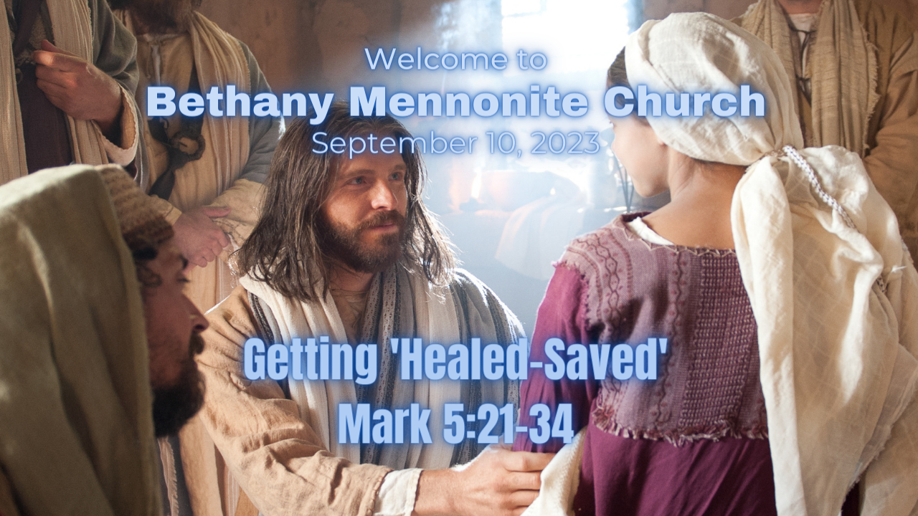

September 10, 2023

572 East & West Line
Box249
Virgil, ON L0S 1T0
905-468-3505
Email: office@bethanymennonite.ca
Website: www.bethanymennonite.ca

59 September 10, 2023 10:00 Service No. 37

Gathering
Prelude
Welcome & Call to Worship Herb Sawatzky
Songs – “Still”
“Be Still and Know”
Prayer

Life Together
Announcements
Ministry time
Pastoral Prayer
Song – “Lord, Help Me Keep My Life in Balance”

Hearing the Word
Scripture – Mark 5:21-34
Children’s Story Video
Message – “Getting ‘Healed-Saved’” Herb Sawatzky

Responding
Song – “He Touched Me”
Offering & Prayer

Going
Song – “You Shall Go Out With Joy” HWB #427
Blessing

Scripture Reader – Julia Klassen
Musicians – Shirley Dick and Friends

Welcome here!
We’re glad you came! Your being here is a sign of God’s love for the world and encourages other Christians. We hope our worship together helps you find
A place to belong and grow in faith.

Praise and Concerns
Prayers:
- Dawson King receiving treatment for a blood clot in his leg
- Kim Salierno daughter to Ted & Syl, receiving treatment for breast cancer
- Sheila Gayman - undergoing cancer treatment
- Our sister church in Pereira, Colombia

Bethany Announcements
Spiritual Formation Opportunities Today:
- 10:00 Worship Service
- 11:10 Sr Youth & Young Adults Sunday School – Youth room
- 11:10 Adult Sunday School in the Library

Coffee Time is back next week, but we need volunteers to help make the coffee. Please sign up on the sheet in the kitchen.

Soup Lunch - Come enjoy a “soup group lunch” experience at Bethany on Sept. 17. Registration forms to sign up for new Soup Groups will be available at the lunch. If you’d like to make a pot of soup to share please let Linda, Anne or Patty know.

Empowering Parents in the Digital Age - an evening with Paul Davis. The internet is an incredible tool, but it is also a dangerous place for kids. At this seminar Paul Davis will give parents, grandparents, and guardians some of the tools we need to navigate the challenges of parenting in the digital age. November 4th, 6:30pm, at Bethany Mennonite Church.

Neurographic Art – Thursday, Sep 28th from 6-8 PM at Bethany. Neurographic Art is a therapeutic form of art that creates a mindful, meditative, yet aware state through the creation of new neural connections. The idea is to focus on an issue or question while working
on an artwork to help direct your neurons to enhance your ability to problem solve and make decisions. Presented by Niagara North Family Health Team. Call 289-272-0180 to register

Local Food Bank Drive: Area food banks inform us that donations are down 30% this year while need is up 20%! Your continued support for our food drive to local food banks is much appreciated. Please drop off your donations in the food bin at the front door. Foods and snacks for breakfasts and school lunches are especially appreciated.

You can make your offering to Bethany by:
• E-transfer to office@bethanymennonite.ca
• Mail to church at Box 249, Virgil, ON L0S 1T0
• Drop in the mailbox beside the front door on Wednesdays or Thursdays 8:30-3:30 and let Marianne know.
• Canada Helps button on www.bethanymennonite.ca. CanadaHelps charges 3.75% of the donation, but you will be receipted for full amount.

Prayers:
Mennonite Church Eastern Canada
- Please pray for MCEC as we seek someone to fill the key leadership position of Operations and Finance Director. Pray for those who view and apply to the opportunity, those involved in the interview process and for the individual who will accept the call to this position. We ask for God’s wisdom and leading.

Mennonite Church
Silver Lake Mennonite Camp
Registration now open for a wide variety of fun retreats coming up this fall. Click here for more info about the retreats below… slmc.ca/retreats
Men’s Retreat (Sep 15-17) – A relaxing weekend away to connect with others and enjoy a variety of fun camp activities. Saturday features a Russian Mennonite dinner with many favourite traditional dishes. Stories and reflections presented by host Mike Schmidt.

MCC, MDS, MEDA
Offices and Thrift Shops closed on Monday, Sept. 25
All MCC Ontario office and thrift shops will be closed on Monday, Sept. 25 to recognize the National Day for Truth and Reconciliation. Learning resources are available on our website.

Resettlement info session: Welcoming the stranger
September 14, 2023 from 7:00pm to 8:00pm, Online
Our Blended Visa Office-Referred (BVOR) program allows groups the opportunity to resettle refugees into their communities with financial assistance from the government. You’re invited to learn more about the BVOR program in the upcoming information session. To register, visit mcc.org/events for details.

MCC Ontario Annual General Meeting
September 25, 2023 from 7:00-8:30pm, Online
We deeply appreciate your support, and how you are impacting so many lives in Ontario and around the world. Join us on September 25 for our Annual General Meeting (AGM) as we share MCC Ontario's financial outcomes and a snapshot of our strategic plan progress. Official Congregational Representatives and Delegates who register as such are entitled to vote. Visit mcco.ca/AGM for details.

Broader Church & Community
FIDA Fall Fundraiser for Haiti – Join FIDA at Trevor Falk’s Farm on Wednesday, September 13th from 5:30-9:30 pm. For $100 per person, join host Joe Pillitteri and special guest Lawrence Hill for some wine/beer tasting, a buffet dinner and a live Auction. Reserve your tickets by calling Betsy Wall at 519-588-7967 or email betsy.wall@fida-pch.org.

Wells of Hope presents “Passion Food & Wine Tasting” Fundraiser for Guatemala at Chateau des Charmes on Friday, September 22 from 6:30-10:00 pm. Enjoy good food, wine, beer, music, dancing silent auction and prizes for $100 per person. Purchase tickets at www.niagarapassion.com.

Xplore – Xplore offers life-long learning courses that investigate dimensions of the Christian faith, our world, and life in it—all without assignments or exams! Join one or more of our offered courses (online). For more information and to register visit cmu.ca/xplore.

The Abner Martin Music Scholarship ($4,000 value last year) is awarded annually by Menno Singers to a student who: 1) will be enrolled in a full-time music in 2023-2024; 2) is affiliated with an MCEC congregation; and 3) has demonstrated involvement in musical activities in church and community. Applications must be received by September 22, 2023. For more information and/or an application form contact Lewis Brubacher, lbrubacher@sympatico.ca, or call him at 519-884-3072.

THIS WEEK AT BETHANY
September 10-17, 2023

Today 10:00 a.m. – Worship Service
Sunday 10:00 a.m. – Worship Service

Speaking: Herb Sawatzky
Theme: Healing, Wholeness, and Hope
Scripture: Mark 5:21-43

Worship services are recorded live and kept on our youtube channel indefinitely. Recordings begin shortly before 10am and end after 11:04. Those who prefer not to appear in the recording are encouraged to sit near the back of the sanctuary in front of the cry room, and exit through the door on that side.

