  - 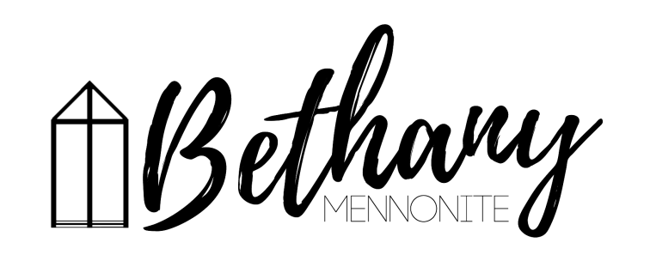
A place to belong and grow in faith

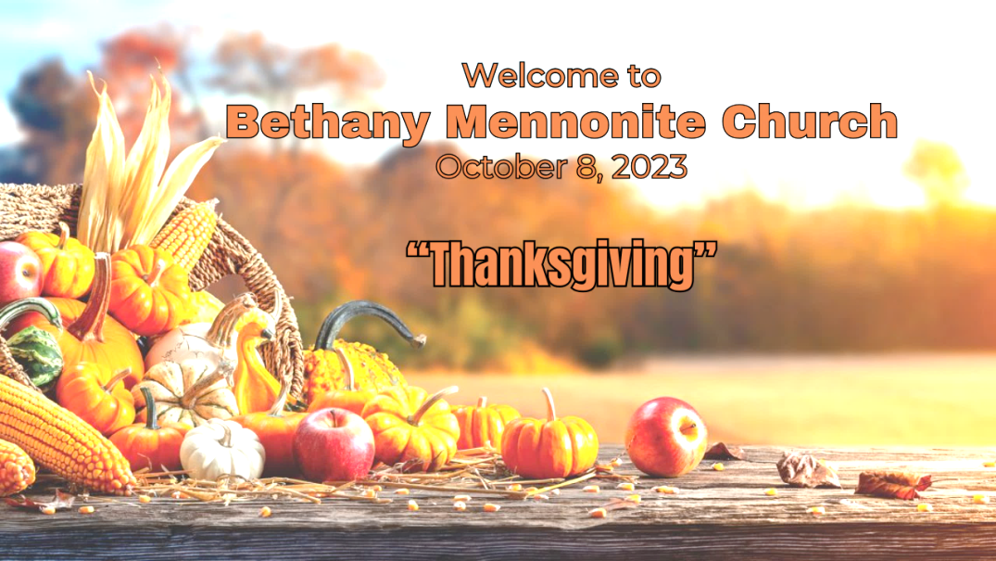

October 8, 2023

572 East & West Line
Box249
Virgil, ON L0S 1T0
905-468-3505
Email: office@bethanymennonite.ca
Website: www.bethanymennonite.ca

59 October 8, 2023 10:00 Service No. 41

Happy Thanksgiving!
Gathering
Prelude
Welcome & Call to Worship Herb Sawatzky
Song – “We Plow the Fields and Scatter”
“Blessed Be Your Name”
Thanksgiving offering of dried goods
Prayer

Life Together
Announcements
Ministry time
Pastoral Prayer
Bell Tree

Hearing the Word
Scripture – 1 Chronicles 29:10-20
Drama
Message – Thankful for a sandwich Herb Sawatzky

Responding
Song – “We Place Upon Your Table”
Communion
Song – “The Goodness of God”
“Great is Thy Faithfulness”
Offering & Prayer

Going
Song – “I Then Will Live”
Blessing

Musicians – Shirley Dick & Friends, Tracey Frena & Gayle Neufeld
Drama – Michael Frena, Colton Sawatzky

Welcome here!
We’re glad you came! Your being here is a sign of God’s love for the world and encourages other Christians. We hope our worship together helps you find
A place to belong and grow in faith.

Praise and Concerns
Prayers:
- Josh Legere (Holly’s husband) recovering from surgery
- Bert Durst - Lorrie Sawatzky's father at Welland Hospital
- Dora Fisch-Willms at Garden City Manor
- Gayle King is dealing with some health concerns
- Kim Salierno daughter to Ted & Syl, receiving treatment for breast cancer
- Sheila Gayman - undergoing cancer treatment
- Our sister church in Pereira, Colombia

On October 7th, Helmut and Sue celebrated their 56th anniversary! Congratulations and all the best.

A Communion Service will be held TODAY. Communion will be served in the pews; prefilled Communion cups are also available. Those worshipping at home are invited to prepare their own bread and cup, and grapes and crackers for your kids. We are all invited to prepare ourselves as we remember Jesus’ sacrifice for us.

For our Thanksgiving Service, on Sunday, October 8th, as a part of our expression of thanks to God, we are asking you to bring a gift of non-perishable food items. These items will be donated to Newark neighbours. There will be a time during the service for these items to be brought forward. If you prefer not to carry these items to the front, someone will be available to take them up for you.

Bethany Announcements
Spiritual Formation Opportunities Today:
- 10:00 Worship Service
- 11:10 No Adult Sunday School
No Youth & Young Adult Sunday School

Bethany Silver Foxes are excited to host a special concert with Eduard Klassen and his wife, Christine, at Bethany Mennonite Church on Wednesday, October 11th at 7:00 p.m. Eduard has been delighting audiences both at home and abroad as he shares his testimony utilizing his wonderful gifts of storytelling and playing the Paraguayan harp. It will be a most enjoyable evening, and we heartily invite everyone to attend. An offering will be taken, and light refreshments will be served after the concert.

Prayer Breakfast - Our first Prayer Breakfast is planned for Thursday, October 26th, 7am at Bethany. Invite friends and neighbours.

Empowering Parents in the Digital Age - a free evening with Paul Davis. The internet is an incredible tool, but it is also a dangerous place for kids. At this seminar Paul Davis will give parents, grandparents, and guardians some of the tools we need to navigate the challenges of parenting in the digital age. November 4th, 6:30pm, at Bethany Mennonite Church. In lieu of tickets please bring a food item to donate to a local food bank. Childcare is available - please register your child by calling the church at 905 468 3505.

Paul Davis child care
If you are able to help out with providing childcare at the Paul Davis event on November 4th, please contact: Dave Dick, Herb, or the office.

The Annual Bethany Bazaar, is scheduled for Saturday November 11 from 10 am until sold out. As per last year brown bread, jars of borscht and baked goods, preserves and quilts will be available for sale in the auditorium. We hope that you can contribute some items to this event. As well, if you are able, we need helpers on the day of the sale such as greeters, cashiers, traffic directors, setting up and cleaning up. Many hands make light work. We appreciate the help you are able to offer. Please let Linda Van Bergen or Pat Andres know by phone or email if you can volunteer your time or for any other information.

Vineridge Academy Conversation Club - If you are interested in being a part of an English conversation group with foreign students at Vineridge Academy on Friday afternoons, please contact Herb, or the office.

Voices Together Hymnal. If you are interested in the new Voices Together Hymnal that the worship team often uses, please contact Kenton or Sheryl or the church office by October 31. The cost is $38.00 plus taxes and shipping. However, the more hymnals ordered together, the lower the shipping cost per book.
Local Food Bank Drive: Area food banks inform us that donations are down 30% this year while need is up 20%! Your continued support for our food drive to local food banks is much appreciated. Please drop off your donations in the food bin at the front door. Foods and snacks for breakfasts and school lunches are especially appreciated.

Our Donations Touching Lives

You can make your offering to Bethany by:
• E-transfer to office@bethanymennonite.ca
• Mail to church at Box 249, Virgil, ON L0S 1T0
• Drop in the mailbox beside the front door on Wednesdays or Thursdays 8:30-3:30 and let Marianne know.
• Canada Helps button on www.bethanymennonite.ca. CanadaHelps charges 3.75% of the donation, but you will be receipted for full amount.

Prayers:
Mennonite Church Eastern Canada
- Please pray for Cassel Mennonite Church. Wanda Roth Amstutz provides pastoral leadership for the congregation. Cassel is a rural church community that seeks to follow Christ in ways of peace, love and justice. Pray for them as they serve the needs of their community.
- Pray for John Head, MCEC Interim Operations and Finance Director, as he begins his ministry with MCEC.

Mennonite Central Committee
• Pray for all levels of government to collaboratively work together on funding for community programs like Circles of Support and Accountability (CoSA) that support individuals returning from prison.

• We give praise for eight sponsoring groups who have welcomed 27 newcomers over the last three months. May these newcomers experience love, peace and belonging in their new community of settlement.

• Please pray for refugees waiting for the Canadian resettlement process to unfold, who fear deportation in their countries of asylum and for those dealing with diplomatic and political bureaucracies related to exit permits.

• Pray for the millions around the world affected by political unrest and humanitarian crises in their home countries.

• We are thankful that, when leaving prison, our restorative justice participants have been able to find housing, employment and connections in the community to feel they belong.
Mennonite Church
Help Build a Future of Peace in Mindanao - Join MCEC, Joji Pantoja (MC Canada Witness Worker), Ka Boyet Ongkiko and Tala Bautista from the Philippines on their information and fundraising tour in Ontario October 17, 2 - 4:30 p.m., MCEC 50 Kent Ave., Kitchener. Discover and be a part of the exciting final stages of a transition plan from MC Canada Witness to Tala and Boyet's capable leadership as the younger, Indigenous generation. Light refreshments will be served. More information at mcec.ca.

Silver Lake Mennonite Camp Fall Work Weekend (Oct 27-29) – Help get camp ready for the winter season! Registration is still open for a couple of fun retreats this fall. Click here for more info about the retreats … slmc.ca/retreats

Hidden Acres’ 3rd Rally for Recreation is happening October 27-29. Will you join us in raising funds to upgrade our sports court? You can sign up as an individual, create a team and invite others to rally with you, or if you're unable to participate but want to support the fundraiser, you can make a donation towards the project. For more information and to sign up visit www.hiddenacres.ca

Voices Together Resource Day, October 28, 2023, 9 a.m. to 4:30 p.m., Shantz Mennonite Church, Baden, ON. A day set aside for worship leaders, worship lovers, musicians, pastors and congregational leaders to explore the music and resources from, Voices Together. An evening hymn sing will close our worship. Registration is open at mcec.ca.

MC Canada Book Study – 3 online conversations in October and November. Do you work with youth or young adults as a pastor, parent, youth worker, counselor, teacher, spiritual director, etc? You are invited to join others from across MC Canada based on readings from In Deep Waters: Spiritual Care for Young People in a Climate Crisis by Talitha Amadeo Aho. Hosted by Sandy Plett (Mennonite Church Canada Climate Action Coordinator) these conversations will offer a space to connect with others, to reflect together and to share our experiences and learning. More information at mennonitechurch.ca.

MCC, MDS, MEDA
On Oct 15 there is a 40th anniversary celebration and fundraiser for Canadian Food Grains Bank, an MCC organization, at Vineland United Mennonite Church at 3327 Menno street in Vineland. It starts at 5:30 pm and will feature a soup and sandwich/bun meal that will be followed by an update from Andy Harrington - executive director of CFGB Canada. There will also be a pie auction to raise funds.

We Own this Now presented by Ted & Company TheatreWorks starring Ted Swartz and Michelle Milne is a play that looks at love of land, loss of land and what it means to "own" something. We Own This Now examines how the Doctrine of Discovery is still being used and causing harm today. You can see it on October 12th at 7:00 pm at Steinmann Mennonite Church, or on October 15th at 7:00 pm at Rockway Mennonite Collegiate. Tickets are $15 each ($10 for students). Get yours at mcc.org/we-own-this-now.
Carpooling to "We Own This Now" at Steinmann Mennonite Church is available on Thursday, October 12th. Contact Vic Ratzlaff at 289 669 0212 to arrange a ride.

The MCC Peace Conference will be held on November 18, 2023 at Rockway Mennonite Collegiate, 110 Doon Rd, Kitchener. It’s your chance to see, hear and experience first-hand how you and MCC are changing lives and communities through peacebuilding. This event will inspire and inform through general sessions, workshops and conversations with messengers of peace. Stay tuned for more details.

Prayer Request for Gathering of Survivors of Mennonite-Run Residential Schools - Forty Survivors of Mennonite-run residential schools in Northern Ontario will gather from October 20-22 in Thunder Bay to share stories and pursue the ongoing work of healing. This is the first gathering of its kind organized by former students of the Mennonite-run schools. This will be a time of powerful and mixed emotions - and the Survivors have asked MCC to call for prayer in our faith communities. MCC honours the strength of Survivors as we continue the unsettling work of knowing and owning the history of Mennonites on this land. We acknowledge that this painful history is part of the life story of many Mennonites. We offer our support to all as we humbly walk forward together in pursuit of healing. MCC will contribute funding and attend the gathering at the invitation of the organizing committee. Contact Scott Morton Ninomiya at scottmortonninomiya@mcco.ca or 519-745-8458 ext 292 for dialogue or support.

Broader Church & Community
Young person looking for a bachelor apartment. Please contact the church office and leave a message.

The Tallman Family invites all to join them for an open house for the newly renovated Tallman Funeral Home facilities on Saturday, October 14th from 2–4 pm at 3277 King St. Vineland.

An author event with Clarence Cachagee (Chapleau Cree) and Seth Ratzlaff (raised in Niagara), will take place on Saturday, October 28, 2:00-3:30pm at the Central Library in St Catharines. They will talk about their book North Wind Man, published locally by Gelassenheit Publications (Jonathan Seiling). The event is free, but you are encouraged to register. Books will be available for purchase ($25.00) and the authors will be signing copies after a presentation and discussion.
North Wind Man Summary: After being displaced into foster care as a young child, and raised by a Mennonite family, Cachagee struggled for years with addictions and homelessness, until he embarked on a new path by reconnecting with his Indigenous culture and accepting the support of his community.

THIS WEEK AT BETHANY
October 8-15, 2023

Today 10:00 a.m. – Worship Service
11:10 a.m. – Sunday School
Tuesday 9:00 a.m. – Quilting
6:00 p.m. – Handbell Choir
7:30 p.m. – JuBELLation
Sunday 10:00 a.m. – Worship Service
11:10 a.m. – Sunday School

Speaking: Herb Sawatzky
Scripture: Mark 5:32-36
Theme: Anxiety “Do not be afraid…”

Worship services are recorded live and kept on our youtube channel indefinitely. Recordings begin shortly before 10am and end after 11:04. Those who prefer not to appear in the recording are encouraged to sit near the back of the sanctuary in front of the cry room, and exit through the door on that side.

