A place to belong and grow in faith

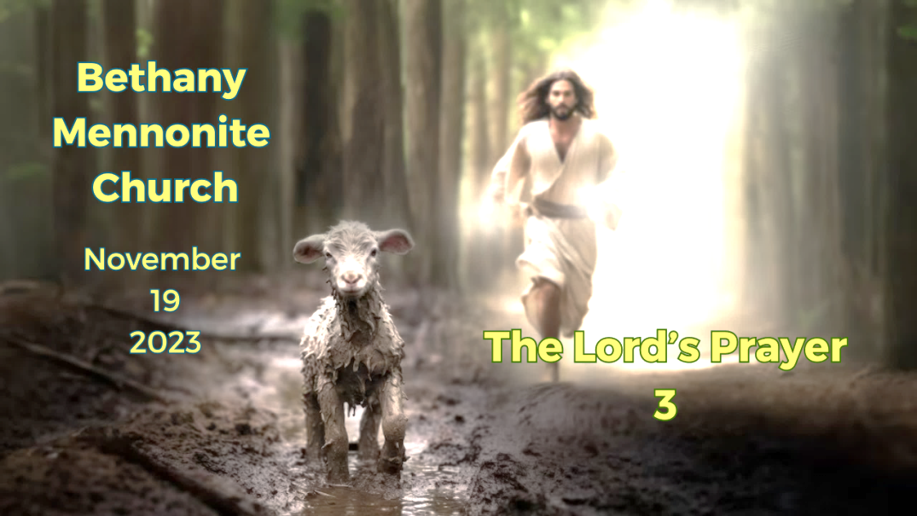

November 19, 2023

572 East & West Line
Box249
Virgil, ON L0S 1T0
905-468-3505
Email: office@bethanymennonite.ca
Website: www.bethanymennonite.ca

59 November 19, 2023 10:00 Service No. 47

Gathering
Prelude
Welcome & Call to Worship Herb Sawatzky
Song – “Wonderful Savior Is Jesus” “Blessed Be Your Name”
Prayer

Life Together
Announcements
Ministry time
Pastoral Prayer
Song – “Our Father, Who Art In Heaven”

Hearing the Word
Scripture – Matthew 6:5-15
Message – Making it real Herb Sawatzky

Responding
Song – “This Is My Song”
Offering & Prayer

Going
Song – “I Love to Tell the Story”
Blessing

Musicians – Kenton & Sheryl Janzen & Friends
Scripture Reader – James Sawatzky

Welcome here!
We’re glad you came! Your being here is a sign of God’s love for the world and encourages other Christians. We hope our worship together helps you find
A place to belong and grow in faith.

Praise and Concerns
Prayers:
- Josh Legere (Holly’s husband) recovering from surgery
- Dora Fisch-Willms at Garden City Manor
- Gayle King is dealing with some health concerns
- Kim Salierno daughter to Ted & Syl, receiving treatment for breast cancer
- Sheila Gayman - in hospice
- Our sister church in Pereira, Colombia

Bethany Announcements
Spiritual Formation Opportunities Today:
- 10:00 Worship Service
- 11:10 Adult Sunday School in library

Prayer Breakfast - Our first Prayer Breakfast is planned for Thursday, November 30th at 7am at Bethany. Invite friends and neighbours.

Winter Clothing Drive for students at Crossroads. Looking for hats, mittens, coats and ski pants for children aged 4-14. Please place items in the donation box located at the front entrance. All donations gratefully accepted. Please direct questions to Ashley Elliott.

The Gift Discernment Team is looking for church members to volunteer their time to the work of the church. Several positions are open to fill. If you feel led to help, please contact Pat Andres, Terri Dick or Ted Wiens by November 30th.

Local Food Bank Drive: Area food banks inform us that donations are down 30% this year while need is up 20%! Your continued support for our food drive to local food banks is much appreciated. Please drop off your donations in the food bin at the front door. Foods and snacks for breakfasts and school lunches are especially appreciated.

Candlelight Stroll - Friday December 1st Niagara UM Church has signed up to sing carols at the Candlelight Stroll on Friday December 1st and would like to invite our Bethany friends to join! We are not rehearsing ahead of time, just showing up for a simple evening of spreading Christmas joy. All singers are welcome to attend. We'll be singing at 134 Johnson Street. Please meet at 6:45; the stroll starts at 7:00. Warm beverages will be provided!

Bethany Christmas Lunch – The Hospitality Team is hosting a Christmas Potluck-style lunch on Sunday, December 3 at 11:30 a.m. We are looking for volunteers to roast turkeys (turkeys will be supplied), make mashed potatoes and stuffing. If you want to volunteer, please speak to Anne Litke, Patty King or Linda Van Bergen. Everyone else who attends is asked to bring a vegetable side dish AND a dessert.

Coyotes/Badgers/Millennials are invited to a Christmas party on Sunday, December 3rd at Kenton and Sheryl's home at 7 pm. Please bring a Christmas treat to share.

Silver Fox Event! On Thursday, Dec. 7 we will enjoy dinner at Betty's restaurant (four choices of entrees) and a Lights Tour. We will meet at Bethany at 4:15. The cost is $65 per person, including coach, taxes, gratuities, buns, coffee or tea, and dessert at Betty's. To ensure your participation, pay Paul and Jo Thiessen, Bud and Ella Andres, or Ted and Sylvia Wiens by Dec. 3. We are limited to 50 participants due to bus capacity.

Our Donations Touching Lives

You can make your offering to Bethany by:
• E-transfer to office@bethanymennonite.ca
• Mail to church at Box 249, Virgil, ON L0S 1T0
• Drop in the mailbox beside the front door on Wednesdays or Thursdays 8:30-3:30 and let Marianne know.
• Canada Helps button on www.bethanymennonite.ca. CanadaHelps charges 3.75% of the donation, but you will be receipted for full amount.

Prayers:
Mennonite Church Eastern Canada
- Please pray for Crosshill Mennonite Church. Julie Ellison-White provides pastoral leadership for the congregation. Lora Gerber is Children's Ministry Worker at Crosshill. Pray for this growing, caring congregation as they care for their community.

- Andy Brubacher Kaethler will be installed at Ottawa Mennonite Church on November 19, 2023 as pastor. Pray for Andy and the congregation as they begin their ministry together. To share your words of encouragement and support with Andy, you can reach him at abkaethler@ottawamennonite.ca.

Mennonite Central Committee
Please pray that the conflict and violence in Palestine and Israel will end and that conciliation can begin.
• Pray for the hostages to return safely to their homes and families.
• Pray for those who mourn to be surrounded by loved ones as they grieve.
• And pray that peace workers, negotiators and government staff will put people's lives and human dignity above political or military gains.

Mennonite Church

High School Students! Are you thinking of attending the University of Waterloo? On Saturday, November 25 from 10-5, attend the UWaterloo Open House and stop by the Conrad Grebel University College residence, right on the UWaterloo campus. Learn about the supportive residence environment that this small and vibrant faith-based community can provide for students studying in any faculty or program at UWaterloo. uwaterloo.ca/grebel/tour.

Three Choir Concert | Saturday, November 25, 7:30 PM - 9:00 PM | St. Matthew's Lutheran Church, Waterloo | Enjoy an evening of choral music with three choirs coming together to perform, including new music by two Grebel alumni composers: Julia Jacklein, and Candace Bustard, commissioned for Grebel's 60th anniversary. $10 general admission, $5 for students. More information at uwaterloo.ca/grebel/events/three-choir-concert

Canadian Mennonite presents Answering the Call: Three Young Pastors Reflect on Ministry, an online discussion on Wednesday, November 29 at 7:00 p.m. CT / 8:00 p.m. ET. Guests Curtis Wiens, Kennedy Froese and Elshaday Baraki will discuss their call to ministry and what they enjoy about being leaders in the church. Register today at: www.canadianmennonite.org/events

Make A Difference (MAD) Holiday Market | Saturday, December 2. 10:00 AM - 4:00 PM Hosted by the Peace and Conflict Studies (PACS) Undergrad Society at Conrad Grebel University College, all funds collected from participating vendors, the silent auction, and suggested $2 entry contribution will be donated to A Better Tent City, Waterloo. Fill your car with family and friends to make a difference while shopping for this holiday season! uwaterloo.ca/grebel/events/mad-market

MCC, MDS, MEDA
A Grow Hope update is available on the bulletin board in the foyer.

The November issue of On the Level, an MDS newsletter, or the UMH newsletter is available from our church office.

SALT Applications and position placement descriptions now available - Serving and Learning Together (SALT) is a year-long service experience for 18-30 year olds with one of MCC’s international partners. SALT service opportunities for 2024-2025 include placements such as tech support, community development, public health, project management, teaching and childcare. To explore SALT assignments, click here. Ready to go? Apply now to see if you qualify for SALT.

Becoming Good Relatives Retreat - January 26/27, 2024, Jericho House, 10845 Rathfon Rd, Port Colborne. In this one-and-a-half-day retreat, author and speaker Patty Krawec will use Anishinaabe teachings to help participants reflect on their social and individual histories in order to improve their capacity to have difficult conversations with others about Canadian history and current impacts on Indigenous people.To learn more and to register, go to mcc.org/events.

Shop Niska for Christmas - This Christmas, give fairly-traded one of-a-kind gifts that support Indigenous Artisans in First Nations and communities living in Northeastern Ontario. Choose from a variety of items, including moccasins, mittens, jewelry and more. Niska products are made with traditional techniques, quality materials, and dedication. Head to niskaartisans.ca to shop today!

Raw Carrot soup is available at your local thrift shop As an MCC Ontario program, The Raw Carrot provides a compassionate workplace to people on long term disability. Our healthy soups are handcrafted in small batches, packed with tasty veggies and free of added preservatives. Fresh ingredients are sourced as locally as possible. Our staff is “stirring up” change with their delicious, handcrafted gourmet soup!” Get your soup today at your local thrift shop.

Christmas gifts that change lives - This Christmas we invite you to explore all the ways that you can share gifts of comfort and joy for the world. Delight your loved ones with wells, goats, emergency food and more. Go to mcc.org/christmas to discover all of the options!

Broader Church & Community
Janice Berg has published two books, most recently, “How life changed”. She tells the story of how Walter Berg’s life changed after surgery and Parkinson’s disease. A book signing will be held on Tuesday, November 21st at 3:30 p.m. in the Pleasant Manor Chapel.

We Never Learned This in School - The Indigenous History of Niagara. Join us as David G Neufeld, U of Waterloo, shares the history of the Niagara Region beginning with the arrival of Indigenous People some 20,000 years ago. A response will be given from an Indigenous perspective, followed by a Q&R Snacks after the presentation provided by 'Beverly Hill's Catering'. The event is free, but donations will be received to help with costs, and dried goods accepted for the Niagara Regional Native Centre food bank. November 24th, 7pm, at St Catharines United Mennonite Church, 335 Linwell Rd.

Pleasant Manor Women’s Auxiliary Christmas Bazaar at Pleasant Manor resumes this year on Saturday November 25th from 10-11:30 am. We will be selling Fleisch Perishky, Christmas cookies and many other food items baked by volunteers, and have a craft area where very creative and beautiful items will be sold. Plan to relax in our tea room where you can enjoy a cup of tea with some baked goods. Please bring your own bag to carry purchases. CASH ONLY. See you there! Bring family, neighbours and friends.

Mark your calendars: the Seasons Chorale will be presenting their Christmas Concert on the following 3 Sundays: Nov 26, 3:00 pm at Scott Street MB Church, 339 Scott St; Dec 3, 6:00 pm at Grace Community Church, 241 St. David’s Road W in Thorold; and Dec 10, 3:00 pm at St. Catharines UM Church, 335 Linwell Rd.

THIS WEEK AT BETHANY
November 19-26, 2023

Today 10:00 a.m. – Worship Service
11:10 a.m. – Sunday School
Tuesday 9:00 a.m. – Quilting
6:00 p.m. – Handbell Choir
7:30 p.m. – JuBELLation
Sunday 10:00 a.m. – Worship Service
11:10 a.m. – Sunday School

Speaking: John Tiessen
Scripture: John 17:13-26, Revelation 21:1-8
Theme: The desire of Jesus

Worship services are recorded live and kept on our youtube channel indefinitely. Recordings begin shortly before 10am and end after 11:04. Those who prefer not to appear in the recording are encouraged to sit near the back of the sanctuary in front of the cry room, and exit through the door on that side.

