A place to belong and grow in faith

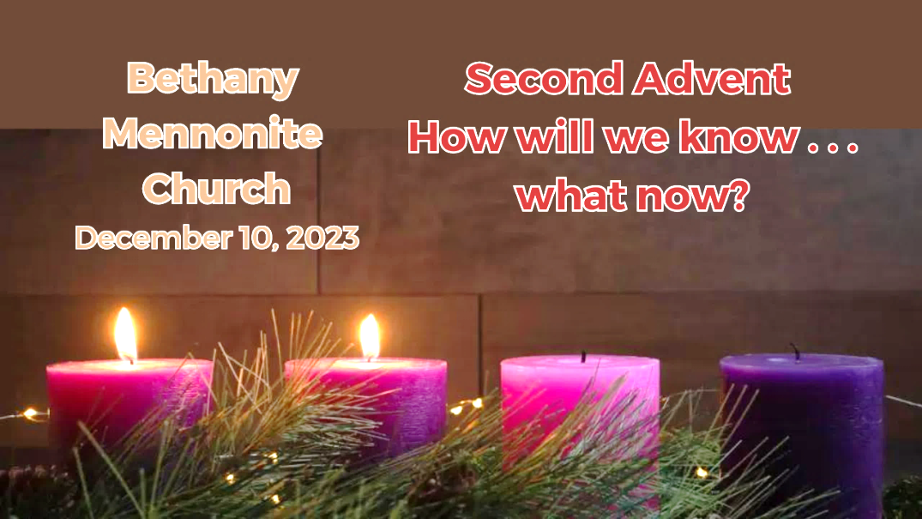

December 10, 2023

572 East & West Line
Box249
Virgil, ON L0S 1T0
905-468-3505
Email: office@bethanymennonite.ca
Website: www.bethanymennonite.ca

59 December 10, 2023 10:00 Service No. 50

second advent

Gathering
Prelude
Welcome
Call to Worship Patty King
Songs – “Comfort, Comfort, O My People” #176
“Lo, How a Rose E'er Blooming” #211
“Angels We Have Heard on High” #197
Prayer

Life Together
Announcements
Ministry time
Pastoral Prayer
Song – “Poor of the Earth”

Hearing the Word
Scripture – 2 Peter 3:8–15a Ted Wiens
Children’s Video
Drama
Message – How will we know . . . what now? Herb Sawatzky

Responding
Candle lighting & Blessing
Song – “God of Justice”
Offering & Interactive Response

Going
Song – “To Us a Child of Hope is Born” #189
Offering Prayer and Benediction

Drama – Colin Horne & Ted Wiens
Musicians – Gayle Neufeld & Friends

Welcome here!
We’re glad you came! Your being here is a sign of God’s love for the world and encourages other Christians. We hope our worship together helps you find
A place to belong and grow in faith.

Praise and Concerns
Prayers:
- Josh Legere (Holly’s husband) recovering from surgery
- Dora Fisch-Willms at Garden City Manor
- Gayle King is dealing with some health concerns
- Kim Salierno daughter to Ted & Syl, who is preparing for surgery on December 14
- Our sister church in Pereira, Colombia

Thank you for all the love shown to our family when Erika passed away. Your support in the way of prayers, gifts of flowers and cards were appreciated. Vic Dyck & family

Renate Klaassen is retiring this Sunday from German Leadership at Niagara UM Church. Our chair, Shirley, has written a letter on behalf of Bethany to wish her well in her retirement. A card for Renate is available for you to sign in the foyer, before and after today’s service.

Bethany Announcements
Winter Clothing Drive for students at Crossroads. Looking for hats, mittens, coats and ski pants for children aged 4-14. Please place items in the donation box located at the front entrance. All donations gratefully accepted. Please direct questions to Ashley Elliott.

Christmas Music Favourites – For the Sunday morning service on Dec 24th, we are having an all-request music Sunday. Please let Kenton or Sheryl know your favourite Christmas hymn or song by Dec 17. All musicians are invited to join in leading the congregation that morning! Please let Kenton or Sheryl know if you are interested.

Our Memorial Sunday service will be held on January 7, 2024. We will acknowledge those who have passed away in 2023. If you would like us to remember your loved one, please submit a photo with name, birthdate, date of passing, and names of immediate family members to the office or Steve (sgoertz@cogeco.ca) by December 31st.

Local Food Bank Drive: Area food banks inform us that donations are down 30% this year while need is up 20%! Your continued support for our food drive to local food banks is much appreciated. Please drop off your donations in the food bin at the front door. Foods and snacks for breakfasts and school lunches are especially appreciated.

Our Donations Touching Lives

You can make your offering to Bethany by:
• E-transfer to office@bethanymennonite.ca
• Mail to church at Box 249, Virgil, ON L0S 1T0
• Drop in the mailbox beside the front door on Wednesdays or Thursdays 8:30-3:30 and let Marianne know.
• Canada Helps button on www.bethanymennonite.ca. CanadaHelps charges 3.75% of the donation, but you will be receipted for full amount.

Prayers:
Mennonite Church Eastern Canada
- Please pray for Église Bethésda Mennonite de Saint-Hyacinthe. Amuri Ayeba provides pastoral leadership for the congregation. Pray for this congregation composed primarily of immigrants and refugees from Swahili speaking countries in East Africa, Béthésda has a vision to be an incarnational gospel presence for everyone in Quebec City.

- Pray for the MCEC Executive Minister Search Committee who have begun their work of seeking a permanent Executive Minister for MCEC. Pray for Ben Cassels and Kay Rempel, co-chairs, and for Hyejung Jessie Yum, Steph Chandler Burns, Kara Carter and Alissa Bender.

- Pray for our world as people live in fear and danger because of armed conflict in areas like Ukraine, Russia, Israel, Palestine, Myanmar and more. Make us channels of God's peace: where there’s despair in life let us bring hope; where there is darkness, only light, and where there’s sadness, ever joy. Lord, hear our prayers.

Mennonite Central Committee
• Please pray for MCC Serving and Learning Together program participants who will be spending their Christmas far away from their families, including Adrian Berrio Klassen from Ontario..

Mennonite Church
Silver Lake Mennonite Camp Outtrips – Registration opens Dec. 1 for children and teens who would like to participate in an overnight hiking or canoe trip during Summer 2024. Sign up before Feb. 1 to get $100 OFF. Visit slmc.ca/summer-camp. See the full list of retreats at slmc.ca/retreats.

MCC, MDS, MEDA
Shop Niska for Christmas - This Christmas, give fairly-traded one of-a-kind gifts that support Indigenous Artisans in First Nations and communities living in Northeastern Ontario. Choose from a variety of items, including moccasins, mittens, jewelry and more. Niska products are made with traditional techniques, quality materials, and dedication. Head to niskaartisans.ca to shop today!

Christmas gifts that change lives - This Christmas we invite you to explore all the ways that you can share gifts of comfort and joy for the world. Delight your loved ones with wells, goats, emergency food and more. Go to mcc.org/christmas to discover all of the options!

Broader Church & Community
Mark your calendars: the Seasons Chorale will be presenting their Christmas Concert on the following Sundays: TODAY 3:00 pm at St. Catharines UM Church, 335 Linwell Rd.

NUMC’s German Advent Celebration - If you love singing traditional German Christmas carols, hearing German Christmas stories, and socializing over a plate of Christmas cookies, Niagara United Mennonite invites you to the annual German Advent Celebration, TODAY at 3:00 p.m. 1775 Niagara Stone Rd. NOTL.

Niagara Life Centre Newsletter is available on the shelf in the foyer.

Pleasant Manor Tenant Council Christmas Crafts and Bake Sale on Saturday December 16 from 9:30-11:30 in the in the Creekview Link. Donations of baked goods much appreciated. All proceeds go to Tenant Council to fund more great activities for our seniors.

Calling All Carolers for Pleasant Manor! Hello Bethany! For the last couple Christmases, Niagara UM has caroled around the grounds of Pleasant Manor, and we'd love to have you join us this year! From strollers to seasoned singers, everyone is invited on Sunday December 17th at 5:00. We will meet in the Creekview parking lot, and don't forget to dress warmly! If you have family or friends at Pleasant Manor, remind them to keep an eye out their windows around 5:00 to enjoy the singing!

Grace Mennonite Church at 677 Niagara St. in St. Catharines welcomes donations of homemade shawls and or small blankets for our Bears and Blankets program for Elders in Long Term Care. We have provided 117 care-kits thus far. We have requests for 171. Our care-kits go to Seniors who don’t get many visitors or who are lonely. Please contact Jan at 289-990-4839 or janscats@gmail.com.

THIS WEEK AT BETHANY
December 10-17, 2023

second Advent
Today 10:00 a.m. – Worship Service
11:10 a.m. – Sunday School
Tuesday 6:00 p.m. – Handbell Choir
7:30 p.m. – JuBELLation
Sunday 10:00 a.m. – Worship Service
11:10 a.m. – Sunday School

Speaking: Herb Sawatzky
Scripture: Isaiah 61:1–4, 8–11, Luke 1:46b–55, 1 Thessalonians 5:16–24, John 1:6–8, 19–28
Theme: How will we know . . . what’s next?

Worship services are recorded live and kept on our youtube channel indefinitely. Recordings begin shortly before 10am and end after 11:04. Those who prefer not to appear in the recording are encouraged to sit near the back of the sanctuary in front of the cry room, and exit through the door on that side.

