A place to belong and grow in faith

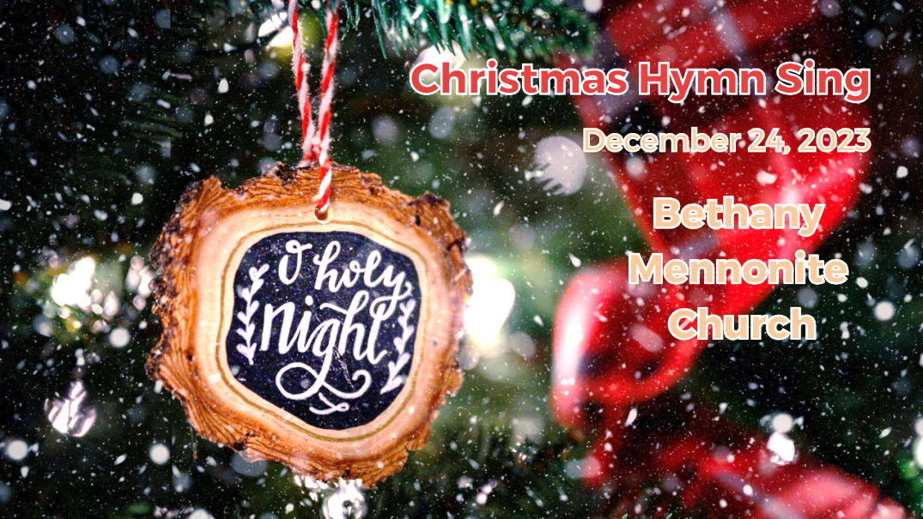

December 24, 2023

572 East & West Line
Box249
Virgil, ON L0S 1T0
905-468-3505
Email: office@bethanymennonite.ca
Website: www.bethanymennonite.ca

59 December 24, 2023 10:00 Service No. 52

Fourth advent

Gathering
Prelude
Welcome
Call to Worship James Sawatzky
Song – “To Us a Child of Hope” #189
Candle lighting
Prayer

Life Together
Announcements
Ministry time
Pastoral Prayer
Songs – “Mary’s Boy Child”
“Mary Did You Know”
“While Shepherds Watched”
“Angels from the Realms of Glory”
“Once in Royal David’s City”
“O Beautiful Star of Bethlehem”

Hearing the Word
Scripture – Luke 1:26-38 Colin Horne
Children’s Video
Message – How will we know…why me? Why not me?
Herb Sawatzky

Responding
Song – “What Child is This / Helpless and Hungry” #215
Offering Prayer

Going
Song – “O Holy Night”
Benediction

Candle Lighters: Pat & Sara Andres
Musicians – Kenton & Sheryl Janzen & Friends

Welcome here!
We’re glad you came! Your being here is a sign of God’s love for the world and encourages other Christians. We hope our worship together helps you find
A place to belong and grow in faith.

Praise and Concerns
Prayers:
- Anne-Marie Enns, Katie Reimer’s cousin waiting for a heart transplant
- Josh Legere (Holly’s husband) recovering from surgery
- Dora Fisch-Willms at Garden City Manor
- Gayle King is dealing with some health concerns
- Kim Salierno daughter to Ted & Syl, as she recovers from surgery
- Our sister church in Pereira, Colombia

Congratulations to Wern & Louise who are celebrating their 60th wedding anniversary on December 28th! We wish you God’s richest blessings as you celebrate with family.

Congratulations to Herb & Lorrie Sawatzky who will celebrate their 25th wedding anniversary on December 29th. We wish them God’s blessings for continued health and happiness together.

We invite you to join these couples for cake next week in the gym, immediately following the service on Dec 31.

Bill & Irene Goertz are unable to make it to church but wish Pastor Herb, Marianne, and the congregation a very Merry Christmas and Happy New Year. God bless you all.

Bethany Announcements
Our Christmas Eve Worship service begins at 6:30 this evening. This will be a family friendly service by candle light, including special music, the singing of favourite Christmas carols, and the creative presentation of a very special Christmas story, ‘I am Christmas’. Everyone is welcome. Please invite your family and friends.

Christmas Day Service - Please join us Christmas morning at Niagara UM Church at 10:45 am. You can also watch the service Livestream on our YouTube Channel.

Our Memorial Sunday service will be held on January 7, 2024. We will acknowledge those who have passed away in 2023. If you would like us to remember your loved one, please submit a photo with name, birthdate, date of passing, and names of immediate family members to the office or Steve (sgoertz@cogeco.ca) by December 31st.

Our annual New Year’s Potluck Brunch will be held Sunday, January 7 immediately following the worship service. Please bring food to share.

Annual Reports – It’s time to reflect on the past year and let us know about all the wonderful things that took place! Please send your reports to the office by January 16th at the latest. Earlier is appreciated!

DONATIONS received December 1-20 were $16,305. Please be reminded that at the end of November we had a deficit of $11,800. We need to cover normal December expenses plus seek to cover off the deficit by December 31st. We ask you to give consideration to this matter.

Local Food Bank Drive: Area food banks inform us that donations are down 30% this year while need is up 20%! Your continued support for our food drive to local food banks is much appreciated. Please drop off your donations in the food bin at the front door. Foods and snacks for breakfasts and school lunches are especially appreciated.

Our Donations Touching Lives

You can make your offering to Bethany by:
• E-transfer to office@bethanymennonite.ca
• Mail to church at Box 249, Virgil, ON L0S 1T0
• Drop in the mailbox beside the front door on Wednesdays or Thursdays 8:30-3:30 and let Marianne know.
• Canada Helps button on www.bethanymennonite.ca. CanadaHelps charges 3.75% of the donation, but you will be receipted for full amount.

Prayers:
Mennonite Church Eastern Canada
- Please pray for Église Jésus-Christ Appelle Tous. Pastor Cyprien Kibukila provides pastoral leadership for the congregation in Trois-Rivières, QC. Pray for this congregation who declares their vision in their name as they seek to be a church for all people (Jesus Christ calls all).

- Pray for our world as people experience grief and pain and live in fear and danger because of armed conflict in areas like the Gaza Strip, Ukraine, Russia, Myanmar and more. Incarnate God, holding tenderly all things human, you became one of us... may we be gentled into joining you in the hard and holy work of releasing peace on earth. Lord, hear our prayers.

Mennonite Central Committee
• Please pray for MCC Serving and Learning Together program participants who will be spending their Christmas far away from their families, including Adrian Berrio Klassen from Ontario.

Mennonite Church
MCEC office staff wish a Merry Christmas to all MCEC congregations. Our prayer is that you will experience afresh the love of Christ during this Christmas season. We feel privileged to be able to serve you throughout the year. See office staff at mcec.ca.

Silver Lake Mennonite Camp Outtrips – Registration opens Dec. 1 for children and teens who would like to participate in an overnight hiking or canoe trip during Summer 2024. Sign up before Feb. 1 to get $100 OFF. Visit slmc.ca/summer-camp. See the full list of retreats at slmc.ca/retreats.

MCC, MDS, MEDA
Shop Niska for Christmas - This Christmas, give fairly-traded one of-a-kind gifts that support Indigenous Artisans in First Nations and communities living in Northeastern Ontario. Choose from a variety of items, including moccasins, mittens, jewelry and more. Niska products are made with traditional techniques, quality materials, and dedication. Head to niskaartisans.ca to shop today!

Christmas gifts that change lives - This Christmas we invite you to explore all the ways that you can share gifts of comfort and joy for the world. Delight your loved ones with wells, goats, emergency food and more. Go to mcc.org/christmas to discover all of the options!

MCEC and Rockway Mennonite Collegiate Jr. Youth Event: Lean on Me. January 21, 2024 from 1 - 5 p.m. Join Jr. Youth from across MCEC as we meet at Rockway Mennonite Collegiate to talk about leaning on God and leaning on each other as we walk through life together. Registration is open at mcec.ca.

Learning about generosity with MCC Christmas is a season that is filled with the spirit of generosity. Have you ever stopped to think what it means to be generous? MCC has created a resource to help young people explore that question and many others. Download the resource at mcc.org/learning-about-generosity-mcc.

SALT Applications and position placement descriptions now available. Do you know an 18-30 year old looking for job experience in their field? Serving and Learning Together (SALT) is a year-long service experience with one of MCC’s international partners. SALT service opportunities for 2024-2025 include placements such as tech support, community development, public health, project management, teaching and childcare. To explore SALT assignments, click here. Ready to go? Apply now.

The December issue of On the Level (MDS newsletter) is available from the office.

Wishing you a Merry Christmas
and a blessed New Year!

Herb Sawatzky, Marg Heidebrecht, Marianne Enns

THIS WEEK AT BETHANY
December 24-31, 2023

Fourth Advent
Today 10:00 a.m. – Worship Service
6:30 p.m. – Christmas Eve Service
Monday 10:45 a.m. – Niagara UM Church Christmas Service
Sunday 10:00 a.m. – Worship Service

Speaking: Herb Sawatzky
Scripture: Isaiah 61:10–62:3, Psalm 148, Galatians 4:4–7, Luke 2:22–40
Theme: How will we know . . . who knows?

Worship services are recorded live and kept on our youtube channel indefinitely. Recordings begin shortly before 10am and end after 11:04. Those who prefer not to appear in the recording are encouraged to sit near the back of the sanctuary in front of the cry room, and exit through the door on that side.

