A place to belong and grow in faith

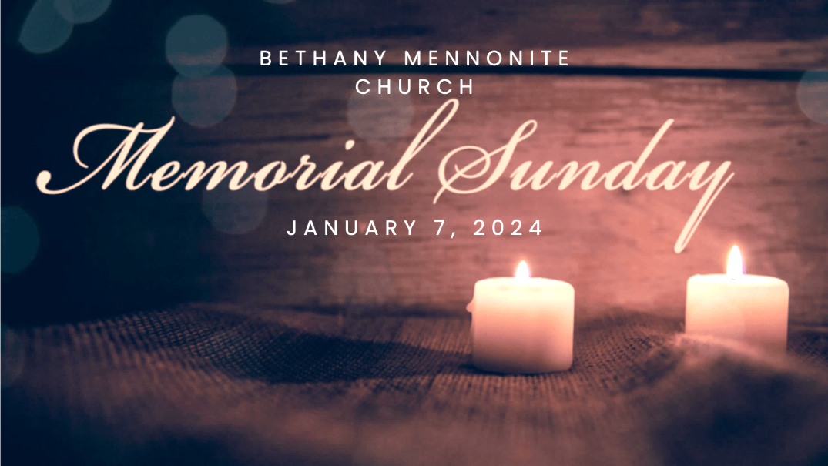

January 7, 2024

572 East & West Line
Box249
Virgil, ON L0S 1T0
905-468-3505
Email: office@bethanymennonite.ca
Website: www.bethanymennonite.ca

59 January 7, 2024 10:00 Service No. 1

Gathering
Prelude
Welcome Herb Sawatzky
Call to Worship
Songs – “Praise Him! Praise Him!”
“Mountain of God”
Prayer

Life Together
Announcements
Ministry time
Pastoral Prayer
Memorial Service
Song – “Moon Over Birkenau” Gayle & Adam Neufeld

Hearing the Word
Scripture – Micah 4:1-5, Mark 10: 17-31 Julia Klassen
Children’s Video
Message – A People of Faith. A People of Fear Betsy Wall

Responding
Song – “Will You let me be your servant”
Offering Prayer

Going
Song – “All who are thirsty”
Benediction

Musicians – Kenton & Sheryl Janzen & Friends

Welcome here!
We’re glad you came! Your being here is a sign of God’s love for the world and encourages other Christians. We hope our worship together helps you find
A place to belong and grow in faith.

Praise and Concerns
Prayers:
- Marie Lepp at the St. Catharines Hospital
- Anne-Marie Enns, Katie Reimer’s cousin recovering from a successful heart transplant
- Josh Legere (Holly’s husband) recovering from surgery
- Dora Fisch-Willms at Garden City Manor
- Gayle King is dealing with some health concerns
- Kim Salierno daughter to Ted & Syl, as she recovers from surgery
- Our sister church in Pereira, Colombia

Bethany Announcements
Our Memorial Sunday service will be held TODAY. We will acknowledge those who have passed away in 2023.

Our annual New Year’s Potluck Brunch will be held TODAY immediately following the worship service. All are invited! Please bring food to share.

Annual Reports – It’s time to reflect on the past year and let us know about all the wonderful things that took place! Please send your reports to the office by January 16th at the latest. Earlier is appreciated!

Quilting will resume this Tuesday, January 9th from 9 am till 12 noon. This is a time of socializing as well as getting our comforters tied. New comers are welcome!

Prayer Breakfast - Our Prayer Breakfast is planned for Thursday, January 25th at 7am at Bethany. Invite friends and neighbours.

Local Food Bank Drive: Area food banks inform us that donations are down 30% this year while need is up 20%! Your continued support for our food drive to local food banks is much appreciated. Please drop off your donations in the food bin at the front door. Foods and snacks for breakfasts and school lunches are especially appreciated.

Our Donations Touching Lives

You can make your offering to Bethany by:
• E-transfer to office@bethanymennonite.ca
• Mail to church at Box 249, Virgil, ON L0S 1T0
• Drop in the mailbox beside the front door on Wednesdays or Thursdays 8:30-3:30 and let Marianne know.
• Canada Helps button on www.bethanymennonite.ca. CanadaHelps charges 3.75% of the donation, but you will be receipted for full amount.

Prayers:
Mennonite Church Eastern Canada
- Please pray for Église Jésus-Christ Appelle Tous. Pastor Cyprien Kibukila provides pastoral leadership for the congregation in Trois-Rivières, QC. Pray for this congregation who declares their vision in their name as they seek to be a church for all people (Jesus Christ calls all).

- Pray for our world as people experience grief and pain and live in fear and danger because of armed conflict in areas like the Gaza Strip, Ukraine, Russia, Myanmar and more. Incarnate God, holding tenderly all things human, you became one of us... may we be gentled into joining you in the hard and holy work of releasing peace on earth. Lord, hear our prayers.

Mennonite Central Committee
• Please pray for MCC Serving and Learning Together program participants who will be spending their Christmas far away from their families, including Adrian Berrio Klassen from Ontario.

Mennonite Church
SLMC Summer Outtrips – Registration is open for overnight hiking and canoeing trips. Sign up before Feb 1 to get $100 OFF. Visit slmc.ca/summer-camp.
SLMC Retreats - Many fun retreats coming up this winter! Click here for detailed descriptions and to register for the weekends below… slmc.ca/retreats
· Fathers & Kids Retreat (Jan 19-21)
· Women’s Retreat (Feb 2-4)
· Valentine’s Day Getaway (Feb 9-11)
· Winter Camp for Grownups (Mar 1-3)

Mennonite Burial Society Annual General Meeting (AGM) will be held both in person at Scott Street Church and online at https://us02web.zoom.us/j/7404216638 on Saturday, January 13, 2024 at 2 pm. Agenda will be similar to past AGMs, discussing 2023 results, 2024 levies and benefit payments, potential revision to the voluntary payment procedure, and future plans. Board and committee positions are available. Further details available at www.mennoniteburialsociety.com, or Barry Boese at 905-228-1850 or email info@mennoniteburialsociety.com

MCC, MDS, MEDA
MCEC and Rockway Mennonite Collegiate Jr. Youth Event: Lean on Me. January 21, 2024 from 1 - 5 p.m. Join Jr. Youth from across MCEC as we meet at Rockway Mennonite Collegiate to talk about leaning on God and leaning on each other as we walk through life together. Registration is open at mcec.ca.

Lunch and Listen with Sara Wyngaarden Tuesday, January 23, 12 - 1 pm, 50 Kent Ave, Kitchener or online. Join us online or in-person at the MCC office in Kitchener as we hear from Sara Wyngaarden, Monitoring and Evaluation Coordinator in Guatemala. Sara will be sharing stories from Guatemala. Go to mcc.org/events for more information.

Becoming Good Relatives Retreat - January 26/27, Jericho House, 10845 Rathfon Rd, Port Colborne. In this one-and-a-half-day retreat, author and speaker Patty Krawec will use Anishinaabe teachings to help participants reflect on their social and individual histories in order to improve their capacity to have difficult conversations with others about Canadian history and current impacts on Indigenous people. To learn more and to register, go to mcc.org/events.

Great Winter Warm-up January 27, 2024 9 am – 4 pm, New Hamburg Material Resources Centre, 65 Heritage Dr, New Hamburg
This winter, compassionate people like you are giving the gift of warm comforters to those in need around the world. Each comforter provides not only warmth but also a tangible reminder to people in vulnerable situations that their needs are not forgotten. Help us meet our goal to collect 7,000 comforters by holding or attending comforter-knotting blitzes during January and February. On January 27, you’re invited to participate in a comforter-knotting blitz. Knotters of all skills are welcome and snacks and drinks will be provided. Learn more at mcc.org/events.

Learning about generosity with MCC Christmas is a season that is filled with the spirit of generosity. Have you ever stopped to think what it means to be generous? MCC has created a resource to help young people explore that question and many others. Download the resource at mcc.org/learning-about-generosity-mcc.

SALT Applications and position placement descriptions now available. Do you know an 18-30 year old looking for job experience in their field? Serving and Learning Together (SALT) is a year-long service experience with one of MCC’s international partners. SALT service opportunities for 2024-2025 include placements such as tech support, community development, public health, project management, teaching and childcare. To explore SALT assignments, click here. Ready to go? Apply now.

THIS WEEK AT BETHANY
January 7-14, 2024

Today 10:00 a.m. – Memorial Worship Service
11:30 a.m. – New Year’s Breakfast
Tuesday 9:00 a.m. – Quilting
6:00 p.m. – Handbell choir
7:30 p.m. – JuBELLation
Sunday 10:00 a.m. – Worship Service

Speaking: Herb Sawatzky
Scripture: Matthew 6:7-15
Theme: Our Daily Bread

Worship services are recorded live and kept on our youtube channel indefinitely. Recordings begin shortly before 10am and end after 11:04. Those who prefer not to appear in the recording are encouraged to sit near the back of the sanctuary in front of the cry room, and exit through the door on that side.

