A place to belong and grow in faith

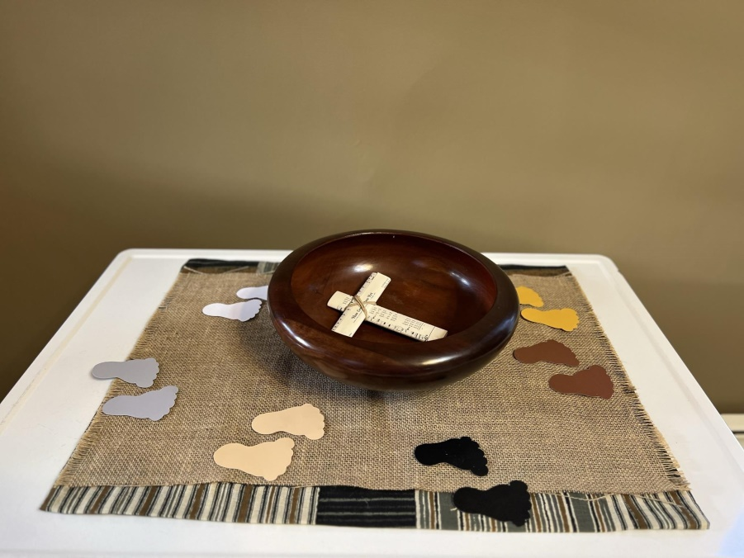

February 25, 2024

572 East & West Line
Box249
Virgil, ON L0S 1T0
905-468-3505
Email: office@bethanymennonite.ca
Website: www.bethanymennonite.ca

59 February 25, 2024 10:00 Service No. 8

Gathering
Prelude
Welcome Herb Sawatzky
Call to Worship
Songs – “Lord, I Am Fondly, Earnestly Longing” #514
“Fill Us With Your Feast”
Prayer of Confession

Life Together
Announcements
Ministry time
Pastoral Prayer
Song – “Jesus, Be the Centre”

Hearing the Word
Scripture – Mark 8:31-38; Romans 4:13–25
Children’s Video – Abram to Abraham - Genesis 17:1-17
Message – Showing Us Faith Herb Sawatzky
Faith Story Vic Neufeld

Responding
Song – “We Walk By Faith” #570
Offering Prayer

Going
Song – “I Have Decided to Follow Jesus”
Benediction

Musicians – Gayle Neufeld & Friends
Scripture Readers – Ted & Syl Wiens

Welcome here!
We’re glad you came! Your being here is a sign of God’s love for the world and encourages other Christians. We hope our worship together helps you find
A place to belong and grow in faith.

Praise and Concerns
Prayers:
- Steve Goertz recovering from hip surgery
- Irene Schellenberg recovering from knee surgery
- Dora Fisch-Willms at Garden City Manor
- Our sister church in Pereira, Colombia

Bethany Announcements
Spiritual Formation Opportunities Today:
- 10:00 Worship Service
- 11:10 Adult Sunday School in library

RECEIPTS were either emailed out, mailed out, or will be available in your mailbox for pick up. Please call the office if you have any questions or would like to change your preference of receiving it.

THE UPPER ROOM is a daily devotional guide for under $20/year. Samples are available on the narthex shelf; please help yourself. If you would like to sign up, please contact the office.

Prayer Breakfast - Our Prayer Breakfast is planned for Thursday, February 29th at 7am at Bethany. Invite friends and neighbours.

Local Food Bank Drive: Area food banks inform us that donations are down 30% this year while need is up 20%! Your continued support for our food drive to local food banks is much appreciated. Please drop off your donations in the food bin at the front door. Foods and snacks for breakfasts and school lunches are especially appreciated.

Our Donations Touching Lives
Budget Donations for February 15-21: $4,685.

You can make your offering to Bethany by:
• E-transfer to office@bethanymennonite.ca
• Mail to church at Box 249, Virgil, ON L0S 1T0
• Drop in the mailbox beside the front door on Wednesdays or Thursdays 8:30-3:30 and let Marianne know.
• Canada Helps button on www.bethanymennonite.ca. CanadaHelps charges 3.75% of the donation, but you will be receipted for full amount.

Prayers:
Mennonite Church Eastern Canada
- Please pray for First Hmong Mennonite Church. Chung Vang provides pastoral care for this congregation. Pray for this congregation as they learn how to live the Christian life faithfully together as a community and share the gospel with others.

- Pray for Kapilan Savarimuthu, pastor of Markham Christian Worship Centre. His wife, Rosabel Paul, suffered a heart attack and died Monday, February 19, 2024. Pray for Kapilan, his 15 year old daughter, and the congregation as they grieve this terrible shock. Visitation and Funeral information can be found here.

- Pray for Michel Monette, MCEC Catalyzer Minister, and MCEC congregations in Quebec as new congregations gather this weekend for a workshop on church governance. Pray that God's spirit will inspire their conversations as they learn and grow together.

- Pray for Mennonite Church British Columbia as they gather this weekend for their annual meeting looking at Stuck Together: The Hope of Christian Witness in a Polarized World. Pray that God's spirit will guide and unify them as they gather in worship.

- Continue to pray as war and rumours of war resound. This is our long-standing prayer, O Lord. We don't understand. Pray for those who experience grief and pain, for those who live in fear and danger. We call to you God - show us how to forge swords into ploughshares, and spears into pruning-knives. Lord, hear our prayers.

Mennonite Central Committee
• Pray for the many displaced people within Ukraine and Gaza and thank you for the witness of your church in Europe and Middle East.

• Please join MCC in holding Weenusk First Nation (Peawanuck) in your thoughts as they mourn the loss of two community members in a recent fatal house fire.

• This year, we have received 290 requests to sponsor 1,100 refugees. We hope to receive 175 spaces from the government for sponsorships. Please pray for emotional strength and wisdom for our team during this process.

• Last year, the number of newcomers we received was quite lower than in 2022. As of January this year, we have received 21 newcomers, sponsored by six sponsoring groups. May the settlement and transition of the newcomers to their new home go smoothly.

Mennonite Church
Peace & Possibility, Part II: Raja Khouri is a Palestinian-Canadian; Jeffrey Wilkinson is an American Jew. Hear them discuss their 2023 book, The Wall Between: What Jews and Palestinians Don’t Want to Know About Each Other. Hosted by Canadian Mennonite, Anabaptist World and the Palestine-Israel Network. Feb. 28, 7:30 p.m. CT. Click here to learn more.

Grandparent & Grandchild Retreat at Hidden Acres Mennonite Camp Monday, March 11th @ 9:15 a.m. - 2:30 p.m. Grandparents and grandchildren in grades 1-6 are invited to camp to "Discover God through the Creative Process" with Mike Vlaming, owner of Little Creek Pottery. Join us for a day of creativity, fun and connecting! For more information or to register go to our website www.hiddenacres.ca

Hidden Acres Mennonite Camp Hiring for our 2024 Summer Staff Team! Are you or is someone you know looking for a summer job filled with meaning, friendships and fun? Apply to join our 2024 Summer Staff Team! Check out our website at www.hiddenacres.ca for available positions, information and to apply. Connect our Program Director, Josh Penfold at josh@hiddenacres.ca with any questions.

Silver Lake Mennonite Summer Camp – Registration is open! Visit slmc.ca/summer-camp to view all programs available at Silver Lake Mennonite Camp this summer.
SLMC 3-v-3 Basketball Tournament – Create a team to participate in Silver Lake’s Basketball Tournament fundraiser on March 23 at Rockway Mennonite Collegiate. Register at slmc.ca/basketball-tournament
Winter Camp for Grownups – This “choose your own adventure” weekend at Silver Lake is the perfect winter escape. Co-hosted by PiE (Pastors in Exile). March 1-3. Register at slmc.ca/retreats.

The MDS Newsletter is available from the office.

THIS WEEK AT BETHANY
February 25-March 3, 2024

Today 10:00 a.m. – Worship Service
11:10 a.m. – Adult Sunday School
Tuesday 9:00 a.m. – Quilting
6:00 p.m. – Handbell choir
7:30 p.m. – JuBELLation
Sunday 10:00 a.m. – Worship Service
11:10 a.m. – Adult Sunday School

Speaking: Herb Sawatzky
Scripture: Exodus 20:1–17, Psalm 19, John 2:13–22, 1 Corinthians 1:18–25
Theme: Showing Us Justice

BETHANY MENNONITE CHURCH
WORSHIP SERVICES – 10:00 a.m.

Herb Sawatzky, Lead Pastor 736-2029
pastor@bethanymennonite.ca
Church Chair: Ken Janzen 289-673-1149
Janzen.kenneth@gmail.com

Pastoral Care Team:
Gayle Neufeld 468-2105
Irene Schellenberg 289-868-8775
Joanne Thiessen 468-7392

Office Hours – Wednesdays & Thursdays 8:30–3:30
Pastor’s office hours – Tuesday-Thursday or by appointment

For the Prayer Chain, please call the office during office hours or Herb after hours.

Worship services are recorded live and kept on our youtube channel indefinitely. Recordings begin shortly before 10am and end after 11:04. Those who prefer not to appear in the recording are encouraged to sit near the back of the sanctuary in front of the cry room, and exit through the door on that side.

