A place to belong and grow in faith

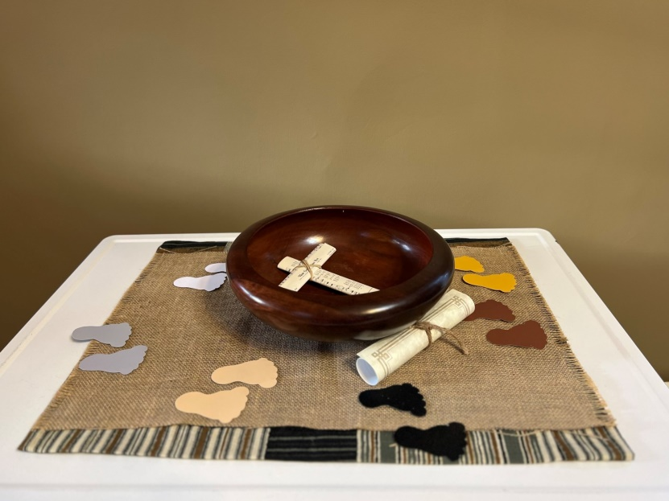

March 3, 2024

572 East & West Line
Box249
Virgil, ON L0S 1T0
905-468-3505
Email: office@bethanymennonite.ca
Website: www.bethanymennonite.ca

59 March 3, 2024 10:00 Service No. 9

Gathering
Prelude
Welcome Herb Sawatzky
Call to Worship
Songs – “Hallelujah! Fairest Morning!”
“Beauty for Brokenness”
Prayer of Confession

Life Together
Announcements
Ministry time
Pastoral Prayer
Song – “Lord I need You”

Hearing the Word
Scripture – Psalm 19:7-8, John 2:13-22 Lorrie Sawatzky
Children’s Video
Message – Showing Us Justice Herb Sawatzky

Responding
Song – “We are People of God's Peace”
Offering Prayer

Going
Song – “We are Marching”
Benediction

Musicians – Kenton & Sheryl Janzen & Friends

Welcome here!
We’re glad you came! Your being here is a sign of God’s love for the world and encourages other Christians. We hope our worship together helps you find
A place to belong and grow in faith.

Praise and Concerns
Prayers:
- Steve Goertz recovering from hip surgery
- Irene Schellenberg recovering from knee surgery
- Dora Fisch-Willms at Garden City Manor
- Our sister church in Pereira, Colombia

The Eva Andres family would like to thank you for your prayers, words of comfort and sympathy, cards and remembrances at her passing. We greatly appreciate your kindness during this time.

Bethany Announcements
Spiritual Formation Opportunities Today:
- 10:00 Worship Service
- 11:10 Adult Sunday School in library

Conrad Grebel Choir will lead us in worship on Sunday, March 17. Please invite your friends and neighbours!

THE UPPER ROOM is a daily devotional guide for $11/year. Samples are available on the narthex shelf; please help yourself. If you would like to sign up, please contact the office.

Local Food Bank Drive: Area food banks inform us that donations are down 30% this year while need is up 20%! Your continued support for our food drive to local food banks is much appreciated. Please drop off your donations in the food bin at the front door. Foods and snacks for breakfasts and school lunches are especially appreciated.

Our Donations Touching Lives
Budget Donations for February 22-28: $2,582.

You can make your offering to Bethany by:
• E-transfer to office@bethanymennonite.ca
• Mail to church at Box 249, Virgil, ON L0S 1T0
• Drop in the mailbox beside the front door on Wednesdays or Thursdays 8:30-3:30 and let Marianne know.
• Canada Helps button on www.bethanymennonite.ca. CanadaHelps charges 3.75% of the donation, but you will be receipted for full amount.

Prayers:
Mennonite Church Eastern Canada
- Please pray for First Mennonite Church in Kitchener, ON. Rene Baergen, Sandra Baez and Liz Weber provide pastoral care for this congregation. They are a diverse and intercultural community of Jesus followers doing their best to connect deeply with God, intentionally with each other and compassionately with the world around us.

- Pray for Fanosie Legesse, MCEC International Mission Minister, and Mennonite Church Manitoba as they meet together for MC Manitoba's annual meeting this weekend. Fanosie is the keynote speaker and will inspire and encourage them toward living into an intercultural church that reflects the vision of Revelation 7 - From Every Nation: Living into an Intercultural Church.

- Pray for the MCEC Transitioning into Ministry participants as they gather next week for equipping days. Pray for Donna Kerfoot (Zion MF), Kimberly Penner (Stirling Ave. MC), Annika Krause (Mennonite Fellowship of Montreal), Zac Klassen (Bloomingdale MC) and Janet Bauman (St. Jacobs MC) as they graduate!

- Pray for Myanmar. There have been two days of fighting in the city of Kalay, Myanmar near the Bible Missionary Church (Mennonite) Head Office and two Mennonite congregations. People have been ordered to leave. Mennonite families including the elderly and children have been displaced amid death, grief, and food shortages. The aerial bombardment was unexpected and sudden. It is not known how long the conflict will last.

- Hold in prayer Mennonite Church Manitoba's Coalition for Indigenous Solidarity, which has launched working groups for collaborative action such as: Land Inheritance/Return, Residential School Advocacy, Congregational Reparations, Search the Landfill/MMIW, and Decolonizing Institutions. May the Spirit of life animate the dozens of people who have come together to form these groups.

Mennonite Central Committee
• Moses Moini, MCC Ontario Migration Refugee and Resettlement Program Coordinator, recently returned from visiting family in Morobi refugee camp in northern Uganda. Thousands of South Sudanese refugees had fled to this camp, but now reduced food rations and limited water supply have forced many to return to South Sudan despite ongoing conflict and killings. Please pray for peace to prevail in South Sudan, the unrest to cease and the people of South Sudan to experience much needed respite and security.

• We pray for an immediate cessation of hostilities and the establishment of a lasting peace in Palestine and Israel. Let the cries of those affected reach the hearts of the world, inspiring collective efforts towards a resolution that prioritizes the well-being and safety of all.

• We pray for an end to the conflict in Ukraine and for the leaders and decision-makers, asking for wisdom, compassion, and a commitment to dialogue. Guide their actions toward reconciliation, understanding, and the well-being of all citizens. Strengthen the resolve of those advocating for peace and soften the hearts of those caught in the cycle of conflict.

Mennonite Church
Grandparent & Grandchild Retreat at Hidden Acres Mennonite Camp Monday, March 11th @ 9:15 a.m. - 2:30 p.m. Grandparents and grandchildren in grades 1-6 are invited to camp to "Discover God through the Creative Process" with Mike Vlaming, owner of Little Creek Pottery. Join us for a day of creativity, fun and connecting! For more information or to register go to our website www.hiddenacres.ca

MCEC Intercultural Volleyball Tournament, March 16, 2024, 9:30 a.m. - 3:30 p.m. A fun day of intercultural, intergenerational volleyball. This event is open to all MCEC congregations. It has been growing since it started with more teams each year. Grab your friends and register your congregation; teams will be made on site in order to mix congregations. Register by congregation at mcec.ca.

MCEC Open Forum: Engaging Youth in the Church, March 21, 2024 Zoom Conversation, 5:00 - 6:30 p.m. How can churches best facilitate youth faith formation within their congregation and in the lives of youth? The recent project, led by the Centre for Community Based Research, in collaboration with MCEC, explored how MCEC can be a resource to its churches and pastors regarding engaging high school youth in faith to address the current need of congregants and recognize the emerging solutions for engaging youth. This event will report on recent findings. Register at mcec.ca.

Silver Lake Mennonite Camp
SLMC Summer Camp – Registration is open! Visit slmc.ca/summer-camp to view all programs available at Silver Lake Mennonite Camp this summer.
SLMC 3-v-3 Basketball Tournament – Create a team to participate in Silver Lake’s fundraiser on March 23 at Rockway Mennonite Collegiate. Register at slmc.ca/basketball-tournament
Music is Medicine Retreat – Come to Silver Lake for a weekend of singing and instrumental music from April 19-21. All meals provided. Register at slmc.ca/retreats.

Hidden Acres Mennonite Camp Hiring for our 2024 Summer Staff Team! Are you or is someone you know looking for a summer job filled with meaning, friendships and fun? Apply to join our 2024 Summer Staff Team! Check out our website at www.hiddenacres.ca for available positions, information and to apply. Connect our Program Director, Josh Penfold at josh@hiddenacres.ca with any questions.

Broader Church & Community
Far East Broadcasting Canada Friendship Tour will be at Scott Street Mennonite Church on March 9 at 6:00 p.m. Please see the poster in the foyer for details to this fundraiser.

THIS WEEK AT BETHANY
March 3-10, 2024

Today 10:00 a.m. – Worship Service
11:10 a.m. – Adult Sunday School
Tuesday 9:00 a.m. – Quilting
6:00 p.m. – Handbell choir
7:30 p.m. – JuBELLation
Sunday 10:00 a.m. – Worship Service
11:10 a.m. – Adult Sunday School

Speaking: Herb Sawatzky
Scripture: Numbers 21:4–9, Psalm 107:1–3, 17–22, John 3:14–21, Ephesians 2:1–10
Theme: The Way of Mercy

BETHANY MENNONITE CHURCH
WORSHIP SERVICES – 10:00 a.m.

Herb Sawatzky, Lead Pastor 736-2029
pastor@bethanymennonite.ca
Church Chair: Ken Janzen 289-673-1149
Janzen.kenneth@gmail.com

Pastoral Care Team:
Gayle Neufeld 468-2105
Irene Schellenberg 289-868-8775
Joanne Thiessen 468-7392

Office Hours – Wednesdays & Thursdays 8:30–3:30
Pastor’s office hours – Tuesday-Thursday or by appointment

For the Prayer Chain, please call the office during office hours or Herb after hours.

Worship services are recorded live and kept on our youtube channel indefinitely. Recordings begin shortly before 10am and end after 11:04. Those who prefer not to appear in the recording are encouraged to sit near the back of the sanctuary in front of the cry room, and exit through the door on that side.

