A place to belong and grow in faith

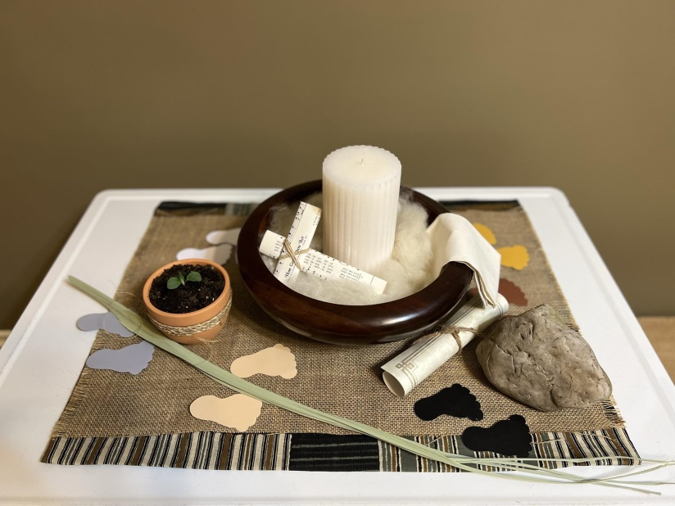

March 31, 2024

572 East & West Line
Box249
Virgil, ON L0S 1T0
905-468-3505
Email: office@bethanymennonite.ca
Website: www.bethanymennonite.ca

59 March 31, 2024 9:00 Service No. 13

Prelude JuBELLation Handbell Choir

Welcome and Prayer Pastor Herb Sawatzky

JuBELLation Handbell Choir

Song: “Low in the Grave He Lay” vs 1 & 3 #273

We Have Seen The Risen Lord!

Who do you see … at the empty tomb?
Song: “You Say”

Who do you see … in the room with his disciples?
Song: “Crown Him With Many Crowns” vs 1, 3 & 2 .#116

Who do you see … at the lakeshore?
Song: “Here I am Lord”

Who do you see … who has followed along the way?
Songs: “The Love of God is Greater Far”
“This I Believe (The Creed)”

JuBELLation Handbell Choir

Offering Prayer

Closing Song: “Christ the Lord is Risen Today” vs 1, 3 & 4 #280

Benediction

Readers: Colton Sawatzky, Lorrie Sawatzky, Colin Horne, Mathew King

JuBELLation Handbell Choir Director: Tracey Frena

Please join us for breakfast and a time of fellowship in the auditorium immediately following the service

Thank you to the Music and Tech Teams for their contribution to the service this morning, and to the Hospitality Team and all those who provided the food for the breakfast
Welcome here!
We’re glad you came! Your being here is a sign of God’s love for the world and encourages other Christians. We hope our worship together helps you find
A place to belong and grow in faith.

Praise and Concerns
Prayers:
- Steve Goertz recovering from hip surgery
- Dora Fisch-Willms at St. Catharines Hospital
- Our sister church in Pereira, Colombia

A thank you card from the Kerber family:
“Dear Bethany Mennonite Church,
It is with deep gratitude that we want to say thank you for all of your attentiveness and help preparing for our mother and Oma’s funeral and visitation. Your compassion and assistance with all the details is greatly appreciated. Lydia loved this church and attended most of her life as she was able. May you know that we have been blessed by you all. God is so good! With thankfulness, the immediate and extended family of Lydia Kerber.”

Bethany Announcements
EASTER SUNDAY BREAKFAST – We are hosting breakfast after our Easter Sunday morning service on March 31st. Please bring your contributions of Paska, raisin bread, or any other breakfast food. We would appreciate your pre-sliced Paska and other food items brought to the kitchen before the service on Easter Sunday. If you’d like to help with set up Good Friday after the morning worship service or clean up after breakfast, please join us in the kitchen.

Please read the latest letter from our friends in the Pereira Church on the bulletin board in the foyer.

We hope to print our 2024 Directory soon. Please send in any changes to your contact information to the office.

THE UPPER ROOM is a daily devotional guide for $11/year. Samples are available on the narthex shelf; please help yourself. If you would like to sign up, please contact the office.

EASTER WORSHIP SERVICES AT BETHANY

Christ among Us!

Good Friday, March 29 at 10:00 a.m., with communion
Easter Sunday, March 31
Handbell Prelude 8:45 a.m.
Service at 9 a.m.

After the service: Paska Breakfast

Local Food Bank Drive: Area food banks inform us that donations are down 30% this year while need is up 20%! Your continued support for our food drive to local food banks is much appreciated. Please drop off your donations in the food bin at the front door. Foods and snacks for breakfasts and school lunches are especially appreciated.

Our Donations Touching Lives

You can make your offering to Bethany by:
• E-transfer to office@bethanymennonite.ca
• Mail to church at Box 249, Virgil, ON L0S 1T0
• Drop in the mailbox beside the front door on Wednesdays or Thursdays 8:30-3:30 and let Marianne know.
• Canada Helps button on www.bethanymennonite.ca. CanadaHelps charges 3.75% of the donation, but you will be receipted for full amount.

Prayers:
Mennonite Church Eastern Canada
- Please pray for Grace Christian Church in Ottawa, ON. Baw Boih Hring Ngen provides pastoral care for this congregation. Please pray for this Chin congregation worshipping in Ottawa.

- Pray for Mennonite Church Canada Witness worker, Tom Poovong, together with Thai colleagues, Pastor Khamphan and Pastor Thipphawan as they travel in Canada during the month of April. Pray for the relationships being built and connections made in this travel. They will be in Ontario (April 4-9) to meet with congregations, Conrad Grebel and the Lao Mennonite Fellowship of Canada.

- Continue to pray for Myanmar, Ukraine, Gaza and throughout a world that cries for peace. Pray for those who are displaced, those who search for family members, those who make decisions and those who attempt to provide aid. Lord, hear our prayers.

Mennonite Central Committee
• Praise God that MCC has delivered a critical truckload of emergency food for besieged families in Gaza. As part of a convoy of other trucks transporting humanitarian relief via Jordan, the vehicle sat for more than a week waiting to cross the border but finally made its way through the Kerem Abu Salem crossing into Gaza on March 19.

• Pray for peace in Haiti and for political and social stability that people can go about their normal lives. Pray also for MCC staff and its 11 partners in the country that they would have wisdom and resilience in the course of ongoing stress and trauma.

Mennonite Church
Hidden Acres Mennonite Camp's 40th Annual Bowlathon is happening again this year on April 6th! You can show your support by making a donation at hiddenacres.ca/donate, and select “Annual Bowlathon” from the list. If you have any questions please contact us at info@hiddenacres.ca or 519-625-8602. Thank you!

MCEC Financial Zoom Call, April 17, 2024, 7-8 p.m. online.
The internal financial statements will be presented in advance of the Annual Church Gathering. This conversation provides an early opportunity for conversation and to ask questions. Register through your Annual Church Gathering registration or at mcec.ca.

Consider the Birds: Point Pelee Pre- MCEC Annual Church Gathering Contemplative Nature Walk, Friday, April 26, 2024, 12:30-3:30 p.m., Point Pelee National Park - Join MCEC Eco-Minister Wendy Janzen for an afternoon excursion to Point Pelee National Park. More information at mcec.ca.

Spring Seniors Retreat at Hidden Acres Mennonite Camp - On Monday, April 29th join us for a day of fellowship, community and conversations. Dr. Martha Taylor will share with us in the morning and Jane Kuepfer will host a panel discussion in the afternoon as we intentionally explore end-of-life conversations.

MCC, MDS
MCC Thrift (formerly MCC Christian Benefit Thrift Shop) on Grantham Ave, St. Catharines is set to reopen on April 1 after undergoing substantial renovations to make the store more accessible and the product displays more organized. Come on out to experience the new look. Follow the shop on Facebook and Instagram for the latest updates.

Doing Good...Better April 4, 11, 18 & 25, 1:30-3:00 pm, online
As Jesus followers, we want to do good and make a difference, especially as it relates to working towards Truth & Reconciliation with Indigenous people. The goal of this 4-week series is to grow curiosity and awareness about how we are approaching truth & reconciliation efforts so that we can all do good…better and be walking a path towards accompanying Indigenous people in Truth & Reconciliation. To learn more and to register, go to newleafnetwork.ca/events/doinggoodbetter.

Learning Tour: Travelling Together Through Truth October 21-25, Timmins, ON - Get ready to be inspired and learn as we embark on an exciting journey of connecting and engaging with First Nations communities, organizations and partners of MCC Ontario's Indigenous Neighbours program in Timmins. To learn more, conatct Cam McEachern at 705-264-2494, ext. 220 or by email at cammceachern@mcco.ca.

The March MDS Newsletter is available from the office.

Broader Church & Community
A BIG SUCCESS!! Many thank you’s go out to all ladies who helped with the Pleasant Manor Spring Bazaar last week. To those that baked delicious Paska, cookies, squares and buns, it was so appreciated. We had enough for everyone except for buns and Zwieback. We'll try to make more of that for the November sale. Thank you to those ladies who helped with cash and directing visitors in the food room, AND the ladies serving tea, coffee, and goodies in the Tea room. Couldn't do it without you! After expenses we raised $5,500. Many things can be purchased for the residents at Pleasant Manor!
Anne Litke, Chair of Women's Auxiliary

Seasons Chorale will be performing “The Conquest of the Cross” on Sunday, April 7 @ 6:00 pm at Glenridge Bible Church on Scott Street, St. Catharines and on Friday, April 12 at 2:00 pm at Harbour Fellowship Church at 51 South Service Road, St. Catharines.

Wells of Hope – Save the dates! Saturday, July 13th the 17th Annual Golf Tournament will take place at Riverview GC. Friday, September 13th they will host their 20th Anniversary Gala at Queen’s Landing. Stay tuned for updates.

THIS WEEK AT BETHANY
March 31-April 7, 2024

Today 9:00 a.m. – Easter Service
10:00 a.m. – Easter Breakfast
Tuesday 6:00 p.m. – Handbell choir
7:30 p.m. – JuBELLation
Sunday 10:00 a.m. – Worship Service
11:10 a.m. – Adult Sunday School

Speaker: John Tiessen

Worship services are recorded live and kept on our youtube channel indefinitely. Recordings begin shortly before 10am and end after 11:04. Those who prefer not to appear in the recording are encouraged to sit near the back of the sanctuary in front of the cry room, and exit through the door on that side.

